Teacher of Psychology

Job Description



Introduction

We are looking to appoint a motivated and inspirational Teacher of Psychology to join this successful and thriving Sixth Form team. The successful candidate will teach students at Key Stage 5 and contribute to all aspects of the department’s work, both inside and outside the classroom. The post would be suitable for an experienced teacher who wishes to progress in their teaching career. This post offers the opportunity to develop your teaching within an outstanding setting. This is a part time position starting from September 2026.

Background

Founded in 1629 by Samuel Harsnett, the son of a Colchester baker who went on to become Archbishop of York, Chigwell School stands on its original site with the original school building still in use. However, whilst Chigwell of today is conscious of its long-standing history, it is a forward-looking, ambitious, coeducational independent school of 990 pupils aged four to eighteen. It enjoys excellent facilities, a dedicated staff, bright and hardworking pupils, and a site of 100 acres.

Chigwell School is located in the picturesque village of Chigwell just over ten miles from central London and on the Central Line. The extensive, beautiful grounds are close to the edge of Epping Forest and it is rare for a school to have so much space and yet be so close to the centre of the capital. Most pupils are day pupils but in the Sixth Form there is a small community of international boarders, roughly thirty from sixteen countries, and these live in four small boarding houses.

As well as being an academic school, Chigwell has the reputation for providing a rich and full education, with plenty of opportunities for all pupils who are enthusiastic, co-operative and able. Chigwell is a caring and friendly school, with a close sense of community, not least between colleagues. As the Good Schools Guide reports: Academically, pupils are put through their paces but it all seems to be done in such a civilised and pleasant manner that you are more likely to hear pupils talk about opportunities and prospects than pressure and stress. “Anyone who wants to do well here, will do well” said one student, “and I can’t think of a nicer place to succeed.” Founded in 1629 by Samuel Harsnett, the son of a Colchester baker who went on to become Archbishop of York, Chigwell School, which is at the centre of the community, has been preparing pupils to make their mark on the world for nearly four centuries.

Whilst the Chigwell of today remains proud of its unique heritage, it is a place of innovation where pupils are well prepared to contribute positively to the community, inspire change for the better and continue learning throughout their lives.
Chigwell has seen many changes since its foundation, including becoming fully co-educational in 1997, establishing the Pre Prep in 2013 and building a state-of-the-art Sixth Form Centre in 2016. Grounded in tradition but preparing pupils for the future, Chigwell is now a large school of 1,110 boys and girls aged 4-18 years, where every individual is known and cherished.
Through the wide range of academic and co-curricular opportunities available to them, each pupil becomes the very best they can be: independent in spirit, adventurous in approach and empathetic in their treatment of others. This allows Chigwellians to forge their own paths to success and realise the words of the school motto: find a way or make a way.
Uniquely positioned on a 100-acre site in the picturesque village of Chigwell, the school benefits from the leafy surroundings of Epping Forest whilst being just 20 minutes away from the City of London on the central line. An enchanting vista through the treeline offers stunning views of the City skyline, giving pupils the rare benefit of having so much space so close to the centre of the Capital.
Chapel is at the heart of the School and although Chigwell follows the Christian tradition, pupils draw on a breadth of spirituality afforded by a vibrant and diverse community.

Vision, Mission and Values

Vision﻿
To inspire pupils to fulfil their potential and forge their own path to success.

﻿﻿Mission
Chigwell is a nurturing community. We strive to ensure that everyone is the very best they can be; independent in spirit, adventurous in approach and empathetic in how they treat others.
Since 1629, pupils have been empowered with a deep respect for lifelong learning, ensuring they are ready to make their positive mark around the world.

Values
As well as representing what makes Chigwell distinct, the values also fuel the vision, as the school cultivates young people who will become inspiring role models for others.
Happiness First
Creating a nurturing space where happiness underpins achievements and drives everyone forward.
Courageous and Resilient
Seizing every opportunity and having the confidence to embrace them wholeheartedly.
Innovative Approach
Adapting and evolving, influencing the changing world.
Community of Kindness
Supporting and collaborating with each other, making a positive contribution to the community.
Lifelong Learning
Cultivating curiosity, keeping the passion for learning alive beyond the school gates.

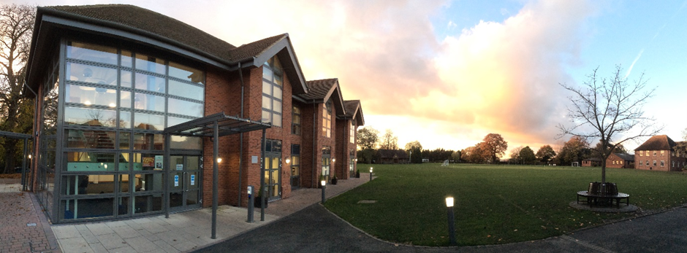

The School

Pre-Prep
Sitting at the very heart of the school site, the Pre-Prep is a safe and nurturing community where the youngest Chigwellians begin their educational journey. Pupils and staff benefit from a state-of-the-art and purpose-built building, with a spacious assembly hall, library and teaching and playing areas designed specifically for ages 4-7 years. The school day is structured to provide a balanced mix of academic, physical and creative experiences. Whilst the National Curriculum forms the basis of all programmes of study, it is adapted to extend and meet the needs of Chigwellians, and significant emphasis is placed on learning outside the classroom. Pupils take part in many educational opportunities, including visits to museums, theatres and workshops, as well as benefiting from enrichment activities in school, such as themed days, visits by speakers, musical workshops and other performances.

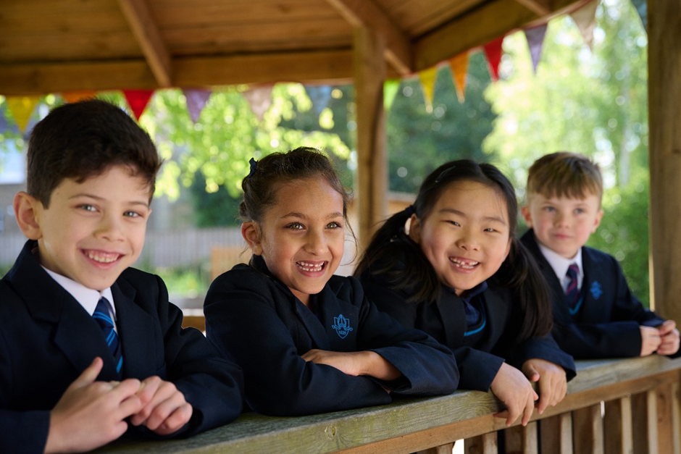

Prep School
Pupils transition seamlessly to the Junior School at 7 years old, benefitting from small class sizes and considerable individual attention. The creative and broad curriculum seeks to make children independent in approach and curious about the world around them whilst embedding key skills within all subject areas.

From the age of 7, children do drama in the purpose-built drama centre, with their plays and assemblies in the theatre itself, and they learn their music in the Walde Music School, performing in choirs, ensembles and orchestras from an early stage. Art, Design and Technology is a particular strength, taught in the Art Centre and with regular exhibitions of the children’s work. Science is taught in the Science labs and ICT is both integrated into all teaching and taught as a separate subject in the ICT labs. Sport and PE are taught by specialist teachers and coaches, with two games afternoons and regular fixtures every week.

Pupils are also expected to develop wider interests and the wide-ranging programme of after school clubs and activities is second to none. From board games, to Korfball, to Stock Market club to Astronomy club to sporting and musical and drama activities, every child can taste a variety of activities to see what suits them best.

Senior School
Pupils follow the senior school curriculum from the start of Year 7 but pastorally Year 7 and 8 operate as a discrete unit. In Year 9, pupils become part of one of the four senior school day houses (Caswalls’, Lambourne, Penn’s and Swallow’s) and these are a focus for co-curricular activities and pastoral care. As pupils’ development accelerates both emotionally and academically, they are prepared to successfully pass public exams, embrace university life and make career choices through the rich combination of a broad and balanced curriculum, variety of co-curricular opportunities and breadth of pastoral support.

Once they reach Year 10, pupils take a core of GCSEs consisting of English Language, English Literature, Maths, at least one foreign language, the sciences (with the vast majority taking triple science) and three other additional subjects. Pupils meet in their house groups each day and will get to know students of all ages. There are a whole host of extra-curricular competitions and activities through the house system, and all are encouraged to participate. Each house has a housemaster or housemistress at its head who has a team of supporting tutors. Every pupil has a house tutor who oversees all aspects of their education, welfare and progress and is the first point of contact for parents.

Sixth Form

Students in the Sixth Form at Chigwell benefit from the exclusive use of the purpose-built Risham Sarao Sixth Form Centre which opened in 2016. The facility is a hub for learning, with six classrooms, study and social spaces and a centre for university and career advice, as well as a coffee shop. Sixth formers also make good use of the specialist facilities around the school and play an active role in the school community, leading by example and shouldering considerable responsibility. Students can pursue three or four A levels selected from a broad academic range, as well as an Extended Project Qualification (EPQ). Those with a GCSE profile commensurate with an Oxbridge application are offered support sessions, as are those considering medicine, veterinary science or dentistry. In Year 12, every student participates in an academic enrichment programme for one lesson a week, aimed at broadening and deepening their intellectual experience. Courses include Medical Ethics, Financial Analysis and a History of Western Art amongst others. The vast majority of Chigwell leavers go on to Russell Group universities or the equivalent, with some gaining places at prestigious universities overseas. A small but growing number also take up degree-level apprenticeships. The Chigwell careers programme follows the eight Gatsby Benchmarks and a mixture of school-based sessions. External speakers, events and employer interactions ensures that students receive a well-rounded careers education.

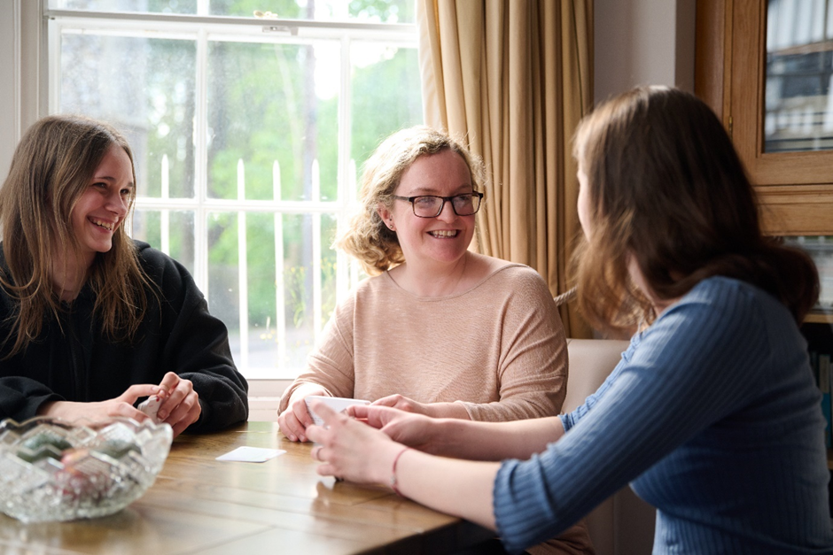

Boarding

Chigwell offers four extended family-style houses (two for girls and two for boys) for 28 international boarders aged 16-18 years. Boarders are well-integrated into school life and well-prepared for both their A Levels and successful entry into British universities. Boarding is a mature community where pupils from around the world benefit from close friendships and cultural exchange.

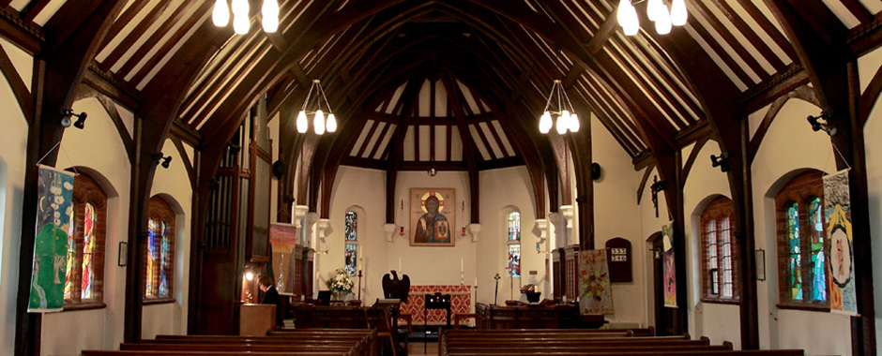

The Chapel

Chigwell is of Anglican foundation and the Chapel, dedicated in 1924, acts as a focus of thought and inspiration for a diverse community representing all the major world faiths and those who have no faith.

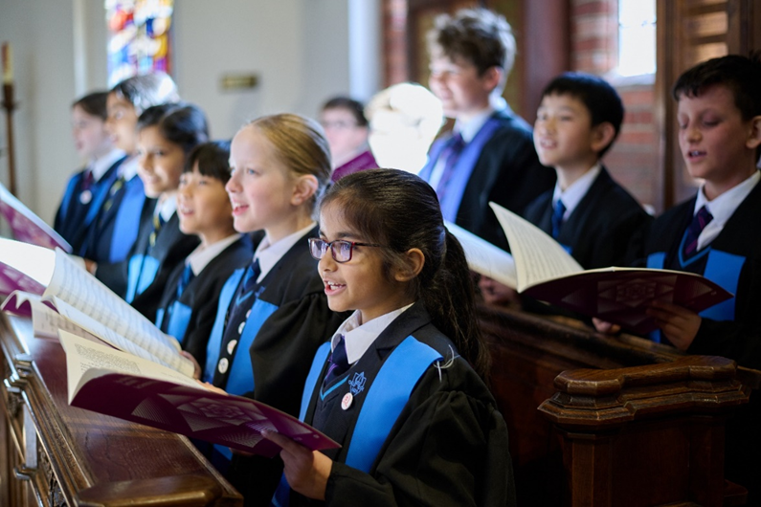

Co-Curricular

A particular feature of Chigwell is the breadth of opportunities offered beyond the classroom. Outdoor learning begins in the Pre Prep and continues throughout the school, from the thriving Scout Troop through to the pupils embarking on their Duke of Edinburgh Scheme Gold Award. Pupils enjoy PE lessons and games afternoons, with a full programme of external fixtures as well as sports tours on offer. The excellent sports facilities include a floodlit AstroTurf, nine tennis/ netball courts, nine football pitches, a new 3G floodlit pitch and indoor and outdoor cricket nets. This provision is due to be substantially enhanced by the new eco-friendly Sports and Wellbeing Centre which will have a six-lane indoor swimming pool, five court multipurpose sports hall, climbing wall, gym and studios and a café.

Drama is key to developing creativity and the inter-personal skills so essential to modern life and at Chigwell pupils are introduced to a range of material from Ancient Greece to Shakespeare to modern texts. With its own state-of-the art 150-seat theatre, Chigwell offers pupils the opportunity to participate in a range of productions as actors, stage designers, lighting and sound specialists and make up and costume designers as well as a host of other roles.

There is a wide range of musical opportunities for pupils of all ages, with several hundred pupils taking private instrumental and singing lessons and participating in ensembles, choirs and orchestras. A regular programme of concerts ensures every pupil has the opportunity to perform during the year, including at events taking place in the local community.

Pupils are encouraged to express their individuality, feelings and thoughts using a mixture of materials and variety of traditional and contemporary tools in Art and Design. The Department regularly hosts exhibitions in the airy gallery and offers a broad enrichment programme, encompassing practical workshops, trips and talks by visiting speakers.

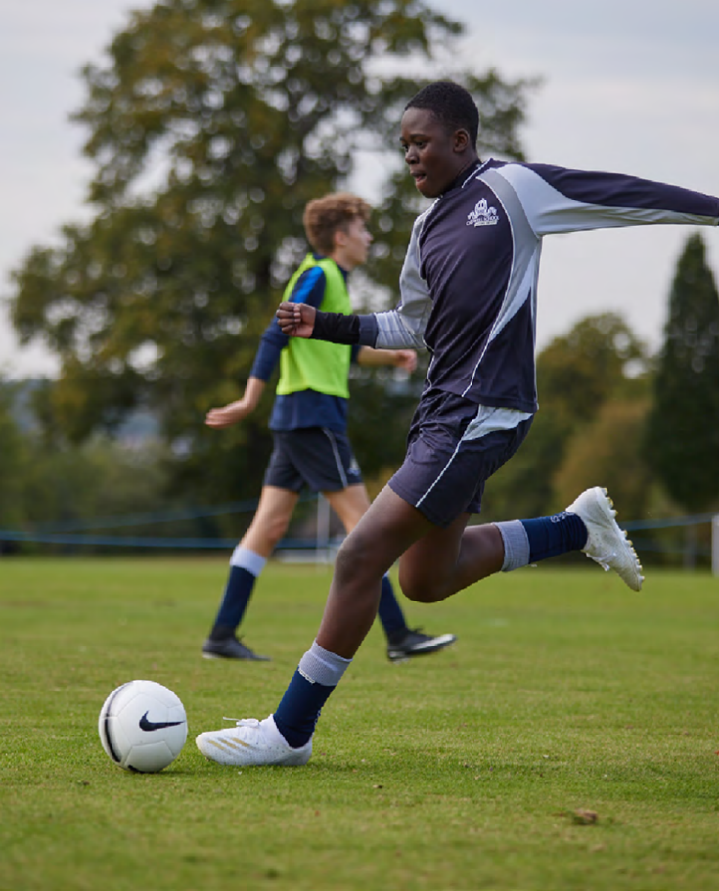

Outreach and Community Partnerships

Working with the wider community has always been part of Chigwell’s DNA and preparation for making a contribution to the world begins when pupils are at school. They are encouraged to work with the local and wider community through voluntary roles at local scout and brownie groups, the Epping Conservation Centre, Chigwell Riding Trust and relevant local charities. Staff share their expertise with local school children, running mock interviews for sixth formers, music classes for local secondary and primary pupils and through a strong relationship with the London Academy of Excellence in Tottenham which it helped to establish. School facilities are also regularly used for events to benefit pupils from other local schools and community groups.



The Psychology Department

Psychology A level is a thriving and popular subject. Within the department, our aims are to foster an interest and develop enthusiasm for the study of human mind and behaviour. The syllabus and the examination papers are designed to allow students across the grade spectrum to flourish and fulfil their potential, and the course encourages students to develop a wide range of skills and not just academic ones.

Psychology is one of the most popular A level subjects in the school, with two classes in each of Year 12 and Year 13. We follow the AQA specification, which teaches pupils breadth and depth and contains clear assessment criteria. The syllabus also has a strong focus on research methods, scientific research techniques and statistics. All students sit the A level linear qualification after completing the two-year course. There are three papers each designed to target particular skills. The department is housed within the dedicated Sixth Form Centre. All classrooms are equipped with interactive boards and high-quality teaching resources. Staff have access to an extensive range of materials, including textbooks, journals and revision guides, while ICT is fully embedded within teaching and learning.
Across the School, we foster a collaborative and supportive learning environment. Pupils are encouraged to question, think critically and engage actively with the world around them. They work both independently and collaboratively, developing the academic, analytical and interpersonal skills required for future success.
Above all, Chigwell School seeks to ensure that pupils are happy, motivated and appropriately challenged within a stimulating and supportive environment.

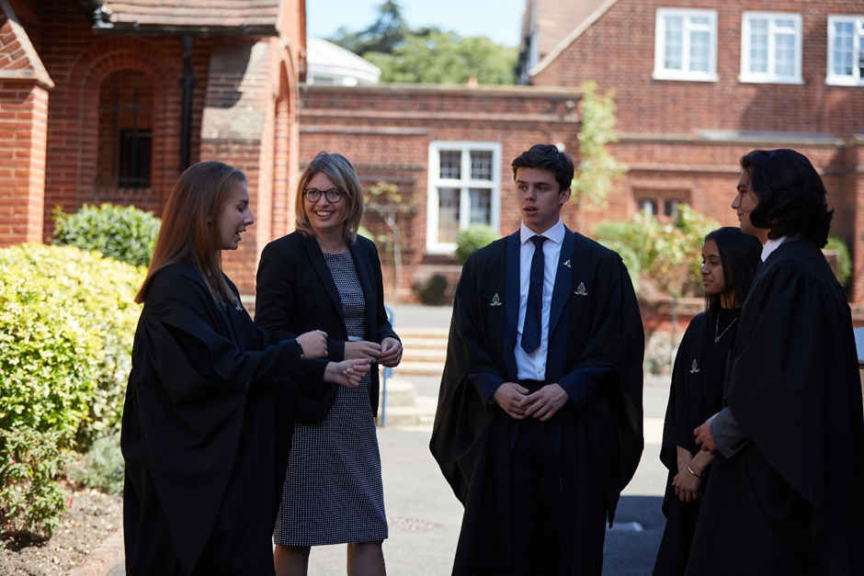

The Person
We are looking for a committed, well-qualified and enthusiastic teacher who can inspire students through a genuine passion for Psychology. The successful candidate will be able to deliver engaging and challenging lessons that meet the needs of all learners and enable them to achieve their full potential.
The ideal applicant will:
- Have excellent subject knowledge and a relevant degree and teaching qualification.
- Contribute professionally to the work of the Sixth Form and be supportive of colleagues.
- Have the ability to work to and achieve high standards.
- Use a range of effective teaching strategies to engage and challenge students.
- Possess excellent communication and interpersonal skills.
- Be a competent user of ICT and use these skills effectively within the classroom.
- Demonstrate enthusiasm and a clear sense of purpose in teaching, learning and assessment.
- Inspire students to think critically, analyse evidence and engage thoughtfully
- Be prepared to contribute to enrichment activities
- Have energy, commitment and the ambition to develop professionally and contribute to the continued success of the department.
- Be expected to take a full and active part in the life of the School and contribute to the wider co-curricular programme.
Chigwell pupils are enthusiastic, curious and eager to learn. This post would suit a motivated and talented teacher seeking career development within a supportive and academically ambitious environment. The School provides a well-established programme of professional development and offers the support necessary for staff to flourish.

Salary
The salary on offer is competitive with a Chigwell enhancement

Benefits
Chigwell School is a welcoming and rewarding place to work, providing a supportive and professional environment for all staff. Benefits of working at Chigwell School include:

- A competitive salary and generous holiday entitlement  - Strong commitment to professional development  - Membership of the Pension Scheme  - Generous fee remission for eligible children  - Personal Accident Cover and Death in Service  - Employee Assistance Support Programme  - Free access to a GP helpline providing round-the-clock GP assistance  - Complimentary lunch and tea, and break time refreshments during term time  - Use of the Sport and Wellness Centre facilities outside of the school day  - Free parking on site and cycle racks  - Wellbeing and Medical Centre on site  - Use of School Library  - A beautiful working environment – 100-acre site, beautifully landscaped with a number of listed buildings  - Good transport links by tube (Central Line), road and local bus route and free shuttle bus to the tube station before and after school  - A supportive community of highly motivated students and staff | 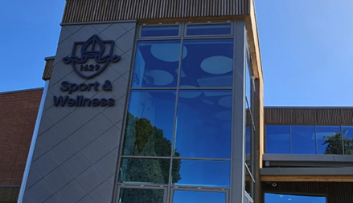

How to apply

Applicants should complete the application form available on our website at https://www.chigwell-school.org/vacancies/ and submit it by email to the Human Resources Manager at hr@chigwell-school.org.

Applications will be reviewed as they are received and, therefore, early applications are encouraged. Shortlisted candidates will be contacted by telephone or email and invited to attend an interview. The School reserves the right to interview and appoint a suitable candidate before the closing date; therefore, an early application is advised.

Chigwell School is committed to fostering an inclusive and diverse community and is proud to be an equal opportunities employer. We welcome applications from a diverse pool of candidates.

Chigwell School is committed to safeguarding and promoting the welfare of children and young people and expects all staff and volunteers to share this commitment. Applicants must be willing to undergo child protection screening including checks with past employers and DBS.

