Mr D.A.P. King Head

dking@chigwell-school.org D: +44 (0)20 8501 5701 T: +44 (0)20 8501 5700
High Road, Chigwell, Essex IG7 6QF www.chigwell-school.org

Deputy Head (Pastoral)

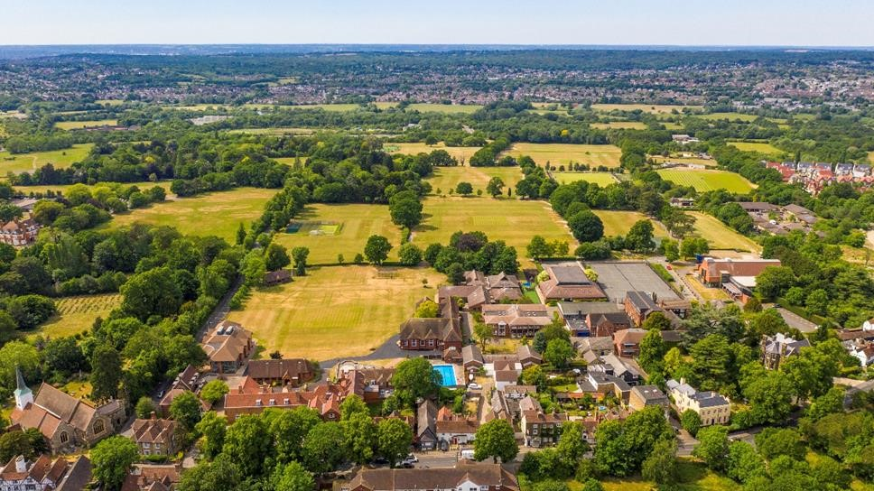

Introduction

Chigwell School is seeking to appoint a Deputy Head Pastoral from September 2023. This is an exciting and challenging whole school role which would suit a candidate with experience of pastoral leadership. The successful candidate will be responsible for delivering and developing high quality pupil-centred pastoral care across the school, including boarding, and for developing and monitoring pastoral support for pupils.

Background

Founded in 1629 by Samuel Harsnett, the son of a Colchester baker who went on to become Archbishop of
York, Chigwell School stands on its original site with the original school building still in use. However, whilst Chigwell of today is conscious of its long-standing history, it is a forward-looking, ambitious, coeducational independent school of 990 pupils aged four to eighteen. It enjoys excellent facilities, a dedicated staff, bright and hardworking pupils, and a site of 100 acres.

Chigwell School is located in the picturesque village of Chigwell just over ten miles from central London and on the Central Line. The extensive, beautiful grounds are close to the edge of Epping Forest and it is rare for a school to have so much space and yet be so close to the centre of the capital. Most pupils are day pupils but in the Sixth Form there is a small community of international boarders, roughly thirty from sixteen countries, and these live in four small boarding houses.

As well as being an academic school, Chigwell has the reputation for providing a rich and full education, with plenty of opportunities for all pupils who are enthusiastic, co-operative and able. Chigwell is a caring and friendly school, with a close sense of community, not least between colleagues. As the Good Schools Guide reports: Academically, pupils are put through their paces but it all seems to be done in such a civilised and pleasant manner that you are more likely to hear pupils talk about opportunities and prospects than pressure and stress. “Anyone who wants to do well here, will do well” said one student, “and I can’t think of a nicer place to succeed.”

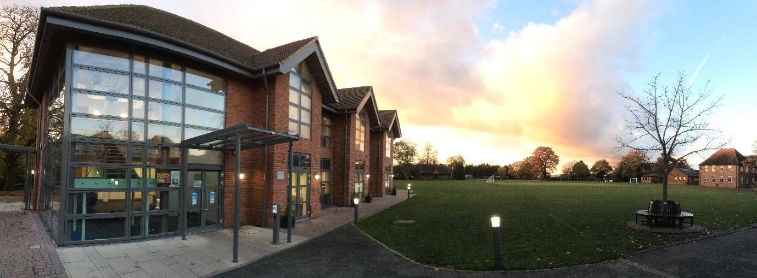

The School Development Programme

Over recent years, the School’s facilities have been extensively developed in order to enhance the educational experience that pupils receive. The development programme has included the following additions:

- 2008 Wilson Building teaching block
- 2008 Floodlit AstroTurf pitch
- 2009 Junior School library extension
- 2010 Complete redevelopment of catering facilities
- 2010 Harsnett’s and Church House converted into boys’ boarding houses
- 2012 The Old Chigwellian Club and land was incorporated into the school estate
- 2013 Pre Prep School completed and opened
- 2013 Two new science labs created
- 2014 Drama Centre balcony extended to provide additional music and drama rehearsal space
- 2016 The Risham Sarao Sixth Form Centre completed and opened
- 2017 Extension of Dining Hall
- 2018 Renovation of the Chapel
- 2019 Extension of Junior School
- 2020 3G football pitch constructed
- 2021 New Sports Centre (currently underway)

The Governors have recently agreed a development masterplan and the next priorities on the School’s development plan are to:

- Further expand our provision of bursaries
- Expand the facilities for music

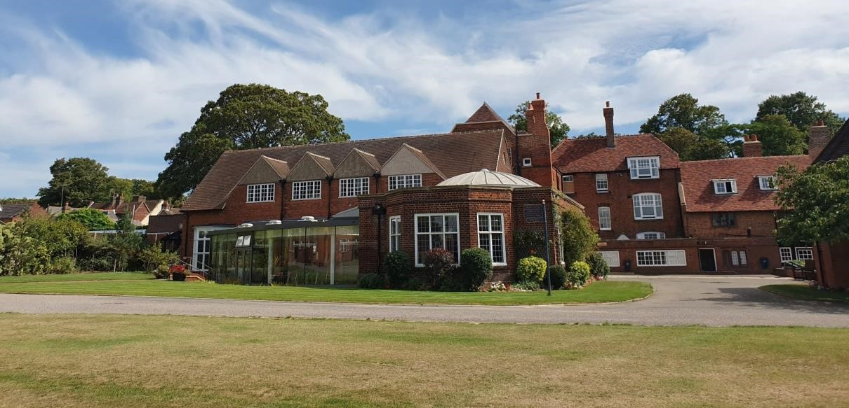

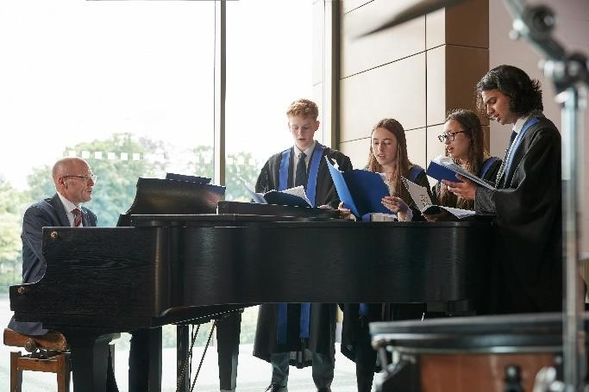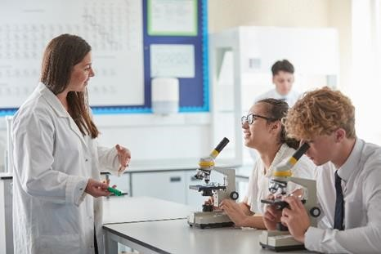

The School

Some pupils join Chigwell School in Reception and there are two classes in each of the three Pre Prep year groups. A small number of children join the Junior School at 7+ (Year 3) and there are three classes in each of the KS2 year groups. At 11+ (Year 7), there is a further entry with four or five classes making up Years 7 to 11. Again, there is a small entry into the Sixth Form. Entry at each stage is selective and although there are three main sections to the School (Pre Prep, Junior School and Senior School) these sections work closely together and there is a common ethos running throughout.

There are over a hundred teachers and together with the support staff, there is a friendly, mutually-supportive atmosphere. We place considerable emphasis on life outside the classroom and believe that the opportunities that we provide help to fulfil our Vision: To inspire our pupils to fulfil their potential and forge their path to success. The School Values are:

- Happiness First
We create a nurturing space where happiness underpins our achievements and drives us forward.
- Courageous and Resilient
We seize opportunities all around us and have the confidence to embrace them wholeheartedly.
- Innovative Approach
We adapt and evolve, influencing our changing world.
- Community of Kindness
We support and collaborate with each other, making a positive contribution to the community.
- Lifelong Learning
We cultivate curiosity, keeping the passion for learning alive beyond the school gates.

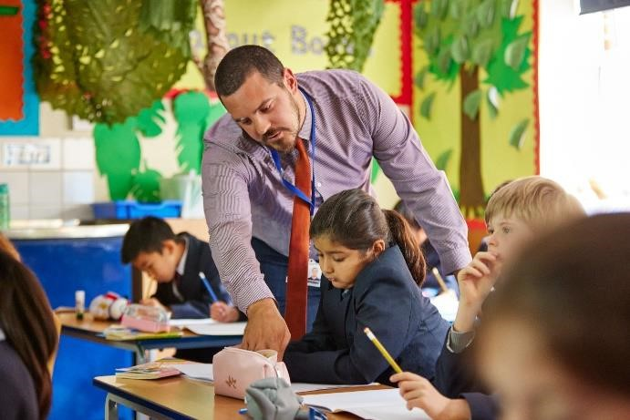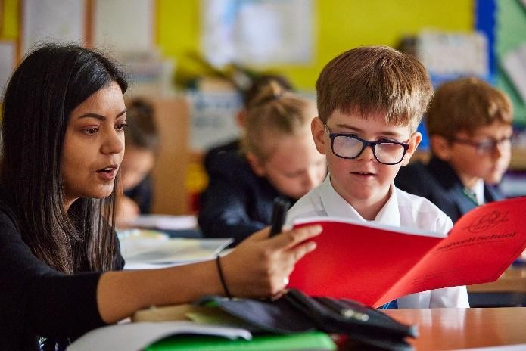

The Role

Overview

The Deputy Head Pastoral will work closely with the Head, the Deputy Head Staff and Systems and the Deputy Head Academic. They will have high level, whole-school responsibility in a number of areas: they will be responsible for leading and overseeing the School’s provision for the pastoral care, support and wellbeing of pupils; for issues relating to behaviour and discipline; for safeguarding and child protection (alongside the Designated Safeguarding Lead); for overseeing and contributing to the development of the School’s boarding provision.

In addition, and as a member of the school’s Senior Management Team, the Deputy Head Pastoral will be expected to be involved in, and to make a pro-active contribution to, all aspects of the life of the school and its leadership and strategic development, identifying and taking every possible opportunity to improve, enhance
and further the school’s educational, pastoral, boarding and extra-curricular provision.

This role reports to the Head.

Key Responsibilities

The Deputy Head Pastoral will line manage the Head of Sixth Form, the Head of Lower School (Years 7&8) and the Day Housemasters and Housemistresses. They will also line manage the Head of Wellbeing. They will line manage the Director of Boarding to oversee the care of the boarding community. They will also oversee the spiritual life of pupils at the school.

The Deputy Head Pastoral will be expected to take the lead in the following areas:

Pastoral and wellbeing

- Support the school’s pastoral staff, guiding strategy and decision-making in this area, and ensuring consistency across the school.

- Regularly evaluate the quality and delivery of the School’s pastoral provision in all its forms across the school, and support initiatives aimed at developing and enhancing this provision.

- Contribute to the development of the school’s provision in the area of pupil welfare and wellbeing.

- Line-manage and oversee the work of the Head of Wellbeing, Day Housemasters and Housemistresses, Head of Lower School and Head of Sixth Form.

- Advise on the organisation of form and tutor groups.

- Oversee the provision of assemblies, tutor time, Chapel and Church.

- Oversee House competitions and House events.

- Select, manage and run the Praefect team.

Behaviour and discipline

- Support colleagues across the school and guide decision-making with regard to issues of behaviour, helping to agree on a course of action and on appropriate sanctions where necessary.

- Ensure that the approach to such issues is always in line with the school’s ethos and consistent across the school.

- Refer to the Head where major disciplinary issues and sanctions may be involved.

Safeguarding and child protection

- This role will be a Deputy Designated Safeguarding Lead. The person will work closely with the DSL to help with oversight of the school’s policies and the requirements set out in KCSIE or any other government regulations or guidance that may take its place in the future.

- Work closely with the other staff with designated responsibility for safeguarding and child protection in school and help to dealing with any (actual or potential) safeguarding and child-protection issues that may arise.

- Help to keep the school’s policy and practice on safeguarding and child protection under regular review and ensure that they are adapted as necessary in light of experience.

- Keep up with national and local regulations and guidelines relating to safeguarding and ensure that the school’s policy and practice in this area are fully compliant at all times.

- Boarding

- Line manage the Director of Boarding and have oversight of decision-making, problem-solving, dealing with practical issues, including emergencies, and with shaping the direction of future developments in the school’s boarding provision.

- Keep the school’s provision and practices in the area of boarding under review and always seek ways of enriching and enhancing pupils’ boarding experience.

- With the Director of Boarding and the Head, take the lead on boarding staff appointments.

- In addition, and as a member of the whole-school Senior Management Team, the Deputy Head Pastoral will have a range of other responsibilities, including but not limited to the following.

Management and Leadership

- Lead by example, providing inspiration and motivation and embodying the ethos and values of the school.

- Work with the Head, the Deputy Head Staff and Systems and the Deputy Head Academic, and the other members of the school’s Senior Management Team and be involved in all aspects of school life and leadership, including school improvement and the formulation of whole school strategy.

- Make a significant contribution to the production and update of the School Development Plan, SEF and other evaluative and strategic plans and documentation.

- In conjunction with the Head and other members of the senior management, lead on matters of staff performance management.

- Contribute to the regular review and monitoring of the structures and systems which underpin the effective and efficient running of the school.

- Work with the Head and other colleagues in the promotion of the school and its benefits to parents, potential pupils, local feeder institutions and placement consultancies.

- Assist the Head in the appointment of staff as appropriate in conjunction with the Deputy Head Academic and the Deputy Head Staff and Systems.

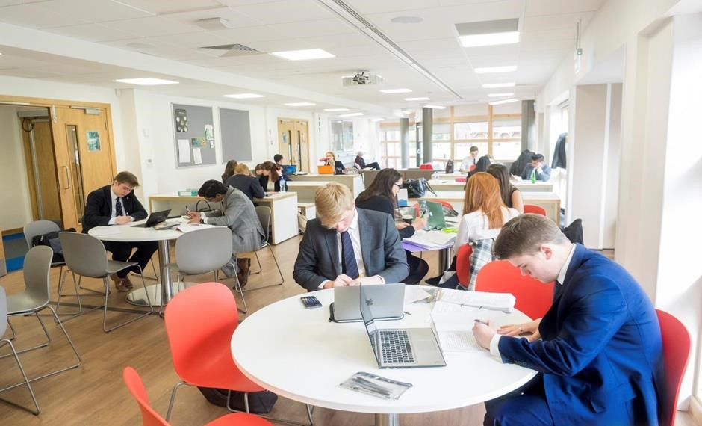

The Person

QUALIFICATIONS/ATTAINMENT
- An honours degree from a leading university.
- Additional academic and/or management qualification(s) desirable but not essential.
SKILLS AND EXPERIENCE
- Highly successful teaching track record across the 4-18 age range, up to and including A level, with a track record of consistently enabling pupils to achieve the highest standards.
- Substantial and successful experience of curriculum leadership, development and management, likely to have been gained as an Assistant Head or Head of Faculty, or an equivalent senior role.
- Prior experience of strategic pastoral planning either as a member of a senior team, or as part of a team/initiative driving whole-school change.
- Excellent interpersonal skills including the ability to relate well to a variety of people, to resolve conflicts in a sensitive manner, to encourage and to motivate.
- Ability to show ambition for the School and its strategic pastoral direction.
- Ability to work effectively and collaboratively as a member of a senior team, to show initiative and imagination,to have vision and the ability to inspire others.
- First class administrative and organisational skills, with the ability to remain calm under pressure, work to tight deadlines and manage competing priorities.
- Strong analytical and problem-solving skills, combined with a proactive and positive approach to delivering change.
- Ability to design and deliver complex strategies from inception to completion.
- Excellent communication skills, both written and oral.
- A keen eye for detail and an appreciation of the legislative and compliance framework for independent schools.
KNOWLEDGE AND UNDERSTANDING
- An up-to-date knowledge of national educational trends and developments.
- A detailed knowledge of modern pedagogy and of recent developments in teaching and learning.
- A coherent academic philosophy and approach to the use of technology in teaching and learning.
PERSONAL ATTRIBUTES
- Confidence, presence and charisma.
- Personal integrity, honesty, energy,stamina and enthusiasm.
- Self-motivation with committed work ethic.
- Commitment to personal development and life-long learning.
- Understanding of the pupils’ perspective.
- Genuine commitment to working as part of a team.
- Capacity to present and speak well in public.
- Empathetic understanding of the particular challenges facing young boys and girls and their well-being in the 21st century.
- Understanding and passion for the values and vision of Chigwell School.

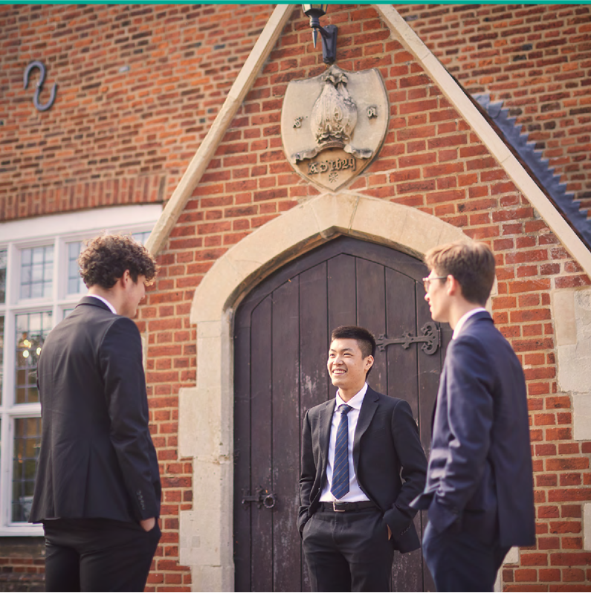

Salary

The salary on offer is competitive reflecting the seniority of the role.

Benefits

Chigwell School provides a very supportive working environment. There is a well-developed programme of professional development, pupils are enthusiastic, co-operative and able, and colleagues get on well together. There is a strong sense of community.

Other benefits of working at Chigwell School include:

- A competitive salary  - Strong commitment to professional development  - Membership of the Pension Scheme  - Fee remission for eligible children  - Personal Accident Cover  - Employee Assistance Support Programme  - Complimentary lunch and break time refreshments during term time  - Use of school sports facilities outside of the school day | - On site free parking and cycle racks  - Medical Centre on site  - Use of School Library  - A beautiful working environment – 100 acre site, beautifully landscaped with a number of listed buildings  - Good transport links by tube (Central Line), road and local bus route  - A supportive community of highly motivated students and staff

Applications

Applicants should complete the application form which can be accessed directly from our website: https://www.chigwell-school.org/vacancies/. Completed applications should be sent to the HR Manager at: hr@chigwell-school.org

Closing date: Wednesday, 8th February 2023 – early applications are welcome.

Applications will be considered upon receipt. Candidates will be contacted by telephone or email to attend interview if required. The School reserves the right to interview and appoint before the closing date.

Chigwell is committed to safeguarding and promoting the welfare of children and young people and expects all staff and volunteers to share this commitment. Applicants must be willing to undergo child protection screening including checks with past employers, prohibition orders and enhanced DBS.

