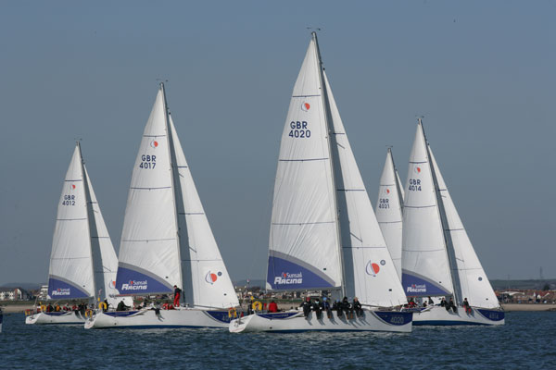

Come for a day’s sail and Race with Prometheus Sailing (Sunsail),
the Master and the WCBYC

The Worshipful Company of Butchers Yacht Club and the Master is looking to hold a day’s sailing and racing. The day is open to individuals or companies to get together to race in the Masters Cup.

The date is the 1st September 2025 and the days event would be

0900hrs Guests arrive at Port Solent Marina and introduced to skippers.
0915-0945hrs Safety briefing and yacht familiarisation onboard
0945hrs Slip lines and head out onto the Solent for training
1230hrs Packed lunches onboard
1300hrs A series of 2-3 fun races on the Solent
1600hrs Arrive back at Port Solent Marina
1630hrs Prize giving
1645-1700hrs Guests depart at leisure/ evening BBQ

The cost for 8 people on a boat with a skipper is £1,380.00, or £172.20 per person. Whole boat hire or individual places are available.

There are 8 boats available, we are also looking to arrange a BBQ evening event to relive the day on the water.

There could be some intercompany rivalry, please advise soonest if this is something that would float your boat.

At Prizegiving ashore post the racing there are 3 bottles of Mermaid Gin available for prizes plus the Masters Cup for the winning team
Please email Andrew.berisford@wcbmarketing.co.uk asap with your interest.
Address of the event
Lock Approach
Port Solent Marina
Portsmouth
PO6 4TJ

www.prometheus-sailing.co.uk

