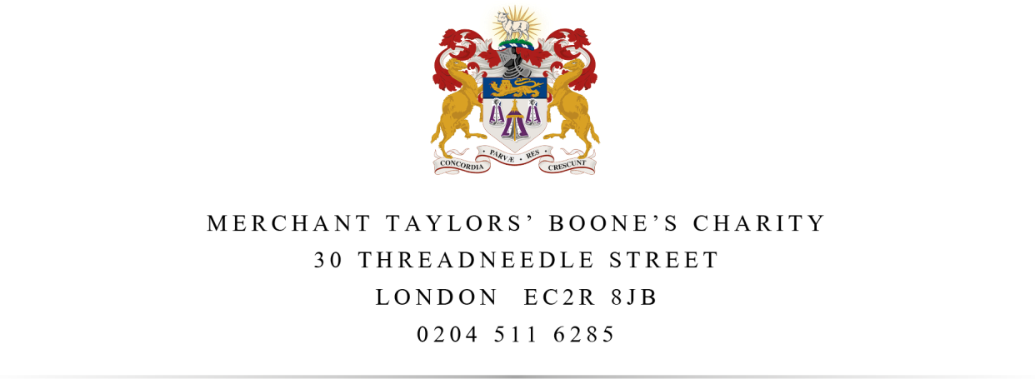

Annual Complaints Performance and Service Improvement Report August 2024-July 2025

Introduction
From April 2024, the Housing Ombudsman Service requires landlords to produce an Annual Complaints Performance and Service Improvement Report.

Response to the report by the Member Responsible for Complaints and Trustee, on behalf of the governing body

This report has been agreed by Phillip Kelvin, who is MTBC’s Member Responsible for Complaints and also a Director, on behalf of Merchant Taylors’ and Christopher Boone’s Almshouse Charity which is the Corporate Trustee of MTBC.

The Corporate Trustee reviewed this report at a meeting on 7 October 2025 and agrees that the details included within this report are an accurate reflection of the performance of MTBC in the year August 2024 – July 2025.

Housing Ombudsman Service
During the last 12 months the Housing Ombudsman Service did not issue MTBC with any non-compliance findings with the Service’s Complaint Handling Code (‘the Code’) or produce any reports on MTBC’s performance.

Complaints Handling Performance 2024-2025
MTBC did not receive any complaints during the last 12 months.

Self-Assessment
A detailed self-assessment of the Complaint Handling Code can be found on our website’s complaints page. In summary, this shows that we are compliant with the Code.

Service improvements made as a result of the learning from complaints
In previous years, MTBC has used complaints as an opportunity to learn and improve services for our residents. However, MTBC did not receive any complaints during the financial year August 2024- July 2025.

Registered Charity 214262 in England and Wales, Registered Provider of Social Housing A2246 in England

