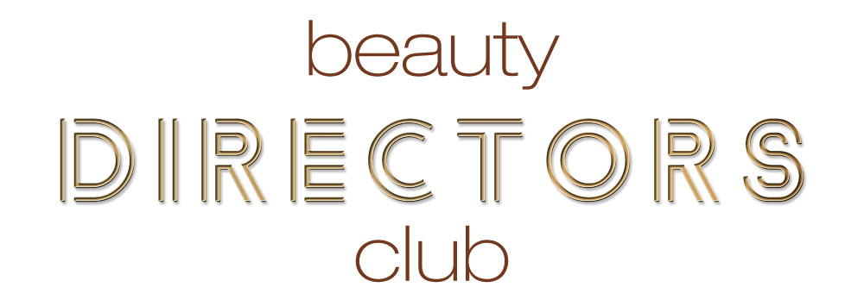
It would be very easy to believe the hype that the easy way to get 100 NEW Clients is to head straight for offers or to the deal sites.
Yes, you may well end up with 100 new clients through your door but if they don’t match the clients that are have organically attracted then you could have your regular clients running for the hills as the dynamics of your business will have changed. Clients chasing offers normally won’t stay with your business with the enticement of the next best deal from a competitor.
The other negative is that you have slashed your prices for little or no gain both financially and in producing client retention.

What we need to do is to get very clear on who your ideal client is and then maximise to get more of the same type of clients.
Attached is a list of client likes and attributes. Look at your top clients or imagine your ideal client and work through what they like to build your ideal client lifestyle profile.
Does your treatment menu reflect this client? Is this the client that you are marketing to…or are you trying to market to everyone?

Give your client a name.
Male or Female?
How old are they?
What is their marital status?
What profession are they?
Where do they work?
Where do they live?
What kind of accommodation?
Do they own their home?
What does home life look like?
What hobbies do they have?
Where do they buy their food?
Where do they buy clothing?
How much would they pay for a shirt?
Which scent do they choose to wear?
What car do they drive?
Where do they go on holiday?
What is their favourite food?
Which restaurant would they go to?
What is their favourite drink?
What is their favourite film?
What are their ambitions?
Do they prefer Fact or Fiction books?
What is their favourite TV programme?
How confident are they in themselves?
What do they see as value? Is it price or service?

An example client survey is attached in this step which will help you to identify your clients wants or needs. You can change the questions and add your logo. Please do not add more questions but swop as you need.
This is proven to be just the right amount of questions to get a great response.

I would suggest printing 100 surveys and giving to every client before they leave. Please do not select clients as you want a clear overview. This survey can be transferred to a digital format if you wish and you may want to use free software such as Survey Monkey.
Compile your results before moving to the next stage.

