

Version 1.1

Grievance Mechanism
Contents
1 Introduction 3
2 Scope of the Plan Vivo Grievance Mechanism 4
3 Submission of Grievances to Plan Vivo 8
3.1 Who can Submit? 8
3.2 How to Submit? 8
4 Regular Grievance Handling Procedure 9
4.1 Acknowledgement and Assignment 9
4.2 Eligibility Assessment 10
4.3 Internal investigation 10
4.4 Resolution 11
4.5 Appeal 11
4.6 Escalation and third-party arbitration 11
5 Anonymous Grievance Handling Procedure 11
6 Transparency 12
7 Confidentiality and Protection 12
8 Data retention 12
Annex 1 – Grievance Submission Template 13

Introduction
As a certification body committed to transparency, accountability, and continuous improvement, we provide a formal grievance mechanism to ensure that all stakeholders have a clear and accessible channel for raising concerns. This mechanism serves two primary purposes:
(1) to allow stakeholders of certified projects, under any of Plan Vivo’s Standards or Programmes, to escalate grievances that remain unresolved through the project's grievance mechanism, and
(2) to provide any external stakeholder the opportunity to raise concerns directly related to the operations, decisions, or conduct of the certification body, Plan Vivo. Through this process, we aim to uphold the integrity of our certification system and ensure that all voices are heard and addressed in a fair and timely manner.
This mechanism operates under the following principles:
- Accessible – Ensuring that the mechanism can be used by stakeholders of Plan Vivo or any Plan Vivo-certified project.
- Confidential – Full grievance details will initially be known only to the third‑party point of contact and the assigned Grievance Coordinator. During subsequent investigations and discussions, the Grievance Coordinator will disclose information to other Plan Vivo staff only when strictly necessary to ensure a fair, effective, and thorough resolution of the case.
- Practical – The mechanism first aims to resolve the grievance without any significant cost burden.
- Timely – Proactive engagement of Plan Vivo ensures urgent grievances to be resolved in a timely manner.
- Transparent – The steps in the process and how decisions are made are documented and shared with affected parties.
- Independent – An independent third party is the first point of contact and responsible for assigning a Grievance Coordinator, and independent third-party arbitration is the final point of escalation.
- Protection from retaliation – The mechanism aims to prevent retaliation on the complainant from the Project or Plan Vivo.
- Maintenance of records – Notes and records of meetings, correspondence and decisions will be securely and appropriately stored.

Scope of the Plan Vivo Grievance Mechanism
This Plan Vivo Grievance Mechanism is designed to address:
- Unresolved Project-Level Grievances: Concerns from certified project participants or other external stakeholders of certified projects, under any of Plan Vivo’s Standards or Programmes, that remain unresolved after exhausting the project's internal grievance procedures.
- Grievances relating to Plan Vivo or any of its technical advice groups or review groups: Concerns from any stakeholder regarding adverse impacts, non-adherence to Plan Vivo Policies and Procedures, or other conduct of Plan Vivo or supporting technical groups. Plan Vivo is the organisation that governs the Plan Vivo Standards and Programmes by assessing projects against Plan Vivo's Carbon Standard (PV Climate) and Biodiversity Standard (PV Nature) and provides oversight to the ACORN Programme. To achieve this, the secretariat liaises with groups of external experts to advise on Standard development, interpretation, implementation and project reviews.
Please refer to Figure 1 for an illustration of how Plan Vivo and an example project interact with each other and their stakeholders within the certification process.
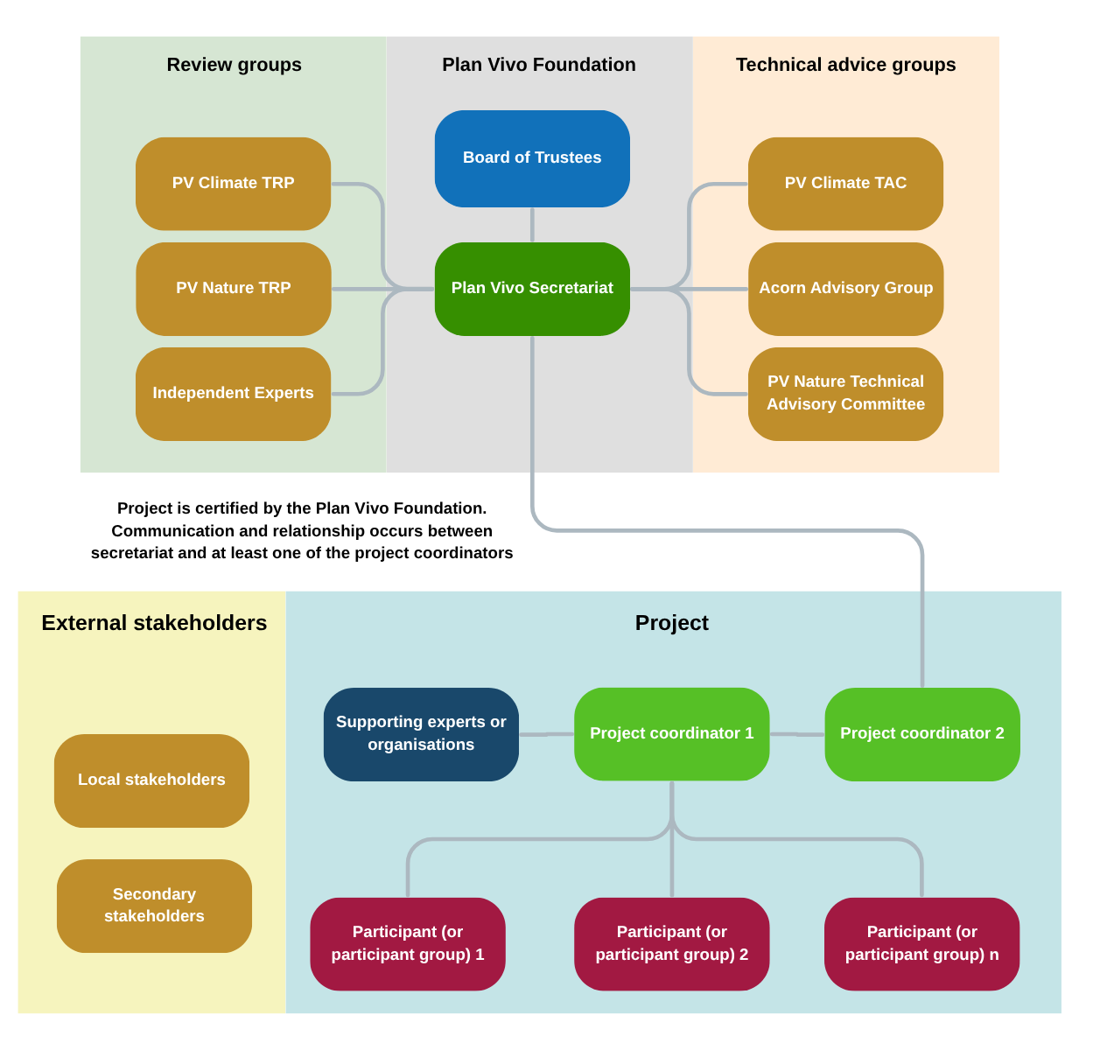
Figure 1 – An illustration of the structure of Plan Vivo, an example project (other project structures are possible), and the interaction between the two entities. NB: TAC refers to the Technical Advisory Committee, and TRP refers to a Technical Review Panel.
Grievances must fall within one of the following categories:
- Adverse impacts – grievances which relate to adverse impacts or non-delivery of benefits, environmental or social in nature, to which an affected party believes that a Plan Vivo project or Plan Vivo has caused, contributed to, or is linked to.
- Non-adherence with procedures – grievances which relate to non-adherence of a Plan Vivo certified project or Plan Vivo staff to any of the Plan Vivo requirements, policies or procedures.
- Conduct – the conduct of Plan Vivo staff.
The following scenarios are not eligible for this grievance mechanism:
- Project grievances that have not first been raised at the project level
  - For project-level grievances, complaints that have not been submitted through and exhausted by the project’s own internal grievance mechanism (unless there is a clear and justified reason for bypassing the project’s grievance mechanism, which will be considered by the Grievance Coordinator).
- Complaints not related to Plan Vivo certified projects or Plan Vivo activities
- Issues that fall outside the scope of Plan Vivo certified projects or the operations of the Plan Vivo.
- Grievances related to organizations, companies, or individuals not associated with Plan Vivo certification.
- Issues already addressed through a completed Plan Vivo grievance mechanism
- Matters that have already been fully investigated and closed by Plan Vivo, unless new, substantive evidence is presented.
- Serious incidents
  - Significant harm to staff, participants, and/or the environment caused by the project’s activities should be raised with Plan Vivo via the Serious Incidents Procedure.
- Complaints pending or resolved in legal proceedings
- Disputes that are currently under review or have been resolved by a competent legal authority or court of law.
- General inquiries or requests for information
- Questions about a Plan Vivo Standard, programme, certification process, or project eligibility that do not involve a specific grievance.
- Personal disputes unrelated to certification or project impact
  - Individual conflicts, employment disputes, or community disagreements that do not involve the certified project’s operations or the certification process.
- Malicious, frivolous, or unfounded complaints
  - Complaints that are clearly intended to cause disruption, harassment, or reputational harm without basis.
- Commercial disputes between project partners
- Contractual or financial disagreements between project developers and third parties that fall outside Plan Vivo’s governance or oversight.

Submission of Grievances to Plan Vivo

Who can Submit?
- Any individual, group, or organisation directly affected by a Plan Vivo certified project or the operations of Plan Vivo (affected parties).
- Representatives (individuals or local organisations) acting on behalf of affected parties.​

How to Submit?
Grievances can be submitted, in English or Spanish, through:
- Email: grievance@planvivo.org (please start the subject line with “GRIEVANCE:”)
- Postal Mail:
Grievance Mechanism,
Plan Vivo Foundation,
4 Gayfield Place Lane,
Edinburgh,
EH1 3NZ
All submissions should include:
- Complainant's and/or representative’s name and contact information (unless complainant prefers to remain anonymous – see section 5)
- Detailed description of the grievance.
- Steps taken to resolve the issue at the project level (if applicable).
- Any supporting documents or evidence.​
A discretionary grievance template can be found in Annex 1 – Grievance Submission Template. Complainants or their representatives may opt to complete this template and submit it via email or post as previously described.
The names and contact details of complainants or their representatives will be maintained solely by the third-party point of contact (The Risk Collaborative) and the Grievance Coordinator (see Section 4.1) and in line with the Plan Vivo Privacy Policy. During the investigations and discussions that follow, the Grievance Coordinator will share information sparingly with other Plan Vivo staff in the process of resolving the grievance, and only when this is needed to ensure an effective investigation and resolution of the case.
Anonymous grievances may be submitted, in which the name and contact details of the complainant or a representative are withheld. We recommend submitting anonymous grievances via the post or a temporary email account for full anonymity. Anonymous grievances will be handled as described in Section 5.

Regular Grievance Handling Procedure

Acknowledgement and Assignment
Grievances are received by a third-party point of contact (The Risk Collaborative), who will acknowledge the submission within five (5) business days.​ If submitting a grievance by post, please also allow time for delivery of the grievance to Plan Vivo, then additional time for the forwarding of the mail to the third party point of contact.
After acknowledgement, the third party will assign the grievance to an internal “Grievance Coordinator”. This will be based on:
- Staff member’s safeguarding training
- Potential conflicts of interests
- If grievance is submitted in Spanish, their fluency in Spanish

Eligibility Assessment
The grievance will be reviewed by the Grievance Coordinator to determine its eligibility based on the scope defined in Section 2. The complainant or their representative will be informed of the outcome within a further ten (10) business days.​

Internal investigation
For eligible grievances:​
- The Grievance Coordinator will review the grievance in more detail, and if necessary, meet with any Plan Vivo staff to discuss the grievance further.
- A meeting shall be held with the complainant where possible to discuss the grievance.
- A separate meeting shall be held where possible with the organisation or person that the grievance is directed to.
- If the grievance is of a technical nature, and where there is no conflict of interest, the secretariat may request advice from the Technical Advisory Committee (TAC) via involvement in internal discussions and/or meetings with relevant parties.
- If the grievance is of a strategic nature, or related to the governance of Plan Vivo , and where there is no conflict of interest, the secretariat may request advice from the Board of Trusties (BoT) via involvement in internal discussions and/or meetings with relevant parties.
- Other relevant parties may be contacted for additional information where necessary.
- Where appropriate and desired by all involved parties, a joint meeting may be held to discuss a possible resolution.
- The investigation will aim to be completed within thirty (30) business days; however, this may be longer if decisions and/or meetings are required from the TAC and/or BOT. Relevant parties will be kept informed of the estimated timeframes.

Resolution
The complainant will be informed of the outcome of the internal investigation, including corrective actions (if any) that must be taken by Plan Vivo and/or the Plan Vivo certified project.

Appeal
If the complainant is dissatisfied with the resolution, they may appeal the decision within fifteen (15) business days of receiving the outcome. Appeals must be submitted, with justification, via either email or postal mail (details of the addresses are provided in Section 3.2).

Escalation and third-party arbitration
If a grievance is not resolved via the internal process, the grievance will be settled by arbitration. There will be one arbitrator appointed by the complainant, Plan Vivo and (if applicable) project coordinator by mutual consent. The place of arbitration will be Edinburgh, Scotland, and the language to be used in the arbitration proceedings will be English.
The outcome reached via third-party arbitration will be considered the final decision.

Anonymous Grievance Handling Procedure
Grievances may be submitted anonymously (without clear contact information for the complainant or a representative). In such cases, Plan Vivo will investigate any eligible grievances by following the process outlined in Section 4 as much as possible. However, steps involving contact with the complainant, for the purpose of updating them on the process, better understanding their grievance, and informing them of the resolution, will not be possible. This also prevents the possibility of a resolution being appealed since the complainant cannot be made aware of the resolution.

Transparency
All relevant parties will be kept informed of the outcome of meetings and any decisions made at all steps in the process.
All grievances are stored on an internal grievance register. This register will be available for audit when confidentiality conditions are satisfied. An annual summary of the number of grievances opened and closed will be provided in the Plan Vivo Annual Report.

Confidentiality and Protection
Plan Vivo is committed to protecting the confidentiality of complainants. Personal information will not be publicly disclosed without consent, except where required by law.​
Retaliation against individuals who submit grievances in good faith is strictly prohibited.​

Data retention
All grievances, correspondence between Plan Vivo and the complainant, minutes from meetings between Plan Vivo and the complainant, and the resolutions, will be stored as outlined in the Plan Vivo Privacy Policy. Complainants may request access to documents related to their grievance at any time.

Annex 1 – Grievance Submission Template
Please read the full Plan Vivo Grievance Mechanism prior to submission of this form.
  - Contact information
- All information/fields in this section are optional
- If the complainant wishes to submit a grievance via a representative, the complainant section may be left empty
- If the complainant wishes for complete anonymity, then this section may be left empty, and the grievance will be managed as described in Section 5.
- Please include the country code in any telephone number provided

Complainant | Name:
Complainant | Email:
Complainant | Telephone:
Representative’s details | Name
Representative’s details | Email:
Representative’s details | Telephone:
Representative’s details | Relation to complainant:

  - Description of grievance
Please provide as much detail as possible, including but not limited to:
- The individual or organisation that the grievance is against
- How the complainant has been negatively affected
- Why you believe that this falls into one or more of the categories of “adverse impacts”, “non-adherence with procedures”, or “conduct” (see Section 2)
- Approximate dates and/or timeframes associated with events
- Links to evidence to substantiate claims in the form of hyperlinks to external URLs, references to attached documents, and/or other evidence provided in Section D of this form.

  - Steps to resolve grievance at project level (if applicable)
If a grievance is about concerns or complaints from participants or other external stakeholders of certified projects, under any of Plan Vivo’s Standards or Programmes, please describe how the project’s own grievance mechanism has been exhausted. Please include details on:
- The steps taken
- Responses provided by the project coordinator
- Approximate timeline of steps in the process
- What the outcome of the process was and why this was unsatisfactory, OR details of when and where the process stalled if a conclusion was not reached.

Alternatively, please provide a clear and justified reason for bypassing the project’s grievance mechanism.

If the grievance does not relate to a project, please leave this section blank.

  - Supporting evidence
Please use this section to provide any further evidence to support the claims being made. This can be in the form of images, URL links to documents, or descriptions and references to documents attached alongside the submission of this form.

Once complete, please submit this form, alongside any desired document evidence, via either:
- Email: grievance@planvivo.org (please start the subject line with “GRIEVANCE:”)
- Postal Mail:
Grievance Mechanism,
Plan Vivo Foundation,
4 Gayfield Place Lane,
Edinburgh,
EH1 3NZ

Projects certified to any of Plan Vivo’s Standards or Programmes are required to have a formal, transparent grievance mechanism.
“External stakeholder” in this context means anyone not formally employed by Plan Vivo. This grievance mechanism can therefore be used by groups that have other forms of contracts with Plan Vivo, including but not limited to members of the Board of Trustees (BoT), Technical Advisory Committee (TAC), or Technical Review Panels (TRPs), in addition to Independent Experts (IEs) and Validation and Verification Bodies (VVBs)
Organisations that are in scope for the grievance process include the Project Coordinator and those that have a formal contract or MoU with the Project Coordinator for the purpose of providing services to the project that are required for certification. E.g., Validation and Verification Bodies (VVBs), external technical support, government monitoring teams, etc. However, attempts must have been first made to resolve the grievance through the project’s own internal grievance mechanism before it is in scope for this grievance mechanism. Any grievance against an organisation that does not have a formal contract or MoU with the Project Coordinator is not in scope for this grievance mechanism.

