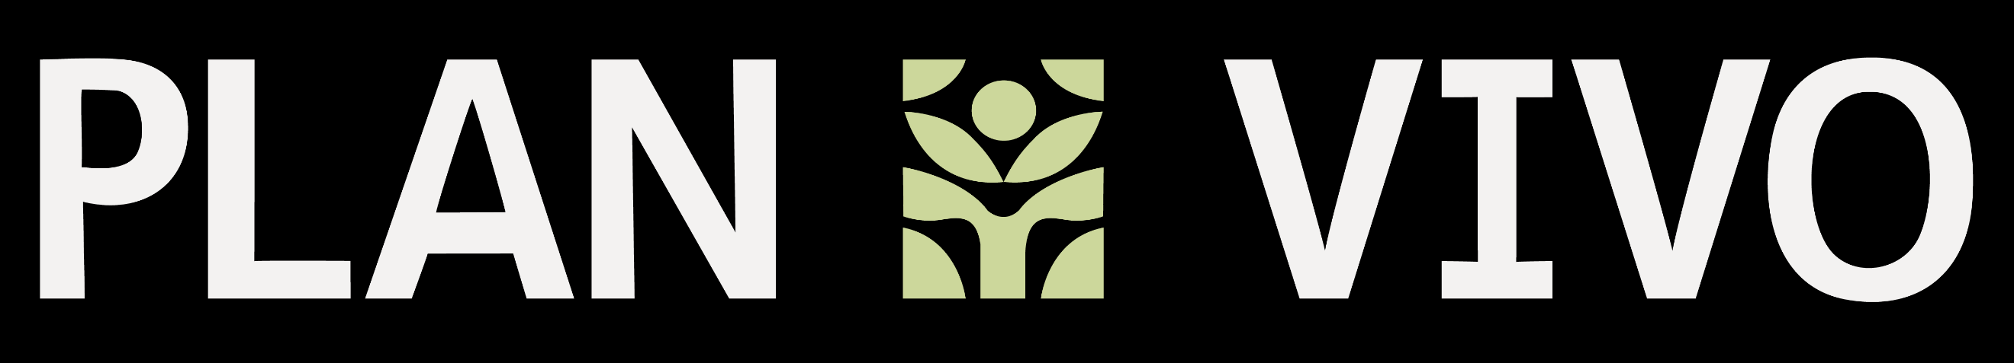

Version 1.0
Validation/ Verification Body Application Form
PV Nature

This form is for application of organisations to become a Validation and Verification Body (VVB) under the Plan Vivo Biodiversity Standard (PV Nature). The requirements to become an approved VVB are established in the latest guidance for PV Nature Validation and Verification.
Application Instructions:
- Once your VVB application form and supporting documents are received, Plan Vivo Secretariat will review it within 4 weeks. The secretariat’s response may include requests for further information or evidence.
- If your application and supporting documents are complete and correct, Plan Vivo will approve your application and you will be asked to sign the PV Nature VVB Terms of Reference (ToR) and pay the VVB registration fee.
- Once the Plan Vivo VVB ToR is signed and the VVB registration fee has been paid, you can start conducting audits under the PV Nature and your organisation will then be listed on the Plan Vivo website as an approved VVB for PV Nature.
- Please fill out the form below honestly and to the best of your ability. Alongside the application, please provide evidence of claims where accreditations, certificates, awards, or other forms of documents are cited. Once completed, you may submit the application form to biodiversity@planvivofoundation.org.

- General Information
Applicant organisation name | VVB Name
Date of submission | DD/MM/YY
Organisation contact | Contact name, email address and telephone number, Website URL
Finance contact (for invoicing the VVB fee) | Contact name, email address and phone number
Geographic areas covered by operations | The geographic locations that the organisation is willing to operate within (e.g. Indonesia only).
Brief description of organisation | A 1-2 sentence description of the organisation that can be used for the Plan Vivo website if the applicant is successful.
Type of Approval Sought (Yes/No) |  | First time approval
Type of Approval Sought (Yes/No) |  | Re-approval
Type of Approval Sought (Yes/No) |  | Re-submission for approval

- Accreditation information
Accreditation body | Identify the standards which the organisation has been accredited. Please provide evidence of any claims.  For further information regarding the PV Nature VVB approval requirements refer to the requirements for approval of validation and verification bodies and/or Independent Experts.
Recognized Accreditations |  | ISO 17029
Recognized Accreditations |  | Other complementary/optional accreditations: FSC, ISO 14065, ISO 14066 ISO14064-3, ISO 14064-2

- Validation/ Verification Experience
Name of the auditor staff | Please complete for each auditor the information of the biodiversity, ecology, conservation or environmental science experience, auditor training and other environmental/social experience.
Evidence of Biodiversity experience | Please provide CVs or biographies for all audit staff within the organisation. If preferred, the applicant may provide this information in a separate document or file.  The applicant must have staff or independent experts with at least three years of relevant work experience, field related to biodiversity, ecology or environmental science, environmental project development or initiative aimed at providing social and/or environmental benefits or at least two years of undertaking audits of such biodiversity, ecology projects or initiatives.
Evidence of country-specific experience and environmental/social sensitivity | Describe experience in country-specific knowledge/language skills and social and/or environmental relevant experience or any other relevant experience that the applicant believes would improve this application.  If preferred, the applicant may provide this information in a separate document or file.
- Insurance Information
Insurer | Name of organization/entity providing the indemnity insurance
Amount | Professional indemnity insurance in the amount of at least USD 1 million is required for all VVBs operating under the PV Nature.  Professional indemnity insurance in any amount less than USD 1 million will not be accepted.  Include USD equivalence if insurance is in a currency other than USD.  The V&V guidance includes further details about liability requirements.
Geographic coverage | State the geographic coverage of insurance (i.e., global or only certain countries/regions)
Certificate | Attach a copy of the certificate of insurance

Upon approval, the organization agrees to comply with PV Nature Procedures and Requirements for VVBs.
The applicant agrees that:

- I will pay the application fee and understand that this fee is not refundable.
- I declare that the information given in this application is correct to the best of my knowledge and belief. I undertake to inform the Plan Vivo Secretariat immediately of any changes with respect to the application and accept full responsibility for any costs incurred because of any changes not reported to the Plan Vivo secretariat in accordance with the procedures for accreditation.
- I understand the manner in which the accreditation system operates and its functions and confirms adherence to PV Nature.
- If my organization has financial interest in, and/or conflict of interest with any Plan Vivo Project, I cannot audit the project.
Hereby, I declare that the operations of my organization follow applicable local/national laws and regulations.
Hereby, I declare that my organization has no pending judicial processes for malpractice, fraud and/or other activity incompatible with its functions as a VVB.
By signing this document, I hereby declare that the details provided above are true and correct to the best of my knowledge and belief.

Name of organization:
Signature:
Name of signatory:
Role within organization:
Date signed (DD/MM/YYYY):

