M27 Southampton Junctions

ARBORICULTURAL IMPACT ASSESSMENT

HE551514-JAC-ELS-PCF3_SS1-RP-LE-0001 | P01
10/10/19
HE551514


DO NOT USE - template integrated with PW
HIGHWAYS ENGLAND

M27 Southampton Junctions
Project No: | B229H190
Document Title: | ARBORICULTURAL IMPACT ASSESSMENT
Document No.: | HE551514-JAC-ELS-PCF3_SS1-RP-LE-0001
Revision: | P01
Date: | 10/10/19
Client Name: | HIGHWAYS ENGLAND
Client No: | HE551514
Project Manager: | Paul McKay
Author: | P. SMALL
File Name: | HE551514-JAC-ELS-PCF3_SS1-RP-LE-0001.docx
Jacobs U.K. Limited
1180 Eskdale Road
Winnersh, Wokingham
Reading RG41 5TU
United Kingdom
T +44 (0)118 946 7000
F +44 (0)118 946 7001
www.jacobs.com
© Copyright 2019 Jacobs. Jacobs U.K. Limited. The concepts and information contained in this document are the property of Jacobs. Use or copying of this document in whole or in part without the written permission of Jacobs constitutes an infringement of copyright.
Limitation: This document has been prepared on behalf of, and for the exclusive use of Jacobs’ client, and is subject to, and issued in accordance with, the provisions of the contract between Jacobs and the client. Jacobs accepts no liability or responsibility whatsoever for, or in respect of, any use of, or reliance upon, this document by any third party.

Document history and status
Revision | Date | Description | By | Checked | Reviewed | Approved
P01 | 10/10/19 | UPDATE FOLLOWING DF3 | PS | MW | MW | PM
P00 | 11/04/19 | FIRST ISSUE | EG | MW | MW | PX
Contents
Executive summary 1
1. Introduction 2
1.1 Scheme design stage 2
1.2 Methodology 2
1.3 Limitations 2
2. Site observations and the tree survey 4
2.1 Site observations 4
2.2 Limitations upon the survey and protected trees 12
2.3 Tree survey results and plans 12
3. Arboricultural Impact Assessment (AIA) 13
3.1 AIA table of impacts 13
4. Conclusions and recommendations 14
4.1 Summary of arboricultural impacts 14
4.2 Arboricultural action required – next steps 15
4.3 Site supervision 16
4.4 Legal obligations 16
References 18

Appendix A. Documents provided, survey methodology and scope
Appendix B. Preliminary Generic AMS
Appendix C. Glossary of terms and abbreviations
Appendix D. Cascade Chart for Tree Quality Assessment (taken from BS5837:2012)
Appendix E. Tree Survey Schedule Key
Appendix F. Tree Survey and Protection Schedule including AIA Results
Appendix G. Existing Tree Constraints Plan
Appendix H. Preliminary Tree Removals and Retention Plan

Executive summary
The following points summarise the recommendations and conclusions contained within this report relating to the anticipated tree impacts from the current design proposals:
- All trees within the Highway boundary are considered at risk of damage or removal from the Proposed Scheme. The recommendations and findings contained within this report relate to the potential for tree retention given the current preliminary design stage.
- Five A grade tree features (three individual trees and two tree groups) have been identified within the scheme extents. Of these, four trees (two from G13, T15 and T20) would require removal which represents 50% of the total A grade trees. These are mature ‘legacy’ trees offering high amenity value to the surrounding area.
- Currently only one A grade tree within the traffic island on Hamble Lane would be retained due to the location and design of the proposed water storage tank. It is recommended that options to install the tank beneath the rooting zones of these trees be explored in order, as design development progresses, to retain an additional 3 A grade trees and reduce losses of these high value trees, within the island, down to one.
- All retained A grade trees would require BS 5837:2012 (BSI, 2012) protection measures during proposed construction works to enable their successful retention. These measures should be detailed and documented prior to construction beginning in the form of a site specific Arboricultural Method Statement (AMS).
- Trees expected to require removal within the highway boundary were identified predominantly within Windhover Roundabout (well established trees) and adjacent to the A3024 Bert Betts Way. Trees adjacent to Bert Betts Way provide screening of the existing highways infrastructure.
- Other trees indicated as ‘encroached’ (i.e. requiring protection measures) within this report should be included within the site specific AMS. This includes those trees outside the Red Line Boundary (non-Highways owned) but calculated to be potentially damaged by construction of the Proposed Scheme. These at-risk third-party trees are G3 to G8, G46, G53 and T54.
- It is recommended that the filter drain alignment around the Tesco supermarket land (adjacent to the northbound carriage way of Providence Hill) be amended in order to safely retain the off-site mature trees lining the highway boundary.
- Three of the interim locations for the flood compensation areas (west of M27 junction 8) have not been fully assessed for the presence of trees or the associated arboricultural impacts. It is noted that impacts are likely with tree cover present within/adjacent to these areas. It is recommended that a further site visit is conducted once confirmation of these areas has been obtained and any additional predicted tree loss and/or tree protection requirements be assessed by an arboriculturist.
- Impacts to the trees, as outlined within this AIA report, could alter with any changes to the current design proposals (as of April 2019). Tree impacts should therefore be reviewed as the design process progresses with all relevant parties informed of the changes, where appropriate.

Introduction
Jacobs UK Ltd (Jacobs) was instructed to undertake a tree survey and provide an Arboricultural Impact Assessment (AIA) report for the M27 Southampton Junctions Scheme. The AIA has been produced in accordance with ‘BS5837:2012 – Trees in relation to design, demolition and construction – Recommendations’ (BSI, 2012).
The requirements of the survey were to:
- record information about the trees that may be impacted by the proposed development;
- assess the potential impact on those trees likely to be affected by the development, including potential tree loss, and to recommended where protection measures may be required for retained trees; and
- provide a tree survey report with all relevant information recorded.

Scheme design stage
Preliminary design detail was provided to produce this report relating to the proposed road widening, associated footway alignments, earthworks, drainage detail, and compensation areas for flood risk and biodiversity (see Appendix A for details). This report is a revision of the original tree report (P00) which referred to Design Fix 2.
The current scheme design has been referred to as the Proposed Scheme within this report. This relates to the scheme design revision, known as Design Fix 3 (DF3), as referenced in Appendix A (table A.1).
The Proposed Scheme is currently in the preliminary design stage (PCF Stage 3). The design is therefore considered preliminary and may be subject to change and/or further design development. Any changes to the design may alter the impacts to adjacent trees. In this instance, it is recommended that these trees are considered further by an appropriately qualified arboriculturist during future design stages.

Methodology
The tree survey was conducted in line with the methodology detailed within BS 5837:2012 (BSI, 2012). This involved the surveying of trees as individuals or groups of trees within a 15m buffer from the Red Line Boundary (RLB). Data from the survey was used to produce a tree constraints plan, which depicts the existing rooting area constraints posed by the trees within the survey site.
More detail in relation to the methodology of the survey and the AIA can be viewed in Appendix A of this report. Survey data (and associated additional information for interpreting this), the Existing Tree Constraints Plan and the Preliminary Tree Removals and Retention Plan can be found in appendices D through to H.

Limitations
Clearance limits for proposed tree removal within tree groups, as shown within the Preliminary Tree Removal and Retention Plan (Appendix H), are approximate and have been calculated using assumed working area buffers of 5m for all design elements assessed.
Limitations to the tree survey and AIA include the following key points:
- Indicative root protections areas (RPA) have been calculated for tree groups.
- No individual tree data for trees within surveyed groups was recorded. This may be required at a later stage for determining accurate tree clearance limits, where tree removals are expected.
- Underground utility runs were not included within this AIA. A review of this element of the design proposals is recommended at a later stage (during detailed design) and fully considered when producing a site-specific Arboriculture Method Statement (AMS).
- It was not possible to access three areas during the tree survey identified for potential flood compensation around M27 junction 8 (however, it was possible to partially survey one area from a vantage point). These were either outside of the original scope of the tree survey or land access had not been granted at the time. The flood compensation areas are currently indicative as the need for the areas will be determined through a Flood Risk Assessment (FRA). Once the FRA is complete and further details on the compensation are known, it is recommended that the AIA is updated to fully consider the impact on trees in these areas.
- Formation of a tree protection strategy (i.e. site specific AMS) may require additional arboricultural site visits and data recording.

Site observations and the tree survey

Site observations
Junction 8 of the M27 is situated to the south west of Hedge End in Hampshire. The Proposed Scheme stretches between the roundabout servicing M27 Junction 8 and Windhover Roundabout, connected by the A3024.
Jacobs arboriculturists conducted the tree survey between 12 and 15 February 2019. Access to the site was pre-arranged and the Jacobs personnel conducted the survey from public access areas and Highways owned land only.
The survey site for this report is divided up into three areas:
- land in and around the M27 Junction 8 roundabout;
- land in and around Windover Roundabout; and
- land adjacent to the A3024 Bert Betts Way.
Tree survey results are described in the survey schedule (Appendix F) and are shown visually in the Existing Tree Constraints Plan (Appendix G). Further explanation of terms used in the schedule can be found in Appendix E.

Land in and around the M27 Junction 8 roundabout
The RLB encompasses all Highways owned land within the roundabout, land adjacent to the approach roads to the east and west (Dodwell Lane and the A3024, respectively), and the M27 slip roads leading to and from the roundabout.
Tree cover within these areas is substantial with juvenile highways screen planting trees located in the embankment areas leading to the motorway slip roads. Tree density becomes more sporadic to the east of the roundabout along Dodwell Lane.
There are several instances where privately-owned third-party trees were observed in this area (figures 2.1, 2.2 and 2.3). Data was recorded for some of these trees outside of the Highways boundary due to their location within the 15m tree survey buffer outside of the RLB. Figures 2.1 and 2.2 show examples of non-Highways owned trees whose RPA could be damaged by the Proposed Scheme. These trees were categorised as B grade because they are largely at a more mature, developed life stage than the highways screening trees, presenting greater arboricultural qualities and elevated levels of landscape contribution due to prominence and size.
Highways owned trees within this area were categorised as B grade where their screening and landscape value was considered important for surrounding residents/properties, however, most were categorised as C grade. From an arboricultural perspective, C grade trees were considered as low quality mainly due to their juvenile age class and group grown form but have potential to develop and continue to contribute to screening of the existing carriageways.
Figure 2.1 and 2.2: A small section of G48 (left) and G53 showing examples of third-party trees potentially impacted by the scheme
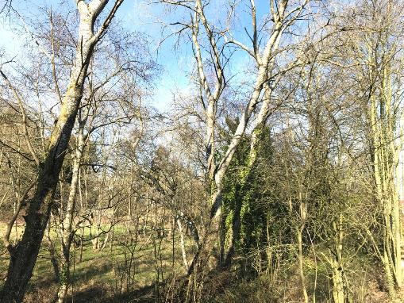  G48 | 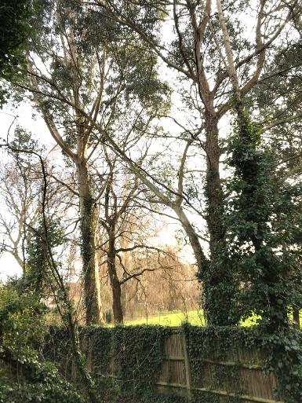  G53
Figure 2.3: G65 a third part tree group that could potentially be impacted by the scheme
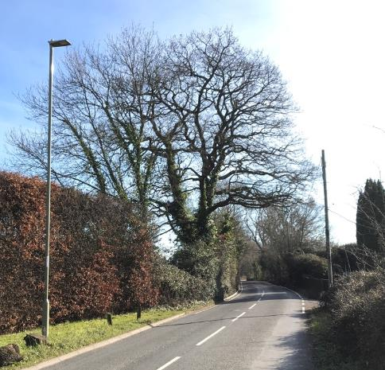
G65

Land adjacent to the A3024 (Bert Betts Way)
This section of the survey site consists of a tree lined corridor passing through agricultural land flanking both sides of the A3024. On both the east and west bound carriageways there is a steep embankment leading down to land below the road level. The embankments are planted with highways screening trees of a standard species mix, with the highway boundary fence located at the toe of the slope (figure 2.4).
These embankment areas contain trees categorised as C grade due to their limited current contribution to the landscape and arboricultural quality, given their juvenile age, early growth stage and group grown form.
There are a limited number of slightly older legacy trees, aligned along the highway boundary fence on the westbound embankment. These are willow trees; however, their condition is poor, with water logged and compacted rooting areas due to livestock movement and drainage issues and were therefore not considered to be of a higher quality. An adjacent oak (figure 2.6) was also observed located outside of the highway boundary in third-party land but was also classified as a low-quality tree due to poor condition.
The only B grade feature within this part of the survey site was a group of third-party trees located behind the highway boundary fence and ditch feature where the east bound side of the A3024 feeds onto the M27 Junction 8 roundabout (figure 2.5). Although this group comprises mostly of broadleaf tree species there are two older legacy trees, of oak and maritime pine, set back from the highway boundary.
Figure 2.4 and 2.5: G45 (left) showing examples of young Highways screen trees; and T51 situated outside of the Highway boundary but in poor condition
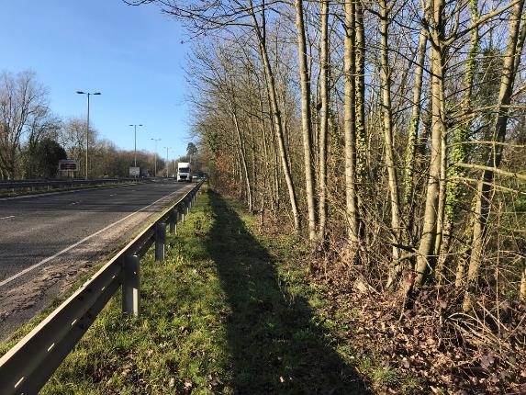  G455 | 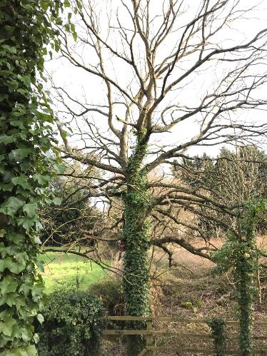  T515
Figure 2.6: G46 showing a B grade third-party tree group containing two large specimen trees (not visible)
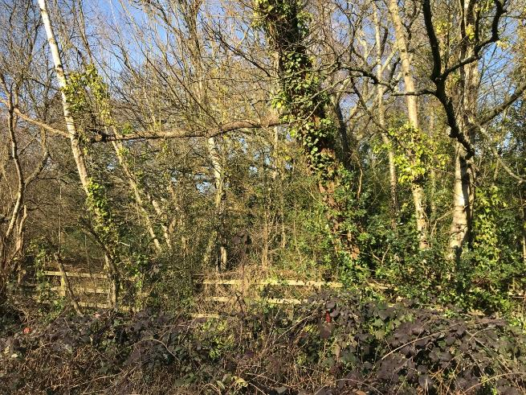
G465

Land in and around Windhover Roundabout
This part of the survey site represents the largest of the three sections and contains most of the notable tree features observed during the tree survey.
Tree cover in this area consists of a relatively large concentration of trees within Windhover Roundabout, trees located within the highway boundaries along the five arms servicing the junction, and trees within some verge/open areas.
All trees which were of the highest quality grading were located within this section of the survey site. These A grade notable trees comprise of large, spreading mature or over-mature, mainly coniferous species which are considered ‘legacy’ trees. All are prominent within the landscape providing high levels of amenity to the surrounding area.
G13, T15 and T20 are all A grade for quality (figures 2.7 and 2.8). These are mature trees located close to the existing road structures, having been retained and incorporated into previous road improvement designs. As such their legacy status should be maintained where possible given their local importance.
Figure 2.7: A grade oak tree identified as a legacy tree in relation to the existing road scheme
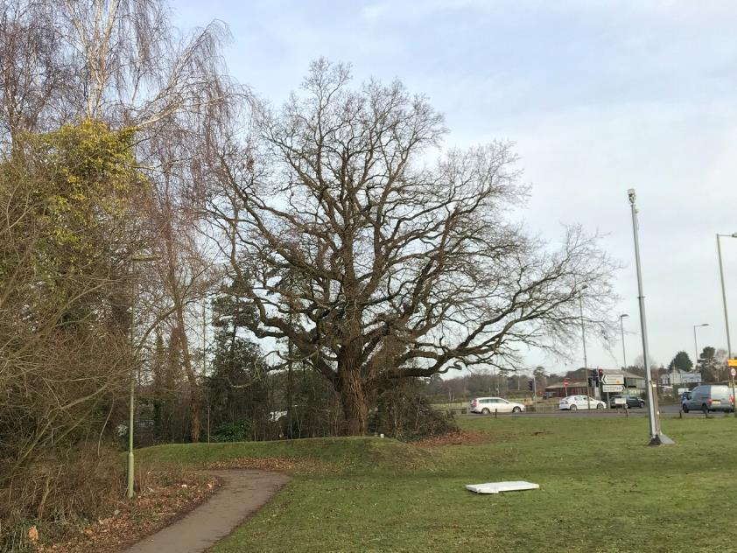
T20
Figure 2.8, 2.9 and 2.10: Examples of A grade tree features close to Windhover Roundabout; bottom right shows view of T34 from Tesco carpark
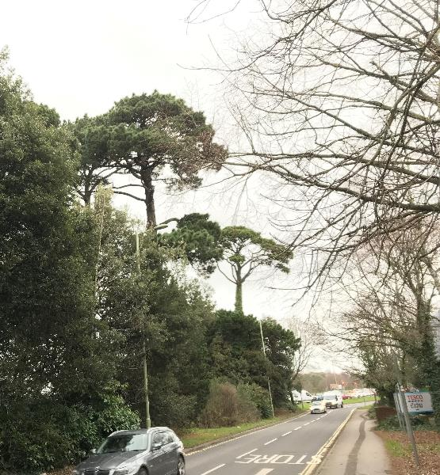
G13
T15
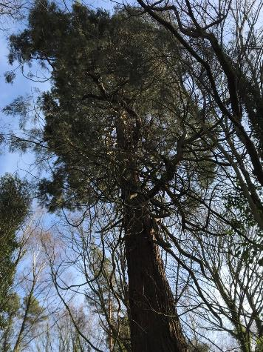  T34 | 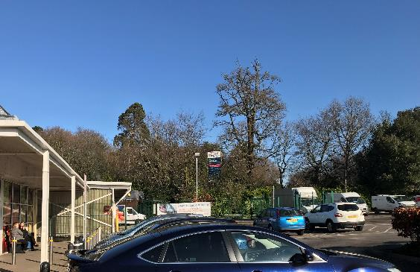  T34
T34 (figures 2.9 and 2.10) is particularly important in terms of amenity value given the recorded height of 34m. This height results in views of this tree from locations surrounding the roundabout where views of other trees around the junction are blocked by buildings and other vegetation. G35 represents two other notable trees (mature Scots pine) within this large cluster of trees within the roundabout.
Aside from the five recorded A grade features there are also a high proportion of tree features in this area categorised as B grade (figures 2.11 and 2.12). The trees within this section of the survey site are considered more noteworthy with significant examples of ‘notable’ trees. This is due to a combination of elevated age class, relative size, screening potential, form (due to greater amounts of open space for development and growth), better condition and greater levels of amenity.
Figure 2.11 and 2.12: Examples of B grade trees in areas close to Windhover Roundabout
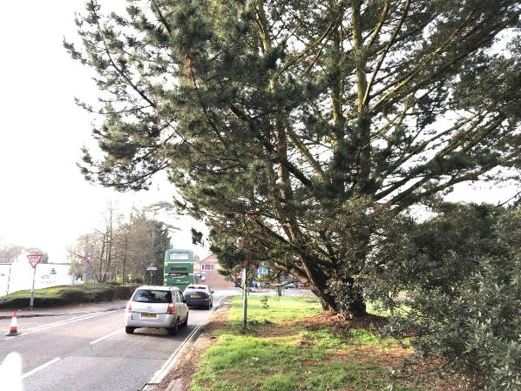
G9
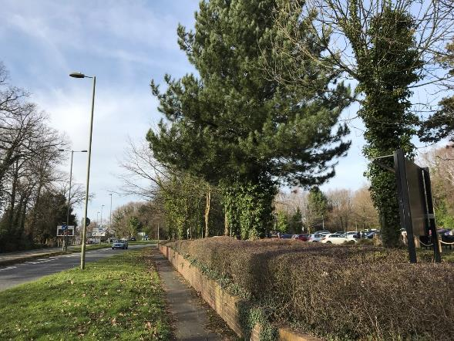
G39
Several linear tree groups located within the Highway and Red Line Boundaries provide important screening of local infrastructure (e.g. supermarket) and an adjacent housing development site currently under construction. These tree screens (specifically G3, T5, G4 and G23; see figures 2.13 and 2.14) are well developed and contain mature specimens.
Figure 2.13 and 2.14: Examples of established tree screening within the Highway boundary around Windhover Roundabout
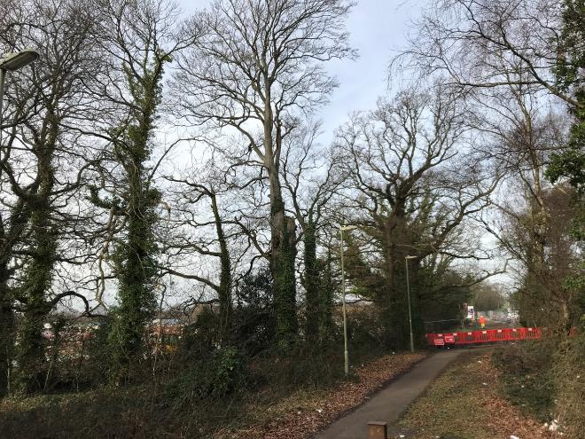
G23
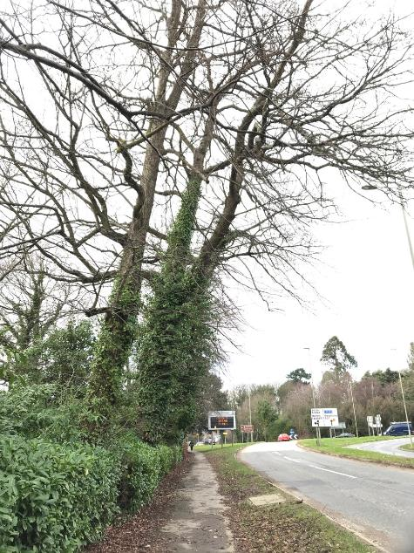
G3

Interim flood and biodiversity compensation areas
Off the four proposed flood compensation areas situated around the M27 junction 8 roundabout three of these areas have not been fully surveyed for tree impacts either due to no access being granted during the tree survey (areas to the north west of junction 8 and the Bert Betts Way approach arm to junction 8), or due to changes to the RLB subsequent to the tree survey occurring (area to south west of junction 8).
Tree cover in these areas has been viewed using online aerial imagery but there is only partial survey data (see Appendix F, G46). There is therefore an incomplete picture of the trees in these areas which are likely to be impacted, as shown in figures 2.15 and 2.16.
Figure 2.15 and 2.16: Indicative locations (green outlined shaded boxes) of un-surveyed trees potentially impacted by current positions of three of the proposed compensation areas
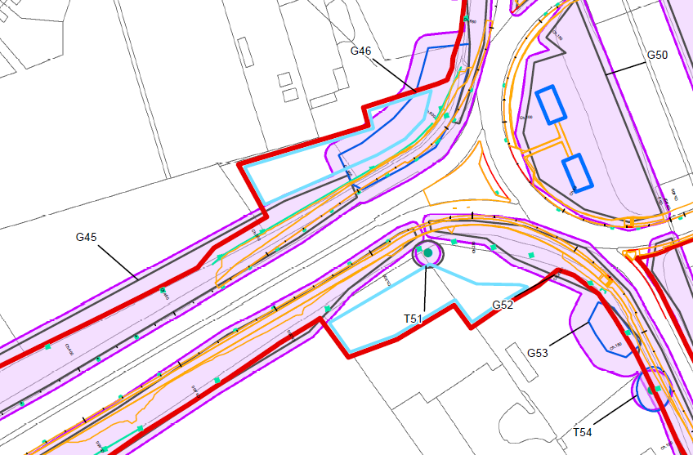
a
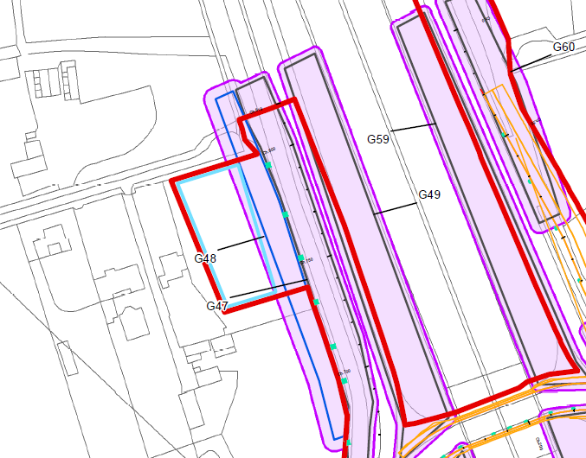
Figure 2.15 shows one of the compensation areas indicated with the letter ‘a’. Observations were made from Highways owned land of this area during the tree survey and photographs taken of some of the trees present (see figure 2.17). It was noted that mature oak and willow trees were present bordering the area with younger scrub within the internal area.

Figure 2.17: Image of area not surveyed during tree survey which is currently indicated for use as a flood compensation area
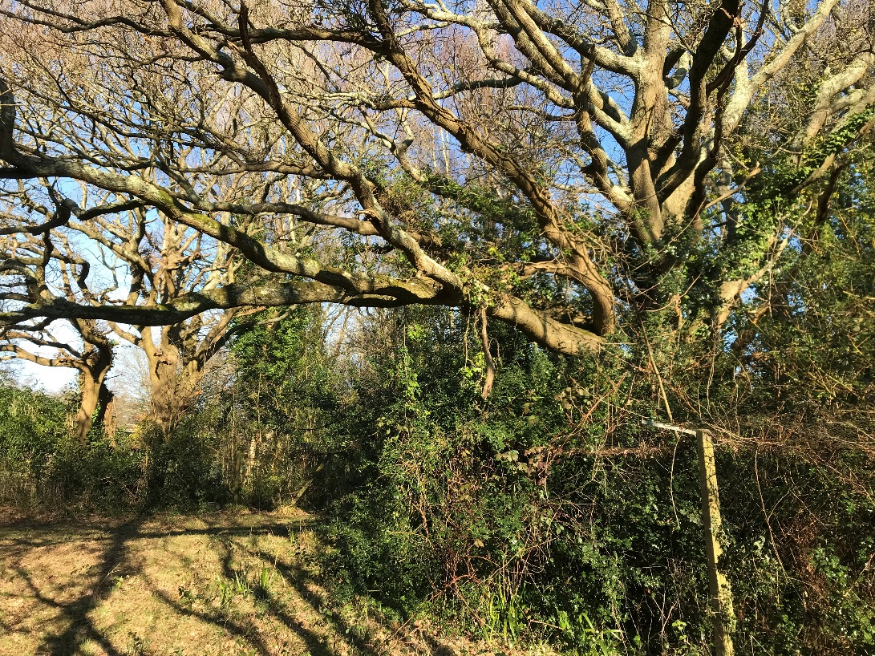

Limitations upon the survey and protected trees
No checks have been conducted by the Jacobs Arboricultural team for Tree Preservation Orders or Conservation Area status relating to this site. It is recommended that these checks are made prior to undertaking any works within the tree RPAs or carrying out any tree surgery operations.

Tree survey results and plans
Table 2.1 shows the total numbers of trees surveyed and their relative grading categories.
'A’ grade trees are of high quality and value and should be retained. ‘B’ grade trees are of moderate quality and value and should be considered for retention where possible, although care should be taken to avoid misplaced retention. Any scheme should consider the retention and protection of trees, but also the tree’s future growth. The ‘C’ grade trees are of low quality and value and should not place a constraint on the proposals. From an arboricultural point of view, the ‘U’ grade trees cannot realistically be considered for retention as a living tree in the context of the current land use due to their low life expectancy of less than 10 years in their current poor condition.
Table 2.1: Grading and amounts of arboricultural features included in the survey
BS5837:2012 grades | Trees | Tree Groups
A | 3 | 2
B | 7 | 19
C | 11 | 25
U | 1 | 0
Totals | 22 | 46

Arboricultural Impact Assessment (AIA)

AIA table of impacts
An interim assessment was made using the Existing Tree Constraints Plan (Appendix G) and the Proposed Scheme design. Table 3.1 and 3.2 display the results from the AIA, showing which trees and groups are considered likely to be affected by the current scheme design.
All trees within the Highway boundary (within the Red Line Boundary) are at risk of being affected by the proposals. This includes the potential that some trees may need to be removed to construct the Proposed Scheme.
This AIA has identified those notable trees which it is recommended are retained through mitigation and design consideration, where necessary. An indicative tree retention model (Appendix H) for other trees has been formed showing where there is potential for keeping existing trees following the construction phase of the Proposed Scheme. This retention model is based on the preliminary design at the time of writing this report.
The ‘Partial Removal’ option relates to groups of trees requiring only part of the feature to be removed to facilitate the proposals.
The ‘Encroached’ option relates to trees that can be retained during and after the implementation of the design proposals but would require protection measures prior to the construction of the development beginning, and/or tree surgery to facilitate construction access.
Anticipated tree removals and tree retention are visually represented in the Tree Removal and Retention Plan (Appendix H).
Table 3.1: Individually surveyed tree impacts (AIA results)
BS5837:2012 Tree grades | Removals | Encroached | No impacts
A | 2 | 1 | 0
B | 1 | 5 | 1
C | 2 | 2 | 7
U | 1 | 0 | 0
Totals | 6 | 8 | 8
Table 3.2: Tree group impacts (AIA results)
BS5837:2012 Tree grades | Removals | Partial Removals | Encroached | No impacts
A | 0 | 1 | 1 | 0
B | 0 | 3 | 7 | 9
C | 2 | 15 | 6 | 2
Totals | 2 | 19 | 14 | 11

Conclusions and recommendations

Summary of arboricultural impacts
All the A graded trees (for quality/contribution) are situated within the Highway Boundary.
It may be possible to retain four of the ‘at risk’ notable trees identified across the survey site, based on the current preliminary design of the Proposed Scheme.
T20 (an A grade mature oak) would need to be removed given the current alignment of the proposed westbound carriageway from Hamble Lane to Bursledon Road. It would not be possible to retain this tree with protection measures within the current scheme design, due to unsustainable expected RPA loss from excavations needed to construct the carriageway.
The three notable tree features within Windhover Roundabout (G33, T34 and G35; maritime pines, giant redwood and Scots pines respectively) would likely suffer from RPA damage by the proposed attenuation ponds on the west side of the roundabout and the carriageway widening adjacent to G35. This encroachment (by excavations) of their expected rooting areas is considered relatively minor and any further impacts which could occur during construction could be reduced to a sustainable level through the application of tree protection techniques and measures, as detailed within BS 5837:2012 (BSI, 2012).
Notable tree RPA encroachment has been identified within the traffic island on Hamble Lane. The two tree features (group of three maritime pines, G13, and a single maritime pine, T15) would be affected by the proposed carriageway widening into the traffic island area with some RPA likely to be lost from the required excavations. Moreover, the proposed location of a storm water geo-cellular confinement tank within the island would necessitate the complete removal of T15 (also partial removal of the trees within G14, B grade group) and the loss of the two closest mature pine trees within G13.
The feasibility of locating the geo-cellular tank at a depth beneath the rooting areas of these trees should be explored and considered during design development. Locating the tank underground with ground cover of at least 1.5m would ensure the majority of roots for these trees would be retained and left relatively undisturbed, potentially enabling the continued contribution and amenity of T15 and G13 to the landscape. Specialist excavation techniques and equipment would be required, and reference made to the relevant section of BS 5837:2012 (BSI, 2012) in relation to the installation of structures beneath retained tree RPA. It is recommended that a Ground Penetrating Radar (GPR) survey be performed to aid in any detailed design work in relation to achieving this aim. This would give an indication of where, and how deep, significant roots from these trees are located within the area for the water tank and aid a feasible design and installation method to be formulated.
Impacts to third-party trees (i.e. located outside the Highway boundary and RLB) carry elevated importance. This is due to the potential for damage to private property (from construction activity) and the identification of permissions that may be required for tree removals/works, including planning permission. There are instances of such trees which are indicated as ‘encroached’ or as ‘partial removal’ (for those trees inside the RLB) within the AIA. These are located adjacent to the Highway boundary in the following locations:
- Around the Tesco supermarket site bordering the RLB (Windhover Roundabout) – G3 to G8 (encroached)
- South east of Windhover Roundabout - T42 (encroached) NB: third party status is uncertain and will require verification
- Land to the north east of the M27 junction 8 roundabout – areas of G46 adjacent to flood compensation area (partial removal for section within compensation area including two mature trees)
- Residential gardens directly adjacent to the north bound off slip road opposite the south west edge of the M27 junction 8 roundabout – G53, T54 (encroached)
- Additionally, any un-surveyed trees next to the proposed flood compensation areas (see section 2.1.4, not listed in AIA).
Protection and mitigation measures for these trees should be detailed within a site specific AMS (see table 4.1). This should include any working practices required to mitigate the installation of any proposed services and utility runs which could damage retained trees. The current alignment and/or design of the filter drain along the highway boundary adjacent to G3 and G4 should be reconsidered during further design development at PCF stage 5, detailed design. The feasibility of retaining the off-site trees adjacent to the proposed trenching is unrealistic (including hand dig or use of compressed air techniques) given the proximity of the mature tree stem locations to the drain alignment (<1m in places).
Other tree features which would be impacted by the current drainage layout are indicated as encroached within the AIA (i.e. no additional removals). This is based upon the assumption that although localised tree removal may be required where trenching within RPAs is expected, this could be largely mitigated with tree protection measures and appropriate work practices, such as those detailed within ‘National Joint Utilities Guidelines for the Planning, Installation and Maintenance of Utility Apparatus in Proximity to Trees, Volume 4’ (NJUG, 2007).
Removal of Highways owned trees would be expected to occur across the Proposed Scheme site. Numerous well-established trees located within Windhover Roundabout would need to be cleared. The loss of screening along sections of the A3024 Bert Betts Way (west bound) would impact the surrounding landscape, opening views of the highways infrastructure. These juvenile screening trees offer a collective landscape contribution but are of limited arboricultural value due to their early life stage, small size and group grown form.
Other Highways trees at risk of substantial damage line the Highway boundary around the housing development to the south west of Windhover Roundabout (G23, B grade group). It is recommended these boundary trees are retained given the screening value and age of the trees. Given the expected encroachment into RPA from to the proposed footway, earthworks and filter drain protection measures would be required and detailed within a site specific AMS.
Although a health and safety survey of the trees was not conducted it was noted that a mature beech tree within G23, set back from the existing footpath, was in poor condition. A large stem wound, from limb loss, and fungal decay brackets on the stem were observed major defects. This should be further assessed by the tree owner and considered in terms of public safety and site safety during any construction work close by.

Arboricultural action required – next steps
Table 4.1 lists the standard elements, as referenced in BS 5837:2012 (BSI, 2012), recommended to satisfy planning concerns for this scheme and to ensure appropriate tree protection is considered and applied throughout the duration of the works.
Table 4.1: Follow up arboricultural input relating to this scheme
Recommended arboricultural input | Purpose | Timing
Exploration of design of underground water storage tank on traffic island on Hamble Lane including use of GPR survey to map roots. | To enable the retention of some, or all, of T15 and G13 (A grade legacy mature trees) | During detailed design stage (PCF stage 5).
Continued arboricultural support for the project | Technical advice provided during the detailed design phase to avoid notable tree impacts where possible and reduce tree loss. | Throughout the design phase of the scheme both pre and post consent. Following any major design fix, drainage and utility design development, advance works design development.
Site specific Arboricultural Method Statement (AMS) | Provide contractors with works information on how specific operations need to be performed to protect trees for retention. This should include use of ground protection, excavations within RPA, facilitation pruning/tree works etc. | Following final design agreement and usually as a part of planning conditions. Produced by the contractor for review by the client and/or LPA following agreement.
TPP – Tree Protection Plan | Provide schematic details of how protective fencing shall be installed and any other pre-planned targeted tree protection. | Following final design agreement in conjunction with the site specific AMS.
On site tree marking for removal | To provide detailed direction on which trees within groups should be removed and which can be safely retained. | Following the completion of all design work, prior to vegetation clearance works.
On site monitoring and supervision | Ensure protection measures and the method statement are being implemented correctly. | At agreed intervals before and during the construction phase of the project.
It is recommended to maintain contact with the project arboriculturist throughout the planning and design stage for the relevant additional input to be addressed at the appropriate point.
Impacts to the trees, as outlined within this AIA report, could alter with any changes to the current design proposals. Tree impacts should therefore be reviewed as the design process progresses with all relevant parties informed of the changes, where appropriate.

Site supervision
Consideration should be given to a competent arboriculturist visiting the site and monitoring the works at a time agreed at the pre-commencement site meeting. The arboriculturist’s role is to monitor compliance with arboricultural protection recommendations and provide advice on any tree problems that arise.

Legal obligations

Trees
Prior to the removal of the trees or groups listed in this report, or any tree surgery works being undertaken, it is essential that the trees are assessed again for legal protected status. These include Tree Preservation Orders (TPO) and Conservation Areas (CA), Sites of Special Scientific Interest, locally or nationally designated sites, designed landscapes and ancient woodland.
Works (either above or below ground) to trees protected by TPO or CA is an offence under the Town and Country Planning Act 1990 (as amended), and in the Town and Country Planning (Tree Preservation) (England) Regulations 2012 and Section 192 of the Planning Act 2008.
A Forestry Commission felling license may be required and would apply if more than 5 cubic meters are to be felled within one calendar quarter. The local Forestry Commission office should be contacted for advice.

Biosecurity
Advice regarding required appropriate biosecurity measures is available from the Forestry Commission to help reduce the risk of spreading plant pathogens.

Wildlife
A tree may be host to wildlife protected by law, including certain fungi, insects, lichens, roosting or nesting birds and all bat species (Wildlife & Countryside Act, 1981).

Bats
Bats are protected by law. If a roost is discovered, all work in the vicinity should cease immediately and the appropriate authorities informed (Natural England). Roosts need to be inspected by a relevant expert before work can recommence.

Birds
Under the Wildlife and Countryside Act 1981 it is an offence to take, disturb or destroy the nest or eggs of any wild bird during its breeding season. The breeding season generally extends from March to October inclusive.
Reference should be made to European law. Directive 2009/147/EC and Council Directive 92/43/EEC concerns wild birds and their habitat.

References
British Standards Institute. (2012). British Standard 5837: 2012 Trees in relation to design, demolition and construction – Recommendations. London: BSI Ltd.
Countryside and Rights of Way Act 2000. London: HMSO.
Lonsdale, D. (1999). Principles of Tree Hazard Assessment & Management. London: TSO.
Mattheck, C. (1994). The Body Language of Trees, Research for Amenity Trees No 4. London: TSO.
National Tree Safety Group. (2011). Common Sense Risk Management of Trees. Edinburgh: Forestry Commission.
National Joint Utilities Group. (2007). NJUG Publication Volume 4: NJUG Guidelines for the Planning, Installation and Maintenance of Utility Apparatus in Proximity to Trees. Issue 2.
Town and Country Planning (Tree Preservation) (England) Regulations 2012. London: HMSO
Town and Country Planning Act 1990 (as amended). London: HMSO.
Wildlife and Countryside Act 1981. London: HMSO.

Documents provided, survey methodology and scope
  - Documents provided
Table A.1 shows the documents provided and used in the production of this report along with the document reference number and how the document is referenced in this report.
Table A.1: Documents provided
Document title | Document number/file name | Reference name
General Arrangement Sheets 1 to 5 | HE551514-JAC-HGN-PCF3- SS1-DR-CH-0001 to 0005 P00 | Proposed Scheme Design
Highways General – Google Earth KMZ | HE551514-JAC-HGN-PCF3_SS1-GS-Z-0001 | Kmz of Proposed Scheme Design
Drainage Layout Plan | HE551514-JAC-HDG-PCF3_SS1-DR-CD-0001 to 0005 | Proposed Drainage
Online aerial photography of the survey site was also used during a desktop study.
Reference to trees in this report should be taken to include individual trees and groups of trees where appropriate.
  - Survey methodology
Table A.2 lists the tools and techniques used to conduct the tree survey and the parameters measured.
In this report, the Root Protection Area (RPA) for single trees is measured from the centre of the main trunk and plotted as a circle.
Tree group RPAs have either been calculated by:
- applying a buffer to the canopy extents equal to the RPA radius, calculated from the largest or most representative tree stem within each respective group; or
- calculating RPA extension towards the Proposed Scheme from individual trees within the group then combining these to form a collective RPA.
Deviation in the RPA (section 4.6.3 of BS 5837:2012 (BSI, 2012)) from the original would have to consider the following factors whilst still providing adequate protection for the root system:
- morphology and disposition of the roots, when influenced by past or existing site conditions e.g. the presence of roads, hard surfacing, ditches, footings;
- topography and drainage;
- the soil type and structure; and
- the likely tolerance of the tree to root disturbance or damage, based on factors such as species, age, condition and past management.
However, there has been no RPA modification when producing the tree constraints and removal plans within this report.
Table A.2: Survey tools and techniques used
Parameters recorded | Tools used or estimated
Tree, first branch break and crown height | Metres estimated from ground level
Stem diameter at breast height (DBH) taken from 1.5m at ground level | Diameter measuring tape and recorded in millimetres
Structural and physiological condition | External visual tree assessment (from the ground) – The Body Language of Trees, Research for Amenity Trees No 4 (Mattheck, 1994)
Root Protection Area (RPA) | Calculation method in BS 5837:2012 (BSI, 2012)
Tree quality assessment | Cascade chart and grading methodology in BS 5837:2012 (BSI, 2012) – see Appendix D
  - Scope of survey
The survey relates to trees with a stem diameter of 75mm or more (measured at 1.5m above ground level) located within the Proposed Scheme’s RLB not including mitigation areas (e.g. for flood compensation; or potential compound areas), as shown on the Proposed Scheme Design.
Any tree within a 15m buffer (representing the largest possible RPA of a tree as per calculations in BS5837:2012 (BSI, 2012)) of the Proposed Scheme’s RLB that was potentially impacted by the works associated with the junction improvement works was also included in the survey.
The health and condition of trees can change rapidly and all trees, even healthy ones, are at risk from unpredictable climatic and man-made events. The assessment of risk for any tree is based upon factors evident at the time of the inspection and the interpretation of those factors by suitably qualified inspectors. The health, condition and safety of trees should be checked on a basis commensurate with the level of risk and preferably on an annual basis, as recommended in Common sense risk management of trees (National Tree Safety Group, 2011). The tree survey conducted for this report is not a tree health and safety survey and should not be used as such.

Preliminary Generic AMS
Trees to be retained should be adequately protected by stout fencing, ‘fit for purpose’ and preferably as prescribed in BS 5837:2012 (BSI, 2012), section 6.2. This would provide an adequate RPA/Construction Exclusion Zone (CEZ) that would allow its successful retention during and after the proposed works. All fencing barriers should be secured using above ground stabilising techniques.
Areas of retained hard surfacing would act as sufficient protection for RPAs beneath and require no additional level of exclusion. Any soft ground within RPA areas should be suitably protected as described in section 4.2.3 of BS 5837:2012 (BSI, 2012).
All excavation work within RPAs during construction must proceed with caution with hand tools only. Tree roots should be protected for the duration of the works period. In the event roots over 25mm diameter are exposed, excavation works would cease immediately and the appointed arboriculturist contacted.
Should roots between 10-25mm in diameter be encountered, these would be retained undamaged wherever possible, and protected from desiccation/frost by damp hessian sacking or a similar protective material until the excavation is back filled. Roots below 10mm in diameter may be trimmed back neatly in line with the edge of the excavation trench using secateurs.
Tree stems and buttress roots should be protected when proposed works are located within 1.5m of the main stem. Ideally the entire stem would be protected by robust solid timber boards forming a rigid structure. In the event a continuous rigid frame cannot be achieved, solid boards should be utilised to provide sufficient stem protection for the duration of the works.
Any mixing of cement-based materials, re-fuelling of machinery or mixing of fuel products should take place outside the tree RPAs.
In the event any tree canopy pruning is required to facilitate the works these are to be undertaken by qualified and competent staff working to BS3998:2010 Tree work – Recommendations. The LPA would be notified of any tree pruning required to enable the works to proceed prior to the pruning occurring.

Glossary of terms and abbreviations
AIA Arboricultural Impact Assessment
AMS Arboricultural Method Statement
BS5837:2012 British Standards used when assessing trees for design and construction impacts
Co-dominant stems Competing tree stems growing side by side on the same tree potentially leading to structural weaknesses
DBH Diameter at breast height (tree stem diameter at 1.5m from ground level)
Defects Physical weaknesses observed upon any given tree
GPR Ground penetrating radar used to map tree root distribution
Legacy trees Standout trees which have been retained following previous tree clearance works, usually associated with a development, within a specified area or piece of land
LPA Local Planning Authority
LU London Underground
Notable trees Usually large, mature stand out trees contributing to the landscape and/or high-quality specimens of a species, especially when compared to other trees within the same landscape
Monolithed Severe pruning method whereby only the tree stem is retained in a shortened form
Operational/Non-operational land Land owned by LU which has either operational related activity occurring or is unused
Pollarded Form of tree management where canopy is cut back into the larger limbs, usually performed on a repetitive cycle from early age but can be instigated in later life stages as a ‘high pollard’ but only on certain species of tree and must be maintained with regular pruning
RPA Root Protection Area
Unmade ground Ground not covered by hard surfacing materials such as tarmac, asphalt etc. Can be bare earth or grass covered.

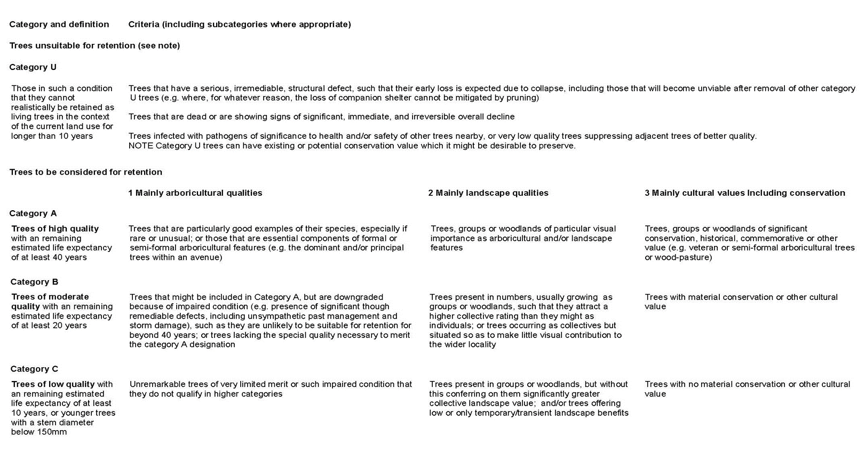
Cascade Chart for Tree Quality Assessment (taken from BS5837:2012)

Tree Survey Schedule Key
Column Header | Explanation
Tree Ref No | T - Tree  G - Group  # - DBH measurements estimated due to access restrictions or safety concerns.
Tree count data (groups) | Tree number data in groups of trees are either based on a head count or a sample plot within a feature. These should be assumed to be estimates.
Diameter at breast height (DBH) | Tree stem diameter measured at 1.5m from the ground. This figure relates to both single stemmed trees or the combined DBH for multi-stemmed trees.
Canopy spread - N E S W | Approximate horizontal canopy spread in the four compass directions
Age Class | Young (Y) - A tree in the first quarter of its life span.  Semi Mature (SM) - A tree in the latter stages of its first quarter, well established.  Early Mature (EM) - A tree half way through its life span significant further growth potential  Mature (M) - A tree at or near its potential maximum size which is still growing vigorously in its third quarter of life span.  Over Mature (OM) - A tree in decline in its final quarter of life span.  Veteran (V) - A tree that by recognised criteria shows features of biological, cultural or aesthetic value that are characteristic of, but not exclusive to, individuals surviving beyond the typical age range for the species concerned.
Structural Condition (S) | Good (G) - No signs of decay or structural weakness.  Fair (F) - Minor defects not causing structural weakness.  Poor (P) - Severe decay in the main stem or branches/structurally weak.
Physiological Condition (P) | Good (G) - Showing no adverse risk of failure/defects.  Fair (F) - Showing minor signs of deterioration.  Poor (P) - Unlikely to recover to a good condition.  Dead (D)
Estimated Remaining Contribution (ERC) | <10 - Less than 10 years of normal life expectancy remaining.  10+ - Between 10 and 20 years of normal life expectancy remaining.  20+ - Between 20 and 40 years of normal life expectancy remaining.  40+ - Tree would normally expect to live for more than 40 more years.
Root Protection Area (RPA) radius | Root Protection Area dimensions as calculated using formulae in BS5837:2012. Applied as either a circular area measured from an individual tree stem as a radius (individually surveyed trees) or as an off-set from the canopy extents of a collective feature (tree groups, hedgerows or woodlands).
Arboricultural Impact Assessment (AIA) results | R - Remove  P - Partial removal (used for groups only)  E - Encroached RPA  N - No impacts

Tree Survey and Protection Schedule including AIA Results
Tree ref. no. | Species | Tree count (groups) | Height (m) | DBH  (mm) | Canopy spread (m) |  |  |  | Height of crown clearance  (m)  &  1st branch height and direction | Age class | Struc cond. | Physiol cond. | General Observations and Comments | ERC | Category grading | RPA radius  (m) | AIA
 |  |  |  |  | N | E | S | W
T1 | Sycamore | - | 15 | 662 | 6 | 6 | 6 | 6 | 4  4N | M | F | F | Snap outs, minor deadwood | 20+ | C2 | 7.9 | N
T2 | Lime | - | 22 | 750 | 9 | 6 | 6 | 8 | 4  5E | M | F | F | Tag no 1336, ivy on main stem, previous crown reduction, hanger, minor deadwood. | 40+ | B2 | 9.0 | N
G3 | Oak, lime | 9 | 23 | 800 | 11 | 9 | 7 | 9 | 2  1.5N | M | F | F | Prolific ivy, moderate deadwood | 20+ | B2 | 9.6 | E
G4 | Lime, holm oak, oak, sweet chestnut, sycamore | 19 | 17 | 600 | 7 | 7 | 7 | 7 | 2  1.5NW | EM | F | F | Minor deadwood | 20+ | B2 | 7.2 | E
T5 | Oak | - | 23 | 950 | 12 | 7 | 8 | 6 | 3  2S | OM | F | P | Crown dieback in upper canopy, major deadwood in mid and upper canopy | 20+ | B2 | 11.4 | E
T6 | Oak | - | 13 | 480 | 2 | 6 | 6 | 4 | 3  2N | EM | F | F | Prolific ivy, moderate deadwood, asymmetrical canopy | 40+ | C2 | 5.8 | R
G7 | Holm oak, oak, lime, holly, sycamore, hawthorn | 16 | 16 | 340 | 6 | 6 | 6 | 6 | 1.5  1.5SW | SM | F | F | Minor deadwood, prolific ivy | 20+ | C2 | 4.1 | E
G8 | Lime, silver birch | 6 | 16 | 410 | 6 | 6 | 6 | 6 | 1  2SW | EM | F | F | Minor deadwood, side pruned by building | 20+ | B2 | 4.9 | N
G9 | Holm oak, birch, oak, maritime pine | 4 | 15 | 950 | 9 | 9 | 9 | 9 | 1  0E | M | F | F | Minor deadwood | 40+ | B2 | 11.4 | N
G10 | Lime, rowan, silver birch, Norway maple | 6 | 8 | 340 | 4 | 4 | 4 | 4 | 1  0.5E | SM | F | F | Bark damage wounds, minor deadwood | 20+ | C1 | 4.1 | N
G11 | Maritime pine | 3 | 17 | 900 | 9 | 9 | 9 | 9 | 0.5  0S | M | F | F | Multi stemmed, minor deadwood. | 40+ | B1 | 10.8 | N
G12 | Holm oak | 13 | 11 | 470 | 6 | 6 | 6 | 6 | 0  1E | EM | F | F | One standing dead tree in middle of group, prolific ivy, moderate deadwood. | 40+ | B2 | 5.6 | N
G13 | Maritime pine | 3 | 27 | 1250 | 8 | 8 | 8 | 8 | 5  2.5SW | M | F | F | Over extended limbs, end loaded, snap outs, previous pruning wounds, managed, major deadwood. 2 oaks and 2 pines (SM) underneath. Tag 1825, 1827. | 40+ | A1 | 15.0 | P
G14 | Holm oak, pine, oak, sweet chestnut, lime | 20 | 16 | 540 | 6 | 6 | 6 | 6 | 0  1W | SM | F | F | Minor deadwood, prolific ivy. | 40+ | B2 | 6.5 | P
T15 | Maritime pine | - | 24 | 820 | 5 | 6 | 6 | 4 | 6 | M | F | F | No comments | 40+ | A1 | 9.8 | R
G16 | Oak, birch, field maple | 21 | 15 | 743 | 8 | 8 | 8 | 8 | 1  0S | SM | F | F | Mixed age range Y to SM, occluding barbed wire, minor deadwood, prolific ivy. | 20+ | B2 | 8.9 | E
T17 | Oak | - | 11 | 580 | 9 | 4 | 7 | 8 | 5  4W | EM | F | F | Minor deadwood | 40+ | B2 | 7.0 | E
G18 | Oak, hawthorn, sweet chestnut | 14 | 14 | 520 | 6 | 6 | 6 | 6 | 0.5  0N | SM | F | F | Minor deadwood, prolific ivy, stem cavities. | 20+ | B2 | 6.2 | E
G19 | Silver birch, pine, goat willow | 9 | 17 | 320 | 5 | 5 | 5 | 5 | 0  0NE | EM | F | F | Prolific ivy, minor deadwood. | 20+ | C2 | 3.8 | E
T20 | Oak | - | 25 | 1170 | 13 | 13 | 13 | 13 | 3  1N | M | F | F | Prolific ivy severed at base, major deadwood, snap outs, canopy cavities, numerous services and chambers around base, decline within mid canopy to north west. | 40+ | A3 | 14.0 | R
G21 | Scots Pine, silver birch, holm oak, hawthorn | 25 | 18 | 300 | 6 | 6 | 6 | 6 | 1  0.5N | SM | F | F | Prolific ivy, standing dead birch trees, major deadwood. | 20+ | C2 | 3.6 | R
T22 | Oak | - | 19 | 950 | 10 | 9 | 9 | 9 | 2  1.5W | M | F | F | Moderate deadwood. | 20= | B2 | 11.4 | R
G23 | Hawthorn, oak, beech, sweet chestnut, sycamore, ash | 36 | 21 | 940 | 11 | 9 | 10 | 10 | 0.5  0.5S | M | F | F | Mature oak and beech, major deadwood, prolific ivy, major limb failure on beech tree with fungal brackets at circa 6m. | 20+ | B2 | 11.3 | E
T24 | Sycamore | - | 9 | 220 | 4 | 3 | 3 | 3 | 3  2W | Y | F | F | No comments | 40+ | C1 | 2.6 | N
T25 | Oak | - | 9 | 480 | 7 | 8 | 7 | 7 | 2  2E | SM | F | F | Minor deadwood, ongoing excavations within RPA. | 40+ | C2 | 5.8 | N
T26 | Oak | - | 7 | 320 | 4 | 2 | 1 | 4 | 2  3E | Y | F | F | Prolific ivy, poor pruning. | 20+ | C2 | 3.8 | N
T27 | Apple | - | 7 | 376 | 6 | 6 | 6 | 6 | 0  0SE | M | F | F | No comments | 40+ | C2 | 4.5 | E
G28 | Oak, elder, silver birch, Scots pine, lime | 8 | 12 | 460 | 6 | 6 | 6 | 6 | 0.5  1N | SM | F | F | Moderate deadwood snapped leader within birch | 20+ | C2 | 5.5 | E
T29 | Lime | - | 12 | 500 | 6 | 5 | 5 | 5 | 0.5  0N | SM | F | F | No comments | 40+ | B2 | 6.0 | E
G30 | Sweet chestnut, goat willow | 2 | 5 | 190 | 3 | 3 | 3 | 3 | 0.5  0S | Y | F | F | No comments | 20+ | C2 | 2.3 | E
T31 | Austrian pine | - | 8 | 525 | 5 | 7 | 5 | 4 | 1  3S | EM | F | F | Lost leader, stem fractures, minor deadwood | 20+ | C2 | 6.3 | R
G32 | Scots pine, silver birch, holm oak, hazel, cherry, sycamore, oak, false acacia, lime, beech, goat willow, larch, maritime pine, aspen | 5m centres | 20 | 550 | 9 | 9 | 9 | 9 | 1  2N | EM | F | F | Unmanaged woodland fragment, major deadwood, standing dead trees, Japanese knotweed weed present, prolific ivy throughout. 5m centres for density. Some mature trees present | 40+ | B2 | 6.6 | P
G33 | Maritime pine | 2 | 27 | 1360 | 12 | 12 | 12 | 12 | 5  6SW | M | F | F | Major deadwood form one canopy, ivy on stem. | 40+ | A3 | 16.3 | E
T34 | Giant redwood | - | 34 | 2050 | 7 | 7 | 7 | 7 | 15  10W | OM | F | F | Major deadwood, hanging limb fractures. | 40+ | A3 | 24.6 | E
G35 | Scots pine | 2 | 23 | 800 | 6 | 6 | 6 | 6 | 10  11S | M | F | F | Major deadwood, significant decay in one dead stem, potentially historical trees. | 20+ | B3 | 9.6 | E
G36 | Holm oak, silver birch, Scots pine | 35 | 18 | 190 | 5 | 5 | 5 | 5 | 0.5  1E | Y | F | F | Prolific ivy, predominantly silver birch, minor deadwood | 40+ | C2 | 2.3 | P
G37 | Silver birch | 2 | 6 | 177 | 2 | 2 | 2 | 2 | 2  2.5S | Y | F | F | No comments | 20+ | C2 | 2.1 | E
G38 | Sycamore, silver birch, Scots pine, blackthorn | 35 | 11 | 240 | 4 | 4 | 4 | 4 | 1  1.5SW | SM | F | F | Prolific ivy. | 20+ | C2 | 2.9 | P
G39 | Black pine, cherry, ash, rowan, red oak, silver birch | 40 | 15 | 380 | 6 | 6 | 6 | 6 | 3  3W | SM | F | F | Minor deadwood and stems with prolific ivy. | 40+ | B2 | 4.6 | N
G40 | Red oak, black pine, cherry, silver birch | 14 | 15 | 300 | 6 | 6 | 6 | 6 | 2  3W | SM | F | F | Some stems with ivy, minor deadwood | 40+ | B2 | 3.6 | N
G41 | Oak, ash, sycamore, silver birch, hawthorn, crack willow, cherry, goat willow, hazel | 2.5m centres | 16 | 240 | 7 | 7 | 7 | 7 | 0  0N | SM | F | F | Ivy throughout, 2.5m centres, minor deadwood, older mature willow at toe of the embankment. | 20+ | C2 | 2.9 | P
T42 | Beech | - | 18 | 680 | 9 | 7 | 8 | 6 | 5  4N | EM | F | F | Moderate deadwood | 40+ | B1 | 8.2 | E
T43 | Sycamore | - | 20 | 850 | 6 | 9 | 9 | 9 | 1  0.5E | M | P | F | Stem failure at basal union, moderate deadwood. | <10 | U | 10.2 | R
G44 | Leyland cypress | 19 | 19 | 500 | 5 | 5 | 5 | 5 | 1  2W | EM | F | F | Prolific ivy, historical management. | 20+ | B2 | 6.0 | N
G45 | Oak, silver birch, ash, Scots pine, crack willow, aspen, hawthorn, beech, sycamore | 2.5m centres | 16 | 220 | 7 | 7 | 7 | 7 | 0  0.5S | SM | F | F | 2.5m spacings, some ivy-covered stems, upon embankment, ditch at toe by fence line, contains trees with defects. | 20+ | C2 | 2.6 | P
G46 | Silver birch, Lombardi poplar, crack willow, oak, maritime pine, | 35 | 28 | 500 | 10 | 10 | 10 | 10 | 0  2S | EM | F | F | Contains mature specimen oak and maritime pine, restricted access, ivy throughout, major deadwood, canopy cavities, limb failures, unmanaged woodland cluster, located on far side of HW fence, ditch in between trees and carriage way. | 40+ | B3 | 6.0 | P
G47 | Sycamore, ash, hawthorn, silver birch, oak | 120 | 13 | 170 | 4 | 4 | 4 | 4 | 2  0.5W | Y | F | F | Upon embankment face, highways screening, recent management | 20+ | C2 | 2.0 | P
G48 | White poplar, silver birch, oak | 75 | 24 | 410 | 10 | 10 | 10 | 10 | 5  2W | EM | F | F | Moderate deadwood, prolific ivy, located adjacent to HW post and rail fence. Ditch adjacent on carriageway side. | 20+ | B2 | 4.9 | N
G49 | Ash, silver birch, sycamore, goat willow, oak | 3m centres | 16 | 240 | 5 | 5 | 5 | 5 | 1  0.5N | SM | F | F | Ivy throughout, minor deadwood, 3m spacings | 20+ | C2 | 2.9 | P
G50 | Ash, Scots pine, silver birch, sycamore, goat willow, oak, holm oak | 3m centres | 16 | 300 | 6 | 6 | 6 | 6 | 0  0.5N | SM | F | F | 3m spacing | 40+ | C2 | 3.6 | P
T51 | Oak | - | 16 | 460 | 5 | 7 | 7 | 7 | 2  3W | EM | F | F | Moderate deadwood, signs of decline, ivy clad stem | 20+ | C2 | 5.5 | E
G52 | Hazel, ash, sycamore, oak, crack willow, silver birch, aspen, hawthorn, field maple | 2.5m centres | 17 | 240 | 5 | 5 | 5 | 5 | 1  1W | SM | F | F | Highways screen planting, 2.5m spacing, limited management, minor deadwood, ivy throughout. | 20+ | C2 | 2.9 | P
G53 | Sweetgum, weeping willow | 3 | 22 | 720 | 8 | 8 | 8 | 8 | 0  4NW | M | F | F | Moderate deadwood, third party, restricted access | 40+ | B2 | 8.6 | E
T54 | Oak | - | 24 | 750 | 11 | 9 | 9 | 6 | 4  4N | M | F | F | Moderate deadwood mid canopy, ivy on lower stem, restricted access, third party. | 40+ | B2 | 9.0 | E
G55 | white poplar, aspen | 19 | 18 | 500 | 6 | 6 | 6 | 6 | 4  5E | EM | F | F | Poplars topped at 10m, prolific ivy, restricted access. | 20+ | C2 | 6.0 | P
G56 | Scots pine, oak, silver birch, sycamore, goat willow, hawthorn, | 2.5m centres | 13 | 230 | 4 | 4 | 4 | 4 | 1  1N | SM | F | F | 2.5m centres, highways screening on embankment, unmanaged, ivy throughout | 20+ | C2 | 2.8 | P
G57 | Scots pine, oak, silver birch, sycamore, goat willow, hawthorn, | - | 8 | 150 | 4 | 4 | 4 | 4 | 1  2N | Y | F | F | Highways screening | 40+ | C2 | 1.8 | P
G58 | Ash, silver birch, sycamore, oak, Scots pine, hawthorn, black pine | 3m centres | 15 | 300 | 6 | 6 | 6 | 6 | 1  2NE | SM | F | F | 3m spacings, roundabout planting scheme, minor deadwood, ivy clad stems | 40+ | C2 | 3.6 | P
G59 | Scots pine, oak, silver birch, sycamore, goat willow, hawthorn, | 2.5m centres | 13 | 230 | 4 | 4 | 4 | 4 | 1  1N | SM | F | F | 2.5m centres, highways screening on embankment, unmanaged, ivy throughout | 20+ | C2 | 2.8 | P
G60 | Oak, sycamore, cherry | 20 | 13 | 350 | 5 | 5 | 5 | 5 | 1  2S | SM | F | F | Highways screening | 20+ | C2 | 4.2 | P
G61 | Sycamore, hawthorn, goat willow | 10 | 7 | 318 | 3 | 3 | 3 | 3 | 0  1N | SM | F | F | Multi stemmed, minor deadwood | 20+ | C2 | 3.8 | R
T62 | Sweet chestnut | - | 4.5 | 180 | 2 | 2 | 2 | 2 | 1  1E | SM | F | F | No comments | 40+ | C1 | 2.2 | N
T63 | Cherry | - | 5 | 190 | 4 | 4 | 4 | 4 | 2  2SE | SM | F | F | No comments | 40+ | C1 | 2.3 | N
T64 | Field maple | - | 5 | 211 | 3 | 3 | 3 | 3 | 2  0W | SM | F | F | No comments | 40+ | C1 | 2.5 | N
G65 | Oak, ash | 3 | 13 | 800 | 8 | 8 | 8 | 8 | 4  5N | M | F | F | EM ash in group with mature oaks, moderate deadwood, ivy to mid-canopy, restricted access around base. | 40+ | B2 | 9.6 | N
G66 | Silver birch, goat willow, ash, oak | 11 | 12 | 260 | 5 | 5 | 5 | 5 | 0  0N | SM | F | F | Stem fractures on willow, minor deadwood, ivy to mid-canopy | 20+ | C2 | 3.1 | E
G67 | Sycamore | 1m centres | 10 | 120 | 4 | 4 | 4 | 4 | 0  0S | SM | F | F | 1m spacings, linear feature, ivy throughout | 20+ | C2 | 1.4 | N
G68 | Sycamore, silver birch, ash | 5m linear | 17 | 450 | 7 | 7 | 7 | 7 | 1  2S | EM | F | F | EM ash trees to east of group, SM trees at west end, 5m linear spacings | 40+ | C2 | 5.4 | P

Existing Tree Constraints Plan

Preliminary Tree Removals and Retention Plan

