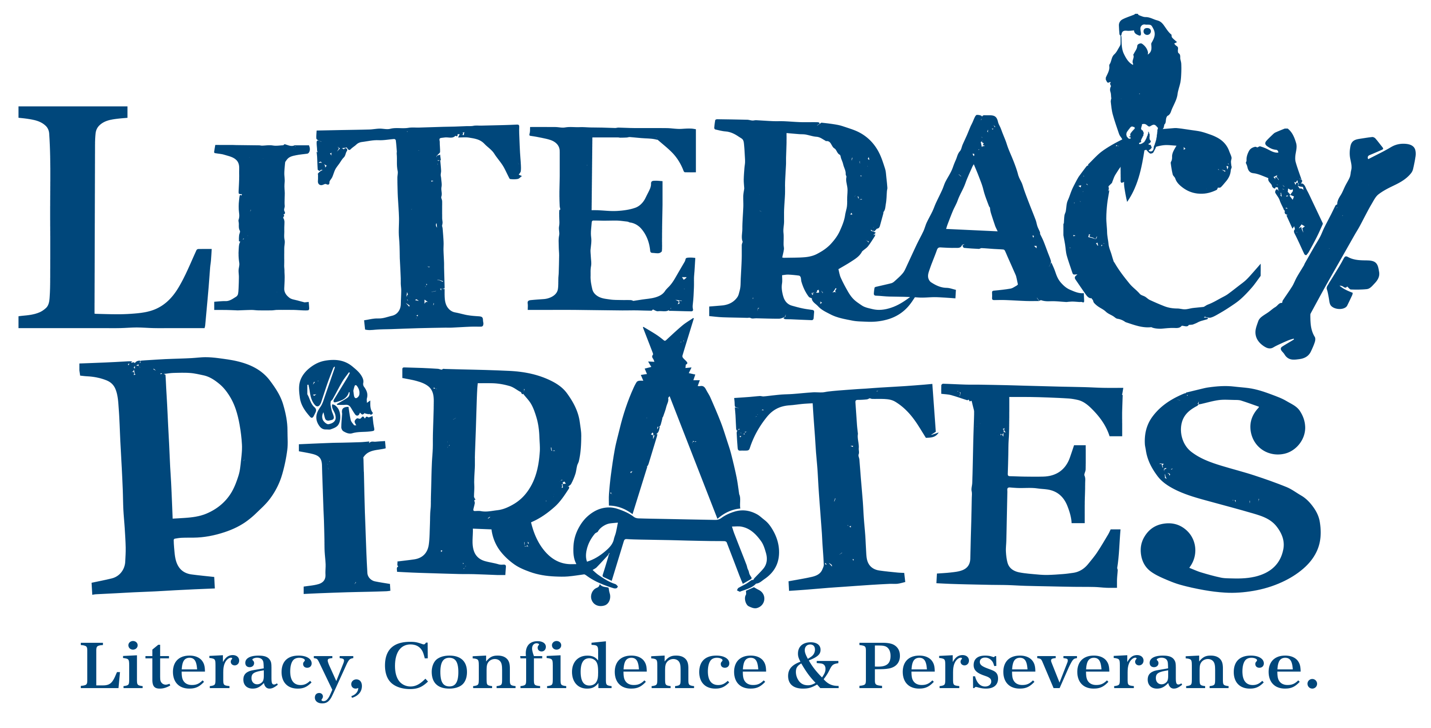

Terms and Conditions for Families

June 2025
Safeguarding – all families:
- We have procedures to review any concerns we see in session. If you have any concerns or queries, you can phone Literacy Pirates on 02033271777 from 9am–6:45pm during term time.
- Our full Safeguarding policy can be found here.
Safeguarding – families with children in online sessions only:
- A responsible adult should be present whilst a child takes part in Literacy Pirates sessions.
- Literacy Pirates use a risk-assessed education platform that is only accessible to those who are sent a specific link.
- Use of the web beyond the platform cannot be supervised by Literacy Pirates and is the responsibility of the responsible adult at home.
Learning Sessions
- I give permission for my child to attend Literacy Pirates After-School Sessions and consent to my child working with Literacy Pirates staff and volunteers.
- I acknowledge that my child needs to attend the weekly sessions they sign up to, and that I must give at least 3 hours’ notice of cancellation if they are unable to attend.
- I support good behaviour in sessions and will discuss any issues with Literacy Pirates staff.
- I give permission for short walking trips in the local area, accompanied by Literacy Pirates staff and volunteers. We will let you know in advance of this happening.
Publishing
- I give a non-exclusive licence for Literacy Pirates to use the contributions of my child (which my child owns the rights to) towards their charitable aims, granting consent required by law for their use both now and in the future.
- I waive and agree not to assert any “moral rights” or other non-transferable rights that I may have in relation to the contribution as my child will be given suitable author credit.
Library
- I understand that if my child does not return books to Literacy Pirates Library that they may be stopped from borrowing books. I will report any books my child loses.
Evaluation
- I agree to contribute to Literacy Pirates Monitoring and Evaluation strategy by completing termly questionnaires about my child’s progress.
Privacy
- I agree to Literacy Pirates privacy policy, which is available at www.literacypirates.org.
- I understand they will never sell my information or the information of my child.
- I understand that they collect information to support my child on the programme and that information that will help support my child is shared between school and The Literacy Pirates.

