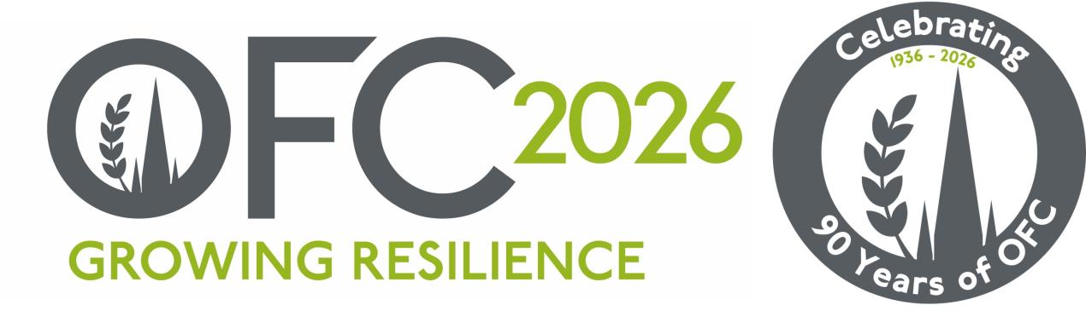

PRESS RELEASE
15 December 2025
New Report Urges UK Agriculture to “Grasp the Opportunities” and Build a Mission-Led Future
The 2026 Oxford Farming Conference report, UK Agriculture: Grasping the Opportunities, calls for urgent action to move the UK’s farming and agri-food sector from survival mode to a mission-driven, opportunity-focused sector capable of thriving in an increasingly complex, brittle and volatile world.
Authored by Dr Louise Manning, the report kindly supported by a generous donation from the Frank Parkinson Agricultural Trust, is based on structured discussions with 25 leaders, influencers and disruptors from across the UK and global agrifood industries. It asks two key questions: What does a good future for UK agriculture look like? and What interventions will drive that outcome?
Dr Manning explains, “This report captures the voices of people who are shaping and challenging the future of farming. The message is clear: change is not optional. To thrive, not merely survive, UK agriculture must become agile, robust and opportunity driven.”
The report describes how UK agriculture now operates in a ‘BANI’ world – one that is brittle, anxious, non-linear and incomprehensible. Shocks from shifts in world trade dynamics, regional conflicts, Brexit, and the public debt crisis have all combined with increasingly disruptive weather events to create uncertainty and instability.
“In a BANI world,” she says, “traditional approaches to managing risk no longer work. What has happened in the past does not necessarily reflect what we will need to adapt to in the future. Farming businesses must build robustness, inspire confidence, embrace non-linear change and use data to make sense of complexity.”
The report hopes for a robust UK agricultural sector where policy is clear, consistent and location aware, where health and wellbeing are seen as fundamental to a secure future, and farming businesses are profitable, innovative and valued contributors to the economy and environment.
“To deliver that vision,” Dr Manning notes, “the UK needs a clear, long-term strategy for agriculture, that defines the kind of sector we want in 20- or 30-years’ time, not one that merely reacts to the immediate pressures, which are commonplace in farming.”
She argues that a “good” future for UK agriculture is one in which farm businesses have confidence in the future, are mission-led, data-driven and capable of demonstrating that they are ‘’investible as enterprises. “Every farm has its own context and challenges,” she says, “but robust businesses are those that know their purpose, invest in people, deliver value right across the system and retain economic value pre-farm gate.”
Manning notes, “given the current economic and policy environment farming businesses need to revisit and refine their business planning and its execution. This will require businesses to set a direction of travel and nurture an environment of curiosity, agility and courage in decision-making.”
The report concluded from the discussions that there are three prevailing mindsets in today’s UK agriculture sector, the ‘doomloop’, ‘drawbridge’ and ‘growth opportunity-driven’ mindsets. The report calls for a decisive sectoral and business shift toward the last of these.
“Mindsets inform thinking,” says Manning. “We need to move away from defensiveness and despair towards identifying opportunities for collaboration and opportunity. That means, like previous farming generations we need to see inevitable change not as a threat, but as a space to innovate and grow.”
Business enablers include knowledge sharing, technology and smarter data use, and pursuing resilience via opportunities for alternative use of business assets. Embedding timely, tailored market insights into more agile farm business management will also be crucial.
“Some of the agri-businesses that will transform UK farming by 2040 or 2050 probably don’t exist yet,” Manning explains. “That’s why we must invest in the skills, systems and mindsets to adapt.”
The report concludes that a thriving agricultural sector needs modern, flexible education and training programmes focused on business management, investment, risk and innovation.
“Agriculture’s future depends on its people,” says Dr Manning. “We must create space for the ‘New Gen’ and ‘Next Gen’, individuals with fresh ideas, digital capabilities and entrepreneurial energy, to enter and shape the sector.”
The core message of UK Agriculture: Grasping the Opportunities is the need for confidence and direction. The report urges policymakers, businesses and individuals to look forward rather than back, and to embrace the uncertainty and the continuous change to come as being the only constant.
“Change is a continuous process,” Manning concludes. “The UK agricultural sector has revitalised and realigned repeatedly in the last century when external economic, geo-political and policy environments have shifted. The UK agricultural sector, and farming businesses needs to dig deep and do so again.”
-ends-
Notes to editors
The report can be accessed here: https://www.ofc.org.uk/2026-ofc-report
For more information on the Oxford Farming Conference (OFC):
Website: www.ofc.org.uk
Twitter: @oxfordfarming
YouTube: OxfordFarmingConference
The OFC is one of the only external events to be allowed to host a debate in the Oxford Union. It has a long and proud history going back to 1936 and a strong reputation as one of the UK’s leading agricultural events. It always takes place in Oxford in the first week of January and is based at the Oxford Examination Schools. It offers a vibrant programme of speakers, panel and politics sessions as well as networking.
OFC is a charity that invests in agricultural education and knowledge-sharing. It attracts over 650 delegates every year, including many people from the wider food chain, retail, NGOs, scientific organisations, media, policy-making bodies and governments from around the world.
HRH Princess Royal is Honorary President of the OFC.
OFC 2026 will take place from 7-9 January 2026 and will mark 90 years since the launch of the charity.
The OFC 2026 Chair is Jude McCann and will be themed “Growing Resilience”

