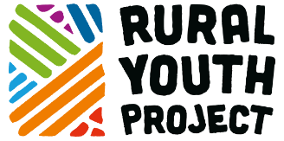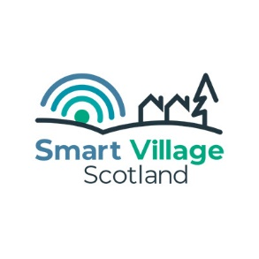
Press Release
For immediate release – 15 April 2021

Exciting opportunity for more rural young people to be part of a pioneering digital platform

The Rural Youth Project, in partnership with Smart Village Scotland continues to develop the pioneering world-first youth centric Smart Village and are seeking five enthusiastic young people to join their team of Digital Champions.

The voluntary role, which will be active from May to August 2021, will see the five new digital champions join a core team of ten young people who are driving the development of the platform. The new digital champions will receive personal and professional support as well as a contribution of £530 during the placement.

Rural Youth Project Co-Founder and Director, Rebecca Dawes, said the recruitment of five additional digital champions would not be possible without the continued support of the LEADER Programme 2014-2020: The European Agricultural Fund for Rural Development: Europe investing in rural areas and the Local Action Groups from across Scotland.

“This is a platform made for and by young people. Our current group of Digital Champions are working hard to find, curate and create content that will appeal to young people in rural areas and we are looking forward to expanding this passionate group.

“If you’re passionate and interested about the future of rural communities, and aged between 18 to 28, I would strongly encourage you to apply. Not only will you have the opportunity to meet like minded people, but the skills gained will be held in high regard with future employers.”

Smart Villages, a concept driven by the European Network for Rural Development, are rural digital ‘villages’ that combine physical and digital communities to improve their resilience, building on local strengths and opportunities. Smart Village Scotland have partnered with the Rural Youth Project, to create the Rural Youth Project Smart Village which will be a super connected community that will function as a space for young people to connect, to build or expand their enterprise and leadership skills and to trade.

Grant Murdoch from Smart Village Scotland, who has been managing and mentoring the Digital Champions, said:

“We are at a very exciting stage with the Smart Village platform and bringing in additional Digital Champions will mean that we can bring in a fresh perspective to help support the work that is already underway.

“Digital Champions are required to attend an open and informal meeting each fortnight and, working in teams, will get the opportunity to work with a web developer in creating, designing and shaping content of the new digital platform.”

Applications will open on Tuesday 13th April and close on Friday 23rd April, with the roles to commence early May. Further details about the role and how to apply can be found here: https://rypsv.com/news/opportunity-for-5-new-digital-champions-to-join-our-team
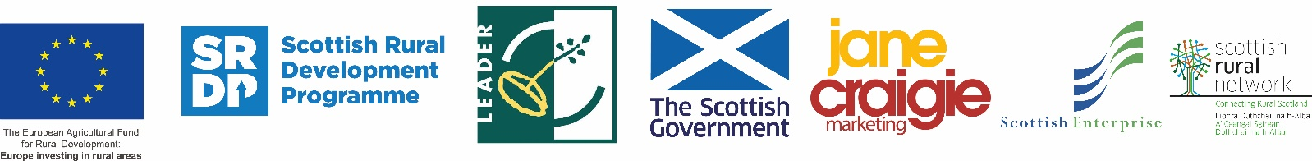

Notes to editors
- About the Rural Perth and Kinross LEADER Fund
The new LEADER, (‘Liaison Entre Actions de Développement de l'Économie Rurale’), Rural Development programme for Perth and Kinross was launched on Thursday 14 January 2016.
Approximately £3.8 million of EU and Scottish Government SRDP (Scottish Rural Development Programme) funding is being invested in the local area between 2014 and 2020, bringing a boost to communities and the rural economy.

The funding will be directed towards the priorities identified in the Rural Perth and Kinross LEADER Programme Development Strategy and Business Plan, with the aim of helping to create a long-term legacy of vibrant, healthy and inclusive rural communities. The priorities include Community Capacity Building, Rural Broadband, Youth Initiatives, Farm Diversification, Rural Enterprise and there are Open Challenge and Co-operation Projects Funds also.

Funding is allocated by the Rural Perth and Kinross Local Action Group, (LAG). This independent body consists of representatives from local businesses and public sector and third sector organisations.

Anyone can apply: www.PKLeader.org , Facebook @PerthKinrossLEADERFunding, Twitter @P_KLeader #PKLeader

- About the Rural Youth Project
The Rural Youth Project was founded in 2018 by Jane Craigie and Rebecca Dawes of Jane Craigie Marketing. Launched to ‘plug the knowledge gap’ about the rural youth (18 to 28 years of age) in Scotland and other countries in the UK and around the world, the project commenced with an online survey completed by 755 young people. It has also engaged with 20 young people who are sharing their story by video logs, hosted an Ideas Festival for 80 young people in 2018, held a parliamentary reception at Holyrood, delivered presentations at over 30 events including internationally and organised a learning journey to the Netherlands to look at the Urban-Rural relationship.
Website: www.ruralyouthproject.com Email: hello@ruralyouthproject.com
Facebook/YouTube: Rural Youth Project Twitter/Instagram: @RYP2018
- For further information, images and interviews, please contact:
Rebecca Dawes - Rural Youth Project - hello@ruralyouthproject.com or 07792 467730

