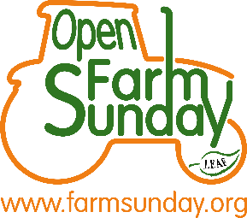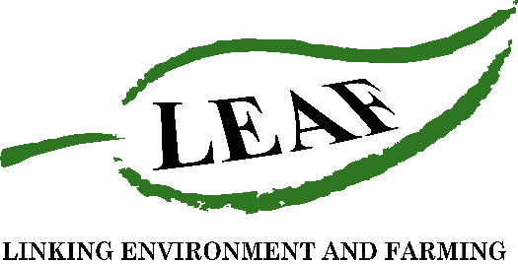

Press Release
*For immediate release*

LEAF Open Farm Sunday strengthens support for farmers

With two months until LEAF Open Farm Sunday on the 27th June, which will see hundreds of farmers open their farm gates to the public, organisers Linking Environment And Farming (LEAF) have today announced the appointment of eight ambassadors to support farmers, crofters and smallholders taking part.

Each with a background in agriculture, their role is to encourage and support farmers looking to open. Ambassadors will share ideas to engage visitors and give practical information on how to implement safe and fun social distancing. This year LOFS is putting a strong focus on hosting small, socially distanced farm walks and talks to provide an intimate insight to what happens on farm.

Annabel Shackleton, LEAF Open Farm Sunday Manager, commented,

“This year we are seeing more people spending time in the great outdoors and cooking from scratch, and there is a genuine interest across society to learn about where food comes from, the work farmers do and how the countryside is managed.

“With staycations and trips to the countryside increasing, we anticipate there will be more people than ever wanting to visit a farm this summer, and we want to encourage as many farmers as possible to get involved with the confidence they can manage their events safely.

“In order to support farmers, we felt it was important to establish a strong network of ambassadors who have knowledge and experience in on-farm events and LEAF Open Farm Sunday. We are very excited to welcome five new ambassadors, and welcome back three former co-ordinators, forming a strong network to support anyone considering taking part.”

In addition to being on hand to speak one-to-one with farmers, co-ordinating regional groups and presenting at events, ambassadors are recording a series of short videos to help with the planning of a LEAF Open Farm Sunday event. Topics covered include how to create a hand-washing station, using a ticketing system to manage the number and flow of visitors through to communications support and creative activity ideas. These will be available on the LEAF website alongside a range of other free resources.

The new appointments are:

Anne Mair-Chapman (North East - England) farms with her family in North Northumberland, including Suffolk and Blue Texel Sheep.

Jon Myhill (East - England) is a crop-consultant, specialising in energy and forage, and Director of MB Farming Ltd, a contracting business in Norfolk and Suffolk.

Molly Biddell (South East - England) supports her family-run diversified estate in Surrey as well as working as a Policy Analyst in the Savills Rural Research team.

Rona Amiss (South West - England) is a first generation, tenanted farmer on the most southerly point of mainland UK and operates her own farm diversification.

Helen Chappell (North West - England) runs a traditional mixed dairy and arable farm that has been in the family for 7 generations.

They join Andy Guy (Midlands - England), Jamie McCoy (Wales) and Rebecca Dawes (Scotland) who have all been reappointed, having worked with LEAF Open Farm Sunday for more than five years and each hosting their own on-farm events.

The ambassadors will be hosting three online farmer meetings open to anyone interested in taking part in LOFS, or any experienced hosts looking for new ideas.

During the short one-hour zoom call, there will be an opportunity to meet some of the new ambassadors, listen to their top tips, answer questions, shares ideas and speak to hosts.

The “LEAF Open Farm Sunday Top Tip” sessions will take place on:

Monday 10th May, 19:30
Wednesday 12th May, 12:30
Friday 14th May, 08:00
To find out more about the ambassadors or register to host an event, visit www.farmsunday.org.

LEAF Open Farm Sunday will take place on 27th June 2021. Following registration, hosts will receive a handbook with guidance on how to ensure events comply with on-farm health and safety regulations.
/ENDS
For further information or to arrange an interview with one of the ambassadors please contact Rebecca Dawes or Susannah Pate at Jane Craigie Marketing on: rebecca@janecraigie.com or susannah@​janecraigie.​com or 07792 467730
Editors’ notes:
- LEAF Open Farm Sunday is managed by LEAF (Linking Environment And Farming) - the leading organisation delivering and promoting Climate Positive action, thriving, resilient and exemplar agro-ecological farming at an increasingly global level. Working with farmers, the food industry, scientists, environmentalists, teachers, young people and consumers we are looking at new ways to deliver productivity and prosperity among our farmers, enrich the environment and engage young people and society in a valuable and meaningful way. LEAF set up and has managed LEAF Open Farm Sunday since it began in 2006. (LEAF is a registered charity no: 1045781)
- LEAF Open Farm Sunday 2021 will take place on 27th June 2021. Register to host at www.farmsunday.org.
- In addition, LEAF Online Farm Sunday virtual farm tours will take place on Sunday 28th March and 26th September, live on Facebook @LEAFOpenFarmSunday, and across Twitter @OpenFarmSunday and Instagram @OpenFarmSunday
- Sponsors of LEAF Open Farm Sunday include: AHDB, Arla Foods, Asda, BASF, Co-op, Defra, Farmers Weekly, Frontier Agriculture, John Deere, Kellogg’s, LEAF Marque, NFU, Sainsbury’s, Tesco and Waitrose.

