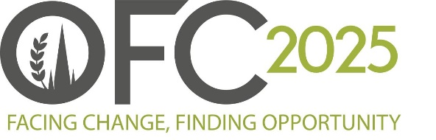

PRESS RELEASE
For Immediate Release
18 September 2024
Return of Oxford Farming Conference bursary scheme opens doors to future farming leaders
The Oxford Farming Conference is proud to announce the return of the bursary programme for the third year, enabling more than 40 individuals to attend the UK’s leading agricultural conference.
Generously supported by the NFU Mutual Charitable Trust and other key partners, these bursaries are available to individuals working within or planning to enter the food, farming, and agricultural sectors who may not otherwise be able to attend due to financial constraints. The bursaries will fully-fund the cost of a ticket to the conference in Oxford from 8 to 10 January 2025, as well as offering accommodation and a small grant for use towards travel.
OFC 2025 Chair, Geoff Sansome, said, “We’re thrilled to be able to offer bursaries once again, ensuring that everyone with a passion for food and farming can attend the event, regardless of economic circumstances.
“The OFC is a unique platform where groundbreaking ideas, cutting-edge research, and real-world farming practices converge in an open and dynamic environment, providing an unparalleled opportunity for networking and learning. By broadening access to this unique gathering, we invite diverse perspectives to enrich the dialogue and inspire the kind of transformative innovation that will shape a resilient and sustainable future for agriculture.”
Jim McLaren MBE, NFU Mutual Chairman and Chair of the NFU Mutual Charitable Trust, commented, “The NFU Mutual Charitable Trust is proud to be a long-standing supporter of the Oxford Farming Conference. Many of our team, including myself, have attended the event and experienced first-hand the invaluable networking it offers as well as gaining insights into what is happening in UK agriculture and at an international level.
“The OFC Bursary Programme is a great initiative to support those who may financially be unable to afford a ticket to the conference but would greatly benefit from all it has to offer.”
Alexandra Muxworthy, an MDS Management Trainee who received a bursary in 2023, shared her experience, "OFC left me with much to digest, not least the delicious food. OFC 2023 highlighted the immense challenge the agricultural industry faces in contributing to climate change solutions while feeding over eight billion people. I walked away inspired and enthusiastic about the future of agriculture."
To apply, candidates must be UK residents aged 18 or older, have never attended the Conference previously, and face social or economic barriers to participation. OFC also encourages applications from individuals who have recently relocated to the UK due to overseas conflicts.
For more information and to apply for a bursary, visit: https://www.ofc.org.uk/bursaries.
Applications close Friday 11th October 2024.
ENDS
Notes to Editors:
For more information on the Oxford Farming Conference (OFC):
Website: www.ofc.org.uk
Twitter: @oxfordfarming
YouTube: OxfordFarmingConference
- The OFC is one of the only external events to be allowed to host a debate in the Oxford Union. It has a long and proud history going back to 1936 and a strong reputation as one of the UK’s leading agricultural events. It always takes place in Oxford in the first week of January and is based at the Oxford Examination Schools. It offers a vibrant programme of speakers, panel and politics sessions as well as networking.
- OFC is a charity that invests in agricultural education and knowledge-sharing. It attracts over 650 delegates every year, including many people from the wider food chain, retail, NGOs, scientific organisations, media, policy-making bodies and governments from around the world.
- HRH Princess Royal is patron of the OFC.
- The dates of the 2025 OFC are 8th - 10th January 2025.
- Geoff Sansome is the chair for OFC25 and the theme is 'Facing Change, Finding Opportunity'.

