
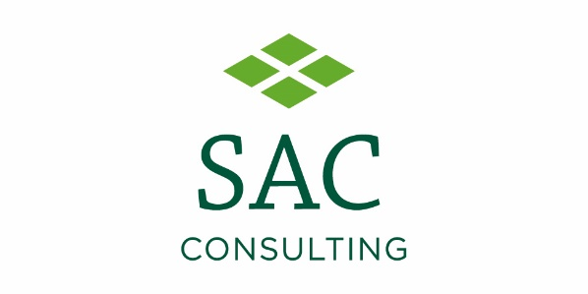
Press release
*for immediate release*
25 July 2022

A time to shine for diversified farming businesses
Following the success of the inaugural award in 2021, AgriScot, in partnership with SAC Consulting, has today launched the “AgriScot Diversified Farm of the Year 2022” award.
The competition, which is open to any Scottish farm, looks to celebrate businesses which have invested in time and resource to develop an additional income stream, alongside day-to-day farming practices.
The judges are keen to see a wide range of applicants come forward, who can demonstrate excellent customer service, collaboration, support for their community and a willingness to adapt to the changing landscape.
The 2021 award was won by Louise and Graeme Nicol from Newton Farm Holidays and Tours in Angus, who offer four-star holiday accommodation and farm experiences, including alpaca walking.
Sascha Grierson from SAC Consulting, part of Scotland’s Rural College, said the judges will be casting the net wide to attract and discover a range of different diversified businesses across the country.
“We are delighted to be supporting the AgriScot Diversified Farm of the Year again, as it is a vital part of our expert offering to customers. Whether your business is operating a meat box scheme, farm shop, vending machines, holiday cottage, wellness retreat, cookery school or clothing and textile business, to name but a few, they all contribute to Scotland’s economy. Winners and finalists will receive widespread recognition, offering the opportunity of new customers, increased sales and a chance to celebrate all they have achieved.”
Robert Neill, AgriScot Chairman said the award demonstrates how important diversification is for engaging with the public.
“With increased costs in agriculture, and a strong desire for many to return to the family farm, diversification is crucial within the agricultural sector. It brings with it opportunities to expand, create new income, inspire generations and connect directly with our consumers.
“Whether the business is public facing and inviting people on to the farm, or behind closed doors and working in partnership with others, every diversification is helping celebrate the work of Scotland’s farmers and building trust for the future.”
Shortlisted applicants will receive a visit from the judges, with the winners announced at AgriScot, on 16 November.
Applications for the award close on Monday 19 September and can be found at www.agriscot.co.uk. Or if you would like to nominate a business, email info@agriscot.co.uk
- Ends-
For more information, to arrange an interview or press enquiries, please contact Rebecca Dawes via rebecca@janecraigie.com or 07792 467730
Notes to editors:
The AgriScot Diversified Farm of the Year is supported and sponsored by SAC Consulting, part of Scotland’s Rural College (SRUC).
AgriScot takes place on Wednesday 16 November 2022, at the Royal Highland Centre, Ingliston. The awards will be presented at this event.
Exhibitor stands for AgriScot 2022 have now sold out, but space for seminars is still available. Contact info@agriscot.co.uk for more information
AgriScot is free to attend, and registration is open at www.agriscot.co.uk
The event is organised by Rural Projects.
AgriScot sponsors include: Aberdeen Angus Cattle Society, ABP, Ayrshire Cattle Services, Arla, Brodies LLP, CIS, Cogent, CowAlert, Datamars, Davidsons Animal Feeds, Farmplan, Harbro, Holstein UK, Kilpatrick & Walker, Krone, McCaskie Farm Supplies, Merlo, McCormick, Moredun, NFUS, NFU Mutual, Norvite, NWF, Power Washer Services, SAC Consulting, Scottish Farmer, Scot Agri, QMS, Semex, Soil Essentials, Spaldings, Thomas Sherriff, Thorntons Law LLP, Watson Seeds, Yara UK
Follow AgriScot online:
Facebook - https://www.facebook.com/AgriScot/
Twitter - https://twitter.com/agriscot

