Press Release
*for immediate release*
23 November 2023

New highs for 2023 AgriScot farm business event

Over 10,000 visitors and 240 trade stands filled the exhibition halls at the Royal Highland Showground at Ingliston last week (Wednesday 22 November) for the largest indoor winter farming event, AgriScot.

As one of the strongest events yet, and with a record number of entries for the various competition categories, Chairman Robert Neill said it had been a rewarding day all round:

“There was a huge buzz in the hall throughout the day, which is always an excellent sign, and a real cross section of exhibitors and visitors making connections. The event has evolved hugely since it first started, and it’s fantastic to now be offering farmers and agri professionals from all sectors this chance to access information and developments in the industry first-hand, from nutrition and technology to machinery and politics. This comes from the trade stands, the seminars and meeting up with each other. I’ve been blown away by the support for the event and I’d like to say a huge thank you to all of those who came, exhibited, and the sponsors and event organisers who made it come together so professionally.”

A key event was the Q&A panel session hosted by NFU Scotland with Cabinet Secretary Mairi Gougeon, which attracted a packed seminar room of 300 as well as 550 people tuning in online, to hear more on the recently announced flooding fund, wider policy approach and NFUS’ asks of Scottish Government.

AgriScot 2023 included several changes, including moving the event date to fit better with other big industry commitments and increasing the age of entry for the silage competition for the Young Farmer category.

Competition entries were up, in particular for the dairy class, which had a £25,000 headline prize, and the popular tri-category silage competition. A highlight for the event annals was Evening Hill Farm winning the SuperCow for the second year running, which has only happened once before in AgriScot’s history.

The show ring hosted the programme’s headliners including a beef demonstration to challenge farmers to consider if they are producing the right cattle for the right markets, the dairy judging and the SuperHeifer championships.

The Product Innovation was won this year by ADF Milking Ltd for its intelligent vent technology, InVent, which makes milking calmer, faster and higher yielding. Seeking out young talent in agribusiness, the Business Skills Award was won by Ian Carlisle, who works in the family beef and sheep farm in Dumfries, as well as supporting their abattoir and butchery business at Lockerbie.
The Best Stall presentation, sponsored by Fullwoodhead Dairy Supplies, was made to pedigree breeder James Wilson of Evening Holsteins.

Seminars throughout the day offered advisory insights from across the industry including how to get the most from agricultural co-ops (SAOS), low-cost green energy opportunities (Davidson &Robertson), reducing methane from livestock through nutrition (Norvite), and through improved animal health (Moredun), new smart technology from John Deere and sustainability in the malting barley chain (Simpsons Malt); and a question time event with the Scottish Dairy Hub and Kite Consultancy.

“Pre-registration for the event was up 100% with 4000 people securing their free, rapid access tickets in advance this year, and we had a waiting list for exhibitors, so we are already looking forward to building on this and getting plans underway for the next AgriScot in 2024,” added Mr Neill.

For a full list of award winners and results please see below.

/ENDS

Editor’s Notes



Results 2023
Silage Results
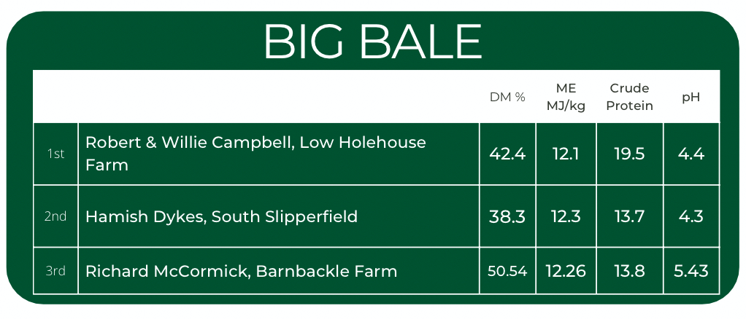
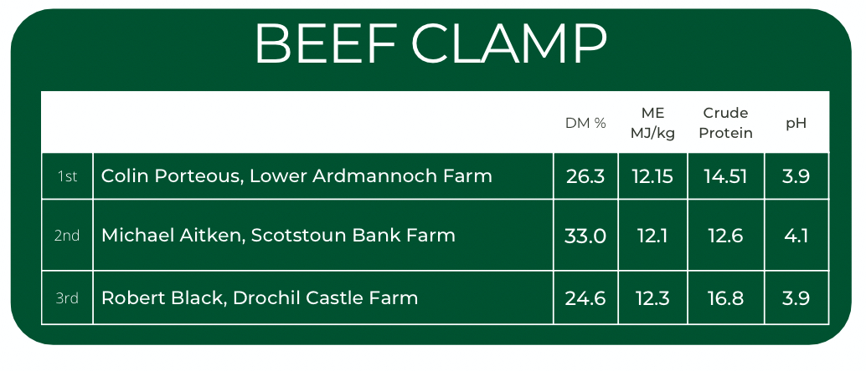
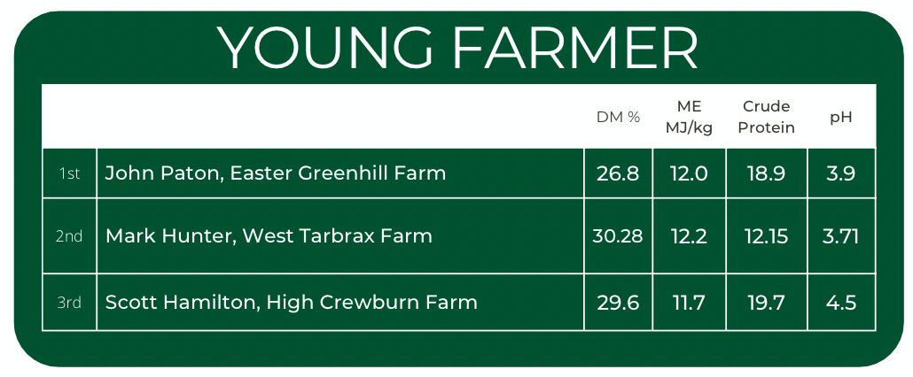

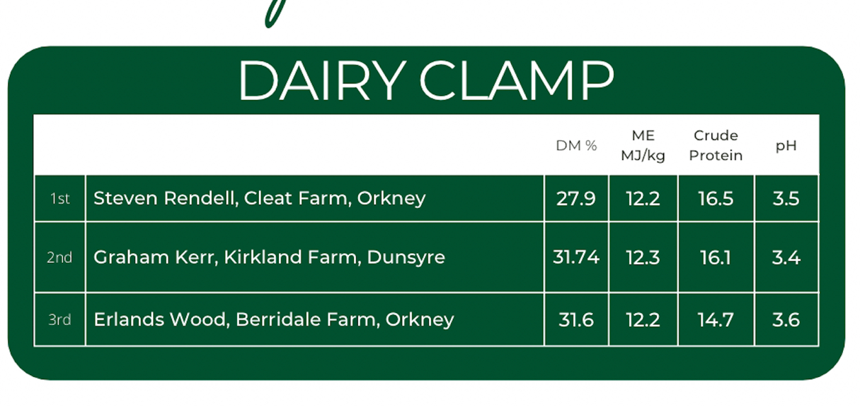

Heifer Classes

Class 1: Ayrshire
1st – 30 - BARR *, J & M, CALDERGLEN NICOLETTE, PLI 150, b 19/06/2021, s HEYDALE WIND CHIME

2nd – 31 - LINDSAY *, D M, HARPERFIELD SANDY ROSE 8, VG85(2YR), PLI 133, b 06/06/2021, s
HARPERFIELD SPIRIT OF SCOTIA

Class 5A: Holstein – Junior Heifer
1st – 32 - FORSYTH , SCOTT, NEWBIRKS CHIEF JAZZ 1970, PLI 53, b 14/09/2021, s STANTONS CHIEF
ET

2nd – 35 - BRIAN WEATHERUP & PARTNERS *, LESMAY DALLIANCE PATENT, PLI 45, b 01/07/2021, s
WILDER DALLIANCE ET

3rd – 33 - LIGHTNING HOLSTEINS , EWEMOO LAMBDA APPLEENA, VG87(2YR), PLI 0, b 29/08/2021,
s FARNEAR DELTA-LAMBDA ET

Class 2 – Any other breeds - Heifer
1st – 38 - LOCHHEAD & SONS *, T, KEDAR RHAPPILY EVER AFTER ET, VG88(2YR), PLI 201, b 17/11/
2020, s GOLDHILL BENDER HUGE SG ET

2nd – 37 - LAWSON *, R J BASIL, LISMULLIGAN PRISCILLA 61 ET, PLI 38, b 30/06/2021, s LAKEMEAD
JINGLE

3rd – 36 - LAWSON & SONS *, B, LISNAMULLIGAN CACTUS 2 ET, PLI 84 , b 13/08/2021, s OXTON
ROYAL ET

Class 3 – Red and White - Heifer
1st – 42 - YATES & SON *, B G, LOGAN AVATAR RAE RED ET, VG87(2YR), PLI 32, b 02/06/2021, s
HOVEN HOLSTEINS AVATAR RED ET

2nd – 40 - BRYSON & SON *, MUNGO, WHITEFLAT ATTRACTION GERALDINE, PLI -8, b 15/10/2021,
s APPLE-PTS ATTRACTION RED ET

3rd – 39 - WEATHERUP *, BRIAN, PARKEND MIRAND STARLET RED ET, PLI -144, b 17/01/2022, s
COOMBOONA ZIPIT MIRAND ET

Class 4 – Jersey - Heifer
1st – 44 - THE DAVIS FAMILY *, RIVERMEAD VICTORIOUS SANGRIA, PLI 57, b 13/09/2021, s RIVER
VALLEY VICTORIOUS ET

2nd – 48 - THE HUNTER FAMILY *, CLYDEVALLEY SSL FIELDFARE, VG87(2YR), PLI 112, b 26/03/2021,
s STEINHAUERS SAMSON LEMONHEAD

3rd – 43 - HEUCHAN *, NEIL, CLANEL VICTORIOUS DAISYBELLE, PLI 113, b 29/10/2021, s RIVER
VALLEY VICTORIOUS ET

Class 5B – Holstein – Senior Heifer
1st – 51 - NEWMEADOW HOLSTEINS , WOLFA CHIEF SUE, VG88(2YR), PLI 62, b 02/03/2021, s
STANTONS CHIEF ET

2nd – 53 - EVENING HILL FARM LIMITED *, EVENING GOLDWYN ADEEN ET, VG87(2YR), PLI -68, b 15/
11/2020, s BRAEDALE GOLDWYN

3rd – 50 - TEMPLETON *, G & G, KNOWESIDE CRUSHTIME PETRELLE, VG86(2YR), PLI -20, b 04/04/
2021, s COL DG CRUSHTIME ET

Heifer Classes continued

Heifer Championship - Breed
Winner – 51 - NEWMEADOW HOLSTEINS , WOLFA CHIEF SUE, VG88(2YR), PLI 62, b 02/03/2021, s
STANTONS CHIEF ET

Runner Up – 53 - EVENING HILL FARM LIMITED *, EVENING GOLDWYN ADEEN ET, VG87(2YR), PLI -68, b 15/11/2020, s BRAEDALE GOLDWYN

Superheifer
Winner – 44 - THE DAVIS FAMILY *, RIVERMEAD VICTORIOUS SANGRIA, PLI 57, b 13/09/2021, s RIVER VALLEY VICTORIOUS ET

Runner Up – 51 - NEWMEADOW HOLSTEINS , WOLFA CHIEF SUE, VG88(2YR), PLI 62, b 02/03/2021, s
STANTONS CHIEF ET

Cow Classes

Class 6 – Any other breed - cow
1st – 58 - LOCHHEAD & SONS *, T, KEDAR CALVIN SANCHIA MARIA ET, EX97-5(8YR), PLI 160, b 21/
12/2012, s VETSCHS NESTA CALVIN ET

2nd – 57 - LOCHHEAD & SONS *, T, KEDAR SUPER NOVA HARMONY, EX95-4(8YR), PLI 100, b 42072,
s KEDAR SUPER NOVA ET

3rd – 56 - LAWSON *, R J BASIL, LISMULLIGAN EMPRESS 69, BFV85, PLI 88, b 07/04/2020, s
DEANGATE PRINCE 2

Class 7 – Jersey – Junior Cow
1st – 63 - THE DAVIS FAMILY *, RIVERMEAD MINX CANDY, VG89(2YR), PLI 114, b 11/01/2019, s
STONYRUN AUS TBONE MINX AJBS

2nd – 59 - HEUCHAN *, NEIL, CLANEL VIDEO DAISYBELLE, VG87(2YR), PLI -110, b 21/11/2020, s ST
LO VIDEO CJCC ET

3rd – 60 - THE HUNTER FAMILY *, CLYDEVALLEY TEQUILA MARIGOLD 2, VG87(3YR), PLI 2, b 16/01/
2020, s TOWER VUE PRIME TEQUILA ET

Class 8 – Red and White - Cow
1st – 65 - YATES & SON *, B G, LOGAN RUBELS SEISME ET, VG88(2YR), PLI 350, b 02/05/2020, s
HOOGERHORST DG OH RUBELS-RED

2nd – 67 - BARR *, J & M, CALDERGLEN MARGOT 3, VG88(3YR), PLI 325, b 13/01/2020, s R DG
ALADDIN-RED ET

3rd – 68 - BRYSON & SON *, MUNGO, WHITEFLAT JORDY LIZZIE RED, EX92(4YR), PLI 263, b 01/02/
2019, s CYCLE MCGUCCI JORDY RED

Class 9 – Holstein – Junior Cow
1st – 73 - BLYTH FARM & FREME BLONDIN , MAG PANDOR, VG89(3YR), PLI 51, b 30/12/2019, s
WALNUTLAWN SIDEKICK ET

2nd – 71 - CROSSFELL HOLSTEINS *, CROSSFELL DISCJOCKEY ERLE, VG89(2YR), PLI 417, b 21/05/
2020, s CLAYNOOK DISCJOCKEY ET

3rd – 72 - SCOTT, R&M & SALVADOR ESQUIERDO , VETECH PEPPER KIM, VG87(2YR), PLI 133, b 14/
05/2020, s DELABERGE PEPPER ET

Class 10 – Ayrshire – Junior Cow
1st – 80 - BAYNES & SON *, G G, MARLEYCOTE MAYBELLE 13, GP84, PLI 74, b 02/06/2019, s ARRAN
VIEW ALLBRAN

2nd – 78 - BARR *, J & M, CALDERGLEN MAISIE 3, VG87(3YR), PLI 43, b 10/01/2020, s CALDERGLEN
RAFFIAS COMMANDER ET

3rd – 76 - ADAMSON & SON *, M/S JOHN, SWAITES MARGARET ANN 34, GP82, PLI 84, b 16/09/
2020, s PAM AYRS HAWAIIAN

Class 11 – Jersey – Senior Cow
1st – 83 - JONES , MISS CERIAN E, RAPIDBAY-UK RUMMEN TJ LOTUS, VG86(2YR), PLI -282, b 28/04/
2015, s RAPIDBAY-UK RUMMEN

2nd – 82 - THE HUNTER FAMILY *, CLYDEVALLEY CAESAR MARIGOLD, EX90(5YR), PLI -17, b 12/12/
2017, s CLIFTON CAESAR

Class 12 – Holstein – Intermediate Cow
1st – 85 - EVENING HILL FARM LIMITED *, EVENING SIDEKICK JENNIFER, EX93(4YR), PLI 46, b 17/11/
2018, s WALNUTLAWN SIDEKICK ET

2nd – 87 - BLYTH FARM , WILT BAILAY, EX93(4YR), PLI -223, b 23/08/2018, s DE OOSTERHOF WILLEMS
EAGEL

3rd – 86 - BRIAN WEATHERUP & PARTNERS *, LESMAY KINGPIN MYAH, VG86(2YR), PLI -76, b 24/08/
2018, s KERNDTWAY KINGPIN ET

Class 13 – Ayrshire – Senior Cow
1st – 90 - LINDSAY , D M, HARPERFIELD QUEEN OF THE SOUTH 60, EX90(5YR), PLI 187, b 10/04/2018,
s ARRAN VIEW ALLBRAN

2nd – 93 - WATSON *, MESSRS J S, HIGH MARK OBLIGATION MELANIE 2, EX94-3(6YR), PLI 88, b 26/
06/2016, s KNOWE OBLIGATION

3rd – 88 - ADAMSON & SON *, M/S JOHN, SWAITES PROMISE 9, VG87(3YR), PLI 429, b 29/09/2019,
s SWAITES DOUBLE 07

Class 14 – Holstein – Senior Cow
1st – 94 - YATES & SON *, B G, LOGAN FITZ BECKY, EX92(4YR), PLI -28, b 04/09/2017, s TOC-FARM
FITZ ET

Jersey Champion
Winner – 63 - THE DAVIS FAMILY *, RIVERMEAD MINX CANDY, VG89(2YR), PLI 114, b 11/01/2019, s
STONYRUN AUS TBONE MINX AJBS

Reserve - HEUCHAN *, NEIL, CLANEL VIDEO DAISYBELLE, VG87(2YR), PLI -110, b 21/11/2020, s ST
LO VIDEO CJCC ET

Holstein Champion
Winner – 85 - EVENING HILL FARM LIMITED *, EVENING SIDEKICK JENNIFER, EX93(4YR), PLI 46, b 17/11/
2018, s WALNUTLAWN SIDEKICK ET

Reserve – 87 - BLYTH FARM , WILT BAILAY, EX93(4YR), PLI -223, b 23/08/2018, s DE OOSTERHOF WILLEMS
EAGEL

Ayrshire Champion
Winner – 90 - LINDSAY , D M, HARPERFIELD QUEEN OF THE SOUTH 60, EX90(5YR), PLI 187, b 10/04/2018,
s ARRAN VIEW ALLBRAN

Reserve – 93 - WATSON *, MESSRS J S, HIGH MARK OBLIGATION MELANIE 2, EX94-3(6YR), PLI 88, b 26/
06/2016, s KNOWE OBLIGATION

Supercow
Winner – 85 - EVENING HILL FARM LIMITED *, EVENING SIDEKICK JENNIFER, EX93(4YR), PLI 46, b 17/11/
2018, s WALNUTLAWN SIDEKICK ET

Reserve – 63 - THE DAVIS FAMILY *, RIVERMEAD MINX CANDY, VG89(2YR), PLI 114, b 11/01/2019, s
STONYRUN AUS TBONE MINX AJBS

Product Innovation Award
Winner - ADF Milking InVent
Highly Commended - Semex UK - Methane Efficiency Index
Business Skills Competition

Winner. - Ian Carlisle
Finalists - Alexander Mitchell and Hector Tomlyn

Ian studied at SRUC Barony (HNC) before going to SRUC Edinburgh to complete his bachelor honours degree. He works in the family beef and sheep farm in Dumfries, as well as supporting their abattoir and butchery business at Lockerbie. Away from work, he is a keen rugby player with Dumfries Saints.

