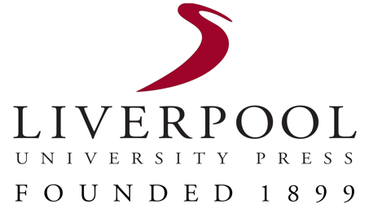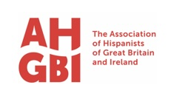

PUBLISHING PRIZE PROPOSAL FORM

[Please read Liverpool University Press’ Publication Ethics before completing this form.]

Author details:

Name:

Affiliation:

Pronouns:

Work address:

Telephone:
E-mail:

The book

Title:

Brief summary:
A few sentences summing up the proposed book in 250 words

Aims and scope of the book:
(A more detailed explanation of the proposed book.

Please provide the following:

500 words about the aims and scope of the book

500 words about the methodology and theory

500 words about the originality

Contents list with a detailed synopsis of each chapter (please supply a maximum of 400 words per chapter)

Length, illustrations and submission date
Note, the length should be between 90,000 to 100,000 words. You may include a maximum of 10 black and white illustrations.

***

