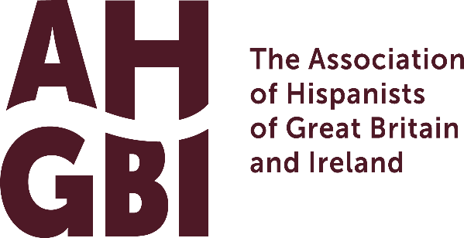 | https://hispanists.org.uk  AHGBI | Peter Lang Publication Prize

Annual Publication Prize with Peter Lang Academic Publishers

The AHGBI-Peter Lang Publication Prize launched in 2026 supports the printing of an edited volume coordinated by an Early Career Researcher (ECR) who is an Association member and who has no prior editing experience; joint editor applications are also permitted. The topic of the volume is open and should fit under one of the publication series listed below. All applicants should meet all the eligibility requirements set out by the scheme and will follow the application process.

Peter Lang has been publishing academic books in multiple languages since its foundation the 1970s and are dedicated to the publication of books in all fields related to Hispanic and Lusophone Studies.

Eligibility
To be eligible, colleagues must fulfil each of the following criteria:

- A member of the Association of Hispanists of Great Britain and Ireland. Continuous membership is required throughout the entire publication process.
- An Early Career Researcher at the time of proposing the edited volume, even if the final submission and publication of material occurs beyond this stage. Colleagues must be within ten years of completing their doctorate. Career breaks and part-time employment will be considered for eligibility. For a discussion on this prior to submitting your application, please contact Dr Aaron Kahn via the submission email below.
Note: If this is a collaborative editorial effort, all editors involved must be ECRs and meet all criteria. Other non-editing contributors to the volume can be at any stage of their career and do not need to be AHGBI members.
- Colleagues will have had no prior experience at editing a book, special edition of a journal or equivalent. This is intended for first-time editing. ECR colleagues who have already published a monograph are eligible to apply.
- The proposed study must be an edited volume with multiple contributors, and not a monograph, and none of the chapters should be under consideration for publication elsewhere.

Process
Proposals are invited for submission by 31st August 2026 and should be emailed to Dr Aaron Kahn at a.m.kahn@sussex.ac.uk. Results of applications will be announced no later than 31st October 2026.

ECR colleagues interested in proposing an edited volume should submit this form along with a completed Peter Lang Book Proposal Form, providing all appropriate materials for consideration. These include, but are not limited to:
- An overview of the entire volume of no more than 500 words and a table of contents
- A proposed title and abstract of no more than 300 words for each chapter
- A biographical blurb of no more than 200 words for each contributor, including institutional affiliation and key recent publications
- Any other relevant sections of the Book Proposal Form

Proposals can be made in the following series and will need to follow all publication requirements set by Peter Lang:

- Hispanic Studies: Culture and Ideas

Editor: Claudio Canaparo

- Golden Age Spanish Studies

Editor: Duncan Wheeler

- Iberian and Latin American Studies: The Arts, Literature and Identity

Editor: Frank Lough

- Reconfiguring Identities in the Portuguese-Speaking World
Editors: Paulo de Medeiros and Cláudia Pazos-Alonso

A select panel of AHGBI members and Peter Lang representatives will consider the proposals and determine who will be awarded the opportunity. Peter Lang and the AHGBI reserve the right not to offer the prize in a given year if the panel feels that no proposal merits it.

Each editor should complete the table below in full to be considered for this prize. By signing this form, all applicants confirm that all eligibility requirements have been met and that all appropriate and relevant permissions are available for publishing the content of the proposed volume.

Editor’s name
E-mail address
Institution
Year of PhD completion
Signature

Additional Support
Colleagues seeking additional support in the application process, or for informal discussions prior to submission, should contact Dr Aaron Kahn via the email below.

Please send this completed form, along with the Peter Lang Book Proposal form and accompanying materials, by the deadline of 31st August 2026 to:

Dr Aaron Kahn (a.m.kahn@sussex.ac.uk)
Members Representative and Trustee of the AHGBI

