An executive agency of the Department for Transport
M1
March 2015

Consultation Document
Junctions 10 to 13

Summary of the Consultation

Topic/Aim consultation: | The M1 Junctions 10 to 13 Managed Motorways (Smart Motorways): introduction of variable mandatory speed limits at a new junction, 11A.
Scope of this consultation: | Regulation already exists to operate variable mandatory speed limits on the M1 between Junctions 10-13.  A new junction 11A of the M1 is to be constructed as part of the A5-M1 Link (Dunstable Northern Bypass), and in order to operate variable mandatory speed limits through this new junction, it is necessary to amend the existing Regulation which is the purpose of this consultation.  We would specifically welcome comments on the regulations.
Geographical scope: | This consultation covers just the extent of the M1 motorway between junctions 11 and 12 where the new junction will be constructed.

General Information
To: | The consultation is aimed at affected stakeholder groups.
Body/bodies responsible for the consultation: | The Highways Agency.
Duration: | The consultation will last for a period of 4 weeks commencing 2 March 2015. The consultation period has been extended and will now close on 13 April 2015. Please ensure responses arrive no later than that date.
Enquiries: | Esosa Ikolo  Highways Agency  The Cube,  199 Wharfside Street,  Birmingham,  B1 1RN  Email:  M1-A5Link_DunstableNorthernBypass@highways.gsi.gov.uk
How to respond: | Please respond to the consultation in writing to the following address:  Esosa Ikolo  Highways Agency  The Cube,  199 Wharfside Street,  Birmingham,  B1 1RN  Or alternatively you can respond to the consultation by email:  M1-A5Link_DunstableNorthernBypass@highways.gsi.gov.uk  When responding, please state whether you are responding as an individual or representing the views of an organisation. If responding on behalf of a larger organisation please make it clear who the organisation represents, and where applicable, how the views of its members were assembled.
After the consultation: | All responses received from consultees within the consultation period will be considered and responded to as necessary. Following the consultation, a summary report will be made available on the Highways Agency website. The summary report will provide an analysis of responses received and the Highways Agency’s response.  Subject to the results of the consultation, we expect that the A5-M1 scheme will be completed by Early 2017.
Additional ways to become involved: | The Highways Agency website will have a copy of this consultation pack, which will be available to the public from the start date of this consultation. The website address is:  www.highways.gov.uk
Compliance with the Consultation Principles: | This consultation complies with the Government’s Consultation Principles (see below for details).

Background to the A5-M1 Link | The A5-M1 link consists of a new all-purpose 4.6km dual two-lane carriageway running east from the A5 (close to its junction with the A505 Leighton Buzzard Bypass) to join the M1 at a new Junction 11a.  The scheme is proposed to also construct three junctions:  - at the western end of the Link a roundabout with the A5;  - near the middle of the Link a roundabout at the intersection with the A5120 Bedford Road; and  - at the eastern end of the Link a new interchange with the M1 motorway (grade separated dumb bell roundabout) to be known as Junction 11A.  The main objective is to relieve Dunstable of significant congestion and to allow through traffic on the A5. As a result, there will be the construction of a new junction. See a map of the proposed scheme at Appendix A.  The scheme will also improve safety in the town centre and unlock the development of 7,000 houses and 40 hectares of employment land. It will also potentially provide 4,000 jobs at Houghton Regis.  Advanced works, which include some archaeological work and statutory undertakers diverting overhead cables underground, commenced in May 2014. Main construction is planned to start in March 2015.

CONTENTS
Executive Summary (i)
1. how are we conducting thIS consultation?
1.1 What is this consultation about? 1
1.2 Sending your consultation response 1
1.3 Joining the debate 1
1.4 How we will act on your responses 2
1.5 Further information 2
1.6 Government’s Consultation Principles 3

Appendices
Appendix A – Schemes Location Plans
Appendix B – List of Consultees
Appendix C – Consultation Response Form

Executive Summary
This consultation provides an opportunity for interested parties to comment on the proposal to introduce variable mandatory speed limits on Junction 11A of the M1. Regulation already exists that provides for the operation of variable mandatory speed limits (VMSL) on the M1 between Junctions 10 and 13. That Regulation now needs to be amended to incorporate the operation of VMSL through a new Junction at 11A which will be constructed as part of the A5-M1 Link (Dunstable Northern Bypass).For a detailed information about the scheme and the existing regulations and scheme information, visit our website with link below,
http://www.highways.gov.uk/roads/road-projects/a5-m1-link-dunstable-northern-bypass/

If you would like to refer to the responses on the M1 Junctions 10 to 13 consultation report, it can be found on the Highways Agency Website via below link but if you would like a hard copy of this and the actual Statutory Instrument regulations please write to us.
http://assets.highways.gov.uk/roads/road-projects/m1-junction-10-13-improvements/M1_Junctions_10_to_13_Response_to_Consultation_Report_October_2011.pdf

The regulations for the area of the completed Smart Motorways scheme identified above between junctions 10 to 13 of the M1, will restrict drivers from driving at a speed exceeding that displayed on the speed limit signs or the national speed limit where no other speed limit sign is displayed. The regulation thus permits drivers to use the hard shoulder as a running lane when the variable mandatory speed limit signal over the hard shoulder indicates that it is open for use.
The A5-M1 Link will join the M1 motorway at a new junction, junction 11A, which will be located between the existing motorway junction J11 and the Toddington Motorway Service Area (MSA). This section of motorway was improved between 2009 and 2013 by the implementation of the M1 J10 to 13 Managed Motorway scheme.
The A5-M1 Link (Dunstable Northern Bypass) has been designed to be compatible with the M1 J10 to 13 Smart Motorways scheme, and so upon opening of the A5-M1 Link, the proposed operational regime will be similar to the dynamic operation of the hardshoulder (HSR) and full time operation of the hardshoulder at this junction (TJR).
The Managed Motorway Scheme will enable proactive management of the motorway network in the Luton and Bedfordshire areas. The speed limits that will be displayed on the motorway will take into account prevailing traffic conditions with the aim of ensuring the smooth flow of traffic. The mandatory speed limits will be clearly displayed above each lane of the main carriageway open for use by traffic. Additionally, the hard shoulder will be used as a running lane during busy periods between junctions.
This consultation exercise concentrates on amending the draft proposed regulations needed to implement Smart Motorways by way of variable speed limits and hard shoulder running, to incorporate the new junction at 11A.
We are keen to have your comments specifically on how amending the draft regulations could affect your organisation or those you represent.

1.1 What is this consultation about?
This is not a full consultation exercise given you have been previously consulted on the existing M1 junctions 10-13 smart motorway scheme. This consultation is thus for an amendment to the existing regulation (Statutory Instrument) so that an additional and new junction can be done.

This is not a consultation on the operation of the M1 J10 – 13 Managed motorway scheme.

The project aims to construct the new junction 11A which will form part of the new dual two-lane carriageway starting east of the M1 at the new junction and run westwards to join the A5.

1.2 Sending your consultation response
Please respond to the consultation in writing or using the “Consultation Response Form” at Appendix C to the following address:

Esosa Ikolo
Highways Agency
The Cube,
199 Wharfside Street,
Birmingham,
B1 1RN

Alternatively you can respond to the consultation via this link

https://www.surveymonkey.com/r/V8868D5

or email:

M1-A5Link_DunstableNorthernBypass@highways.gsi.gov.uk

When responding, please state whether you are responding as an individual or representing the views of an organisation. If responding on behalf of a larger organisation please make it clear who the organisation represents, and where applicable, how the views of its members were assembled.

1.3. Joining the debate
We would like to encourage any representative organisations, businesses or individuals affected by the proposed Smart Motorways Scheme to make contact with us and communicate their views.
If you are responding on behalf of an organisation, it would be helpful if you could note this in your reply. Please also indicate the nature of the organisation, how many individuals’ views are included in the response, and ways in which these views were gathered.

1.4 How we will act on your responses
Confidentiality
Information provided in response to this consultation, including personal information, may be subject to publication or disclosure in accordance with the access to information regimes (these are primarily the Freedom of Information Act 2000 (FOIA), the Data Protection Act 1998 (DPA) and the Environmental Information Regulations 2004).
If you want information that you provide to be treated as confidential, please be aware that, under the FOIA, there is a statutory Code of Practice with which public authorities must comply and which deals amongst other things, with obligations of confidence.
In view of this, it would be helpful if you could explain to us why you regard the information you have provided as confidential. If we receive a request for disclosure of the information we will take full account of your explanation, but we cannot give an assurance that confidentiality can be maintained in all circumstances. An automatic confidentiality disclaimer generated by your IT system will not, of itself, be regarded as binding on the Agency.
The Agency will process your personal data in accordance with the DPA and in the majority of circumstances this will mean that your personal data will not be disclosed to third parties.”
What Happens next?
Following the consultation period, we will publish a ‘Response to Consultation Report’, which is a summary report that will be made available on the Highways Agency website. The summary report will provide an analysis of responses received and the Highways Agency’s response. If you would prefer a hard copy of this do let us know and we will send it.
The Highways Agency will process your personal data in accordance with the DPA and in the majority of circumstances this will mean that your personal data will not be disclosed to third parties.

1.5 Further information
To receive further information on the A5-M1 Link Scheme you can contact the project team at the address above or via the contact details provided above. Alternatively visit the Highways Agency website at www.highways.gov.uk

1.6 GOVERNMENT’S consultation PRINCIPLES
We are conducting this consultation in accordance with the Government’s Consultation principles. It replaces the Code of Practice on Consultation issued in July 2008. Some of its principles are listed below:

1) Subjects of consultation - The objectives of any consultation should be clear and will depend to a great extent on the type of issue and the stage in the policy-making process – from gathering new ideas to testing options.
2) Timing of consultation - Engagement should begin early in policy development when the policy is still under consideration and views can genuinely be taken into account.
3) Making information useful and accessible - Policy makers should think carefully about who needs to be consulted and ensure the consultation captures the full range of stakeholders affected. Information should be disseminated and presented in a way likely to be accessible and useful to the stakeholders with a substantial interest in the subject matter.
4) Transparency and feedback - The objectives of the consultation process should be clear. To avoid creating unrealistic expectations, any aspects of the proposal that have already been finalised and will not be subject to change should be clearly stated.
5) Practical considerations - Consultation exercises should not be launched during local or national election periods.

If you have reason to believe this consultation document does not comply with these Consultation Principles, please write to our consultation co-ordinator at the address below, setting out the areas where you believe this Paper does not meet the criteria:
Ian Sweeting
Highways Agency,
The Cube,
199 Wharfside Street,
Birmingham, B1 1RN
Or alternatively ian.sweeting@highways.gsi.gov.uk
Further information about the Consultation Principles can be located at:
https://www.gov.uk/government/publications/consultation-principles-guidance

Consultation questions
To further help us with our consultation process and our proposal, we would like you to answer to the following questions.
- Do you consider that the proposals to construct the new junction 11A will lead to an improvement in travelling conditions on this section of motorway?

- Are there any aspects of the proposal to apply the existing Smart Motorways scheme to the new junction, which give rise to concerns?

- Are there any additional comments you would like to make about this proposal?

Appendix A- Scheme Location Plans

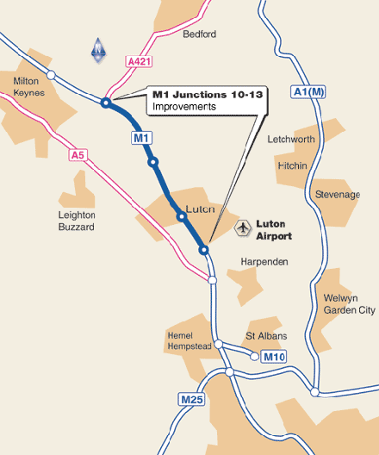
Figure 1A (i): M1 Jnc 10-13 Smart Motorways scheme Map

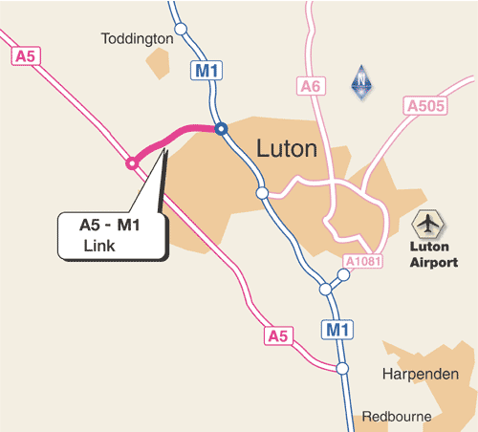
Figure 2A (ii): A5-M1 Link Scheme Location Plan

Appendix B- List of Consultees

Appendix C – Consultation Response Form

