Considerations for disabled students when applying to university in light of
Covid-19

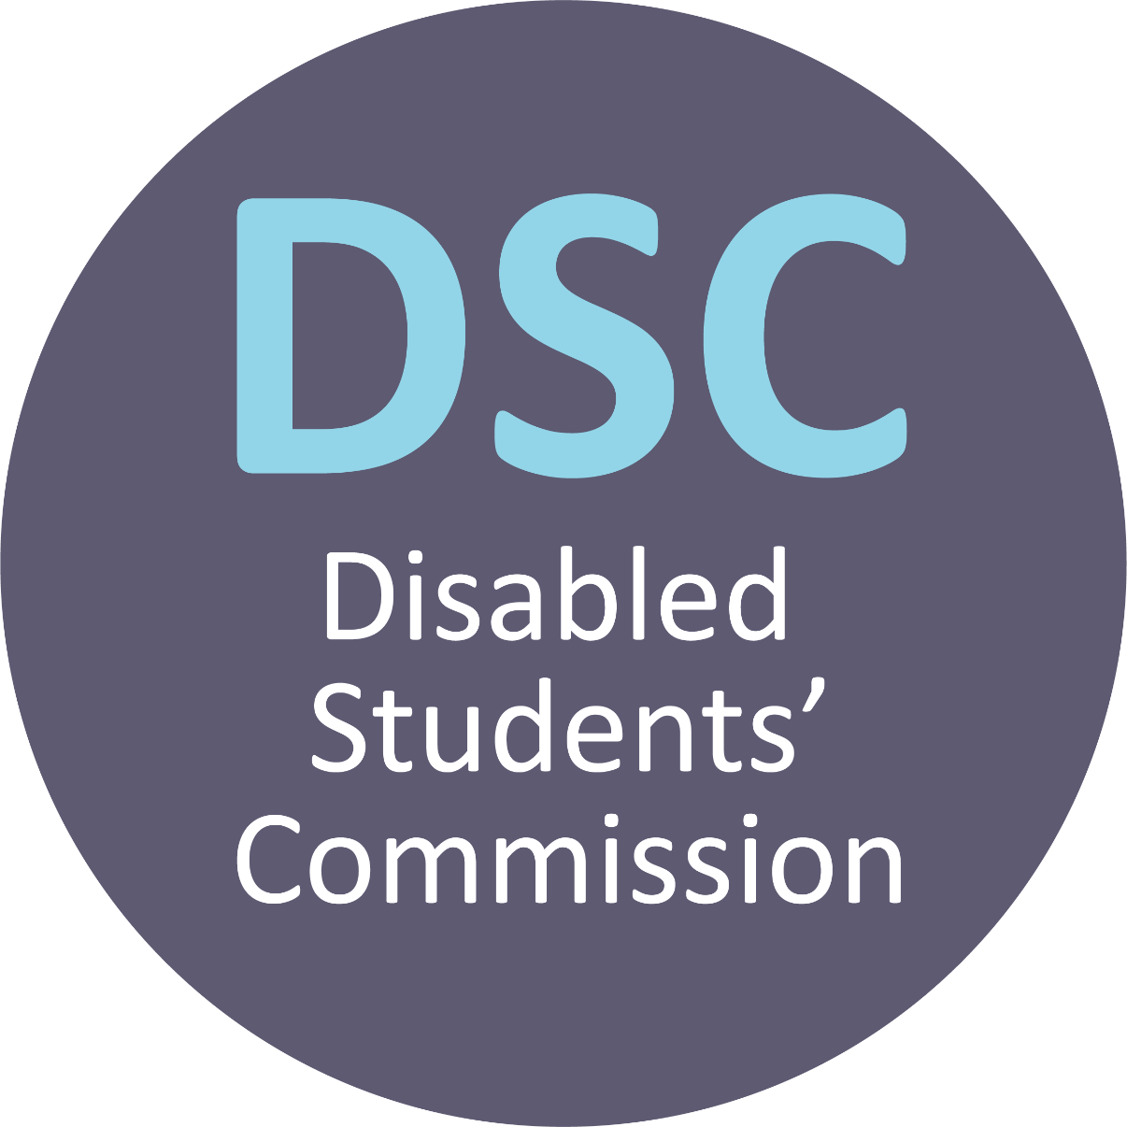

Foreword

To go to university is a life-changing decision and choosing where to study is one of the biggest choices you will make. Higher education is an opportunity that should be available for all those who can benefit from it and no student should be disadvantaged. It is therefore the responsibility of all higher education providers to ensure that they are supportive and equitable so that all students can succeed in their study and indeed afterwards throughout their careers.

It is important that all students have all the information that they need in choosing where to study, and it is particularly crucial that disabled students are sufficiently informed so that they can make the choice that is right for them. In the current pandemic, the challenges faced by disabled students are even more pronounced and there are many factors that must be considered in terms of the support and reasonable adjustments that a disabled student might need. This is why the Disabled Students’ Commission has put together this guide to help disabled students ask the important questions of their prospective or selected higher education provider, to ensure that they have everything they need in order to have the best possible experience of higher education.

Professor Geoff Layer, Chair of the Disabled Students’ Commission and Vice-Chancellor of the University of Wolverhampton

Introduction

The Covid-19 pandemic has put many pressures on our society and the economy and it is a period of great uncertainty. As a disabled person entering higher education, you may feel added pressure in terms of not knowing what to expect when you start your course. It may feel particularly uncertain if you have been shielding, wish to continue shielding or will need to shield in the event of further lockdowns.

Whether you have secured a place at college or university or are currently applying through the UCAS clearing system, this publication aims to help you by providing questions to ask to help ensure a smooth start to your higher education journey.
Adjustments and support will be provided by colleges and universities to enable you to complete your course of study in line with the duty to make reasonable adjustments under the Equality Act 2010. Many of these adjustments are made through inclusive provision for all students, however, barriers can still exist if the individual level adjustments that you require are not implemented from the outset of your course or academic year.

This document contains a number of considerations that will help you to pre-empt any barriers that you could encounter. The majority of questions can be asked of your college’s or university’s disability and wellbeing service. This is likely to sit within student services but colleges and universities will have different names for their services for disabled students. If you are unsure of the person or service to approach, ask the admissions team.

If you are applying via Clearing, before accepting your place, consider:

- searching the website of the college or university you are thinking of applying to and locate the contact details for the disability and wellbeing service. Send an email or telephone the disability adviser to check that the college or university is able to support your requirements
  - ask what campus tours are available, and whether they will be held virtually or physically.
  - ask about accessibility on campus, specifically related to your own
requirements, ie step-free, lift access, distance between buildings etc.
- making contact with the admissions officer or head of department for your course. Discuss course content, delivery methods, placements and assessment for your chosen subject to ensure there will be no significant barriers to your learning experience. At present learning is likely to be a blend of online and face-to-face delivery due to Covid-19, but this may not always be the case. Many disabled students have found the increase in online learning positive but some have found it a barrier, and you can ask about the steps that have been taken to ensure that online delivery for your chosen course is inclusive of your requirements.
- asking the disability and wellbeing service about the known impact of Covid-19 to their service provision, and make sure that any adjustments that have been put in place on a college or university-wide scale will support your needs, especially if you are shielding or would need to shield in the event of further lockdowns.

Once you have confirmed your place, the following questions are important to be aware of. Consider which ones may apply to you:
Funding for reasonable adjustments

- while in higher education at college or university, personal care continues to be provided by your home local authority or the local authority in which you are studying in, depending on which is considered your main local authority. Ask your local authority as soon as possible about the support provided when you go to college or university and how to access it
- if you think you may need reasonable adjustments to undertake your course of study and have not already applied for Disabled Students’ Allowances (DSA) you will need to apply as soon as possible at www.gov.uk/disabled-students- allowances-dsas. Ask the disability and wellbeing service if they provide any support with applications for DSA
- if you are eligible for DSA arrange for a needs assessment with Student Finance England as soon as possible. It may be the case that assessors are working remotely during Covid-19. If you are not provided with information on how the assessment is currently conducted, you can ask Student Finance England for information
- once you have received your assessment report, request a timetable from your disability adviser that maps out when reasonable adjustments will be implemented. Ask for a response over email/in writing, in case of any delays before the start of the academic year
- ask for a copy of your support plan and check for accuracy. You should be asked permission in line with data protection regulations, for the plan to be shared with relevant staff members and departments so that they can implement support. If you are unsure of who it will be sent to or if you feel that it should be shared more widely, ask the disability adviser for further information.

Campus and accommodation

- if you intend to live in college or university-provided accommodation, check with the disability and wellbeing service if they will be able to support any shielding requirements you may have, especially in the event of future lockdowns
- ask the disability and wellbeing service whether they are aware of any planned social distancing measures on campus, and how this may affect you as a disabled student. If there are planned changes to campus and/or accommodation eg one way systems, ask if they will they hinder your ability to access the buildings you need.

Mental health and wellbeing

- find out about the support provided by the disability and wellbeing service, ensuring they can address your requirements for mental health support in light of any restrictions that may be in place
- you may have experienced hardship and/or trauma as a result of Covid-19, and this could have affected your mental health and/or your wellbeing. Ask the disability and wellbeing service what support it is providing to students whose mental health or finances have been impacted by the Covid-19 pandemic when they transition to university.

Learning and assessment

- on accepting a place, if you have not already done so, ask the head of department about the planned learning and assessment methods for your course and make sure that they are accessible to you and whether methods are the same across modules. This will likely be a blended learning approach due to Covid-19
- ask for any reading lists in advance of starting your course, allowing you the time to check whether the resources are accessible
- where possible, enquire about course assessment extensions and any other mitigating/extenuating circumstance procedures, and if there are any known changes due to Covid-19
- be proactive about issues that might affect your studies and your individual needs, and offer solutions where you can.

Welcome week, induction and ongoing social activities

- prior to commencing your course, information is likely to become available about welcome and induction week activities. Communicate any requirements that you have to ensure that they can be more easily accommodated
- contact any sports clubs and societies you are interested in and ask them about their welcome activities and how you can get involved
- ask your Students’ Union about their welcome activities to see if they are accessible to you, especially if they are being delivered virtually. If they aren’t accessible, you could speak to your Students’ Union and explain what changes you might need in order to access the activities.

Learning platforms and technologies

- once you have started your course, collaborate with your college or university to resolve any accessibility issues. Some adjustments may have been introduced quickly in response to the pandemic and may not be polished. With your input, learning delivery could be improved for others on your course as well.

This publication has been informed by a series of roundtables run by the Disabled Students’ Commission (DSC) in July 2020, in response to the Covid-19 pandemic. The Disabled Students’ Commission was established by the Universities Minister and is funded by the Office for Students (OfS). The DSC aims to ensure that disabled students have a positive and successful experience in higher education.

A separate publication, called Three Months to Make a Difference has been issued for colleges and universities in response to the Covid-19 pandemic.

Contact us

General enquiries

+44 (0) 3300 416201
enquiries@advance-he.ac.uk www.advance-he.ac.uk

@AdvanceHE

Media enquiries

+44 (0) 1904 717500
communications@advance-he.ac.uk www.advance-he.ac.uk/contact-us
DSC enquiries
dsc@advance-he.ac.uk

This document is published by Advance HE on behalf of the Disabled Students’ Commission, an initiative funded by the Office for Students. Advance HE provides secretariat support to the Disabled Students’ Commission, and oversees the management, coordination and dissemination of research and other DSC outcomes.
Advance HE enables excellence in higher education, helping it shape its future.
Within the UK and globally, Advance HE supports institutions in the areas of excellence in education, transformative leadership, equity and inclusion and effective governance. This is delivered through membership benefits (including accreditation of teaching, equality charters, research, knowledge and resources), programmes and events, Fellowships, awards, consultancy and enhancement services and student surveys.
Advance HE is a company limited by guarantee registered in England and Wales
no. 04931031. Registered as a charity in England and Wales no. 1101607 Registered as a charity in Scotland no. SC043946. The Advance HE logo should not be used without our permission.

© 2020 Advance HE. All rights reserved.
The views expressed in this publication are those of the author and not necessarily those of Advance HE. No part of this publication may be reproduced or transmitted in any form or by any means, electronic or mechanical, including photocopying, recording, or any storage and retrieval system without the written permission of the copyright owner. Such permission will normally be granted for non-commercial, educational purposes provided that due acknowledgement is given.
To request copies of this report in large print or in a different format,
please contact the Marketing and Communications Team at Advance HE:
+44 (0) 3300 416201 or publications@advance-he.ac.uk

