

Verification and Reconciliation of Gas Composition Using Ultrasonic Speed of Sound

Phil Stockton, Accord ESL
Graeme Birks, Total Energies
Daniel Laing, Accord ESL
Juan Martin, Accord ESL

Bob Peebles, Accord ESL

Allan Wilson, Accord ESL

1 INTRODUCTION

This paper presents and discusses the development of a new approach, based on physical measurements from ultrasonic flare gas flow meters, which provides methods for verifying that reported flare gas compositions are truly reflective of flowing flare gas compositions and for reconciling these compositions where deviations are observed.

The Accord Combustor application is designed to calculate the Combustion Efficiency (CE), Destruction Efficiency (DE) and the emission rates for Carbon Dioxide (CO2), Methane (CH4) and the overall Carbon Dioxide Equivalent (CO2e) associated with the flaring of natural gas.

At the heart of Combustor lies Accord’s process simulation software, CHARM. CHARM’s role within Combustor is to estimate the flare gas composition and derive the lower heating value (LHV) of the flare gas, in mass terms, at the flare tip. The LHV of the flare gas is a primary input to Combustor for calculating CE, DE and emission quantities.

Given the direct relationship between flare gas composition and reported emission quantities there is a natural desire and need amongst operating companies, driven by regulatory or corporate requirements, to verify the correctness of the flare gas composition, Lower Heating Value, and emission quantities determined by Combustor.

Accord have identified and developed a methodology to perform a verification-check of estimated flare gas compositions, by sampling, modelling or other means, and wherein a discrepancy is identified, algorithmically reconcile the estimate providing a composition more reflective of the true flow. Such methods are widely applicable, not only to numerous flare installations, current or future, but to many other instances in the flow measurement industry.

Section 2 provides an overview of the current legislative framework governing flare gas reporting, emphasizing the technical challenges associated with flare gas sampling and noting the lack of mandatory validation procedures in existing standards.

Section 3 presents a real-world case study involving Accord and Total Energies, in which were encountered discrepancies in speed of sound measurements obtained from three distinct sources: the CHARM process model, physical gas samples, and an ultrasonic flow meter concluding with a set of reconciled results derived from these data sources.

Section 4 details the methodology used to rigorously test and validate the reconciliation algorithm developed to address the observed discrepancies before discussing limitations and areas of further development.

Section 5 explores potential alternative applications of the reconciliation technology beyond its initial scope.

Section 6 summarizes the key findings and implications of the study.

2 FLARE GAS COMPOSITION REPORTING REQUIREMENTS

Operators of industrial plants, onshore and offshore, in the United Kingdom (UK) and the European Union (EU) are required to develop sampling and analysis plans, which will include for flare gas composition, in accordance with their respective monitoring and reporting regulations (MRR) [1].

To meet these compliance requirements, operators must routinely obtain samples of flare gas for compositional analysis, conduct the compositional analysis at an agreed laboratory, and report the analysis results through the MRR verification processes. The purpose of this MRR verification activity is to provide assurance that reported flare emissions match closely with the compositional data obtained from sampling and analysis.

Whilst operators are working to comply with the current requirements of the MRR regulations it is apparent that the associated verification activity may be limited to ensuring that the operator is complying with their agreed sampling and analysis plan.

EU regulation 2024/1787, ‘On the reduction of methane emissions in the energy sector’, requires that the regulatory bodies of EU nations implement verification schemes which are focussed on the measurement and monitoring of flared Methane emissions. To verify Methane emission quantities as well as Carbon Dioxide, the verification bodies must be provided with accurate information about the flowing flare gas composition.

The UK Emission Trading Scheme (UK ETS) does not at present contain specific regulations relating to the measurement and monitoring of Methane however it is understood that flaring, as described within the UK MRR [2] is currently under review and that measurement and monitoring of Methane may form a part of future UK MRR requirements.

There may be a gap in the current UK and EU MRR verification processes, where operators are not required to verify that the reported flare gas compositions are truly reflective of the flowing flare gas composition.

This paper proposes a method to bridge this gap in current reporting requirements as it provides a means of verifying the correctness of sampled or modelled compositions and compensates for non-representative samples and/or non-measured flare gas source streams.

2.1 Obtaining a Representative Flare Gas Sample

Operators may take different approaches to obtain flare gas compositional data, more commonly via a manual sampling and analysis program, by installing a dedicated sample and analysis system such as a gas chromatograph (GC), or by process simulation modelling. whilst the GC and process simulation modelling can provide flare gas compositional data at a high frequency, the manual sampling activity will only deliver periodic compositional information.

The purpose of the flare system is to provide a safe means of disposing of hydrocarbons, and the original design of these systems did not necessarily include for routine sampling or analysis by a GC. Obtaining a representative sample of flare gas composition, whether via a dedicated online sample system such as a GC, or from manual spot sampling, has many factors contributing to its difficulty, including:

- The sample point location may be less than ideal.
- No dedicated sample quill or sample equipment installed.
- Low process pressure in the flare gas system.
- The presence of liquids or other contaminants at the sample location.

2.2 Verification of Flare Gas Compositional Data

A verification activity may be defined as a comparison against a known datum, where an observed result is verified against a known quantity to identify any deviations. Given that there are known difficulties in obtaining representative samples of flare gas composition, this paper asks two questions:

- How can flare gas compositions obtained from sampling and process modelling be verified as reflective of flowing flare gas compositions?
- Can flare gas compositions obtained from sampling and process modelling be corrected, becoming more reflective of flowing flare gas compositions?

3 VERIFICATION AND CHECK

One criterion for verifying sampled or modelled flare gas compositions is representative of the true composition is to compare some measurable property of the true flare flow against its calculated value for the estimated composition. Such a property must be available to operators and readily calculable by recognised and trusted methods from existing information on the flare gas stream.

As part of a continuous improvement program, the functionality we have developed utilises the speed of sound measured by an ultrasonic flow meter (USM), therefore requiring that such a flow meter be installed in the flare gas flow line.

3.1 Measured Speed of Sound

The USM flow measurement principle is based upon the calculation of a flowing fluid velocity based upon the time taken for an ultrasonic sound wave, generated as a pulse output by one ultrasonic transducer, to reach and be detected by a second ultrasonic transducer across a known path length. The cross-sectional area of the flow meter may then be used to calculate a volumetric flow rate [3].

One of the key measurement parameters of an ultrasonic flow meter is the speed of sound. This is a physical measurement of the speed at which the ultrasonic signal travels between a pair of ultrasonic transducers. This is defined as the measured speed of sound (MSOS).

The MSOS indicated by the USM is influenced by the flowing gas temperature, the gas composition at the flow meter, the gas flowing pressure, the geometry of the flow meter across the measurement section, the transit time measured by the meter and the stratification under low flow conditions.

3.2 Theoretical Speed of Sound

When the gas composition, temperature, and pressure of the flowing gas is known, the Theoretical Speed of Sound (TSOS) can be calculated using an equation of state such as those provided in AGA8-2017 parts 1 and 2 [4].

Part one of ISO17089 ultrasonic meters for gas provides accuracy requirements for the deviation between MSOS and TSOS, however, part two of this standard which is applicable to the use of ultrasonic gas flow meters for flare service does not provide for MSOS versus TSOS accuracy requirements.

Part two of ISO17089, section 6.5.2 states that investigations should be undertaken when an ‘unacceptable difference’ is observed between MSOS and TSOS but there is no guidance as to what value of difference would be unacceptable.

The Combustor software includes the functionality required to calculate TSOS in accordance with the latest AGA8 and GERG equations and Combustor utilises the measured speed of sound MSOS measured by the flow meter to compare against the calculated theoretical speed of sound TSOS.

3.3 Verification Check Using MSOS versus TSOS

Figure 1 provides a visual indication of the MSOS versus the TSOS for a Low Pressure (LP) flare on a North Sea offshore asset where Accord deployed its reconciliation functionality. This comparison is based upon the analysis results of six manual gas samples taken (monthly) over a period of six months. The High Pressure (HP) flare presented the same pattern. It can be observed that only one of the six manual samples delivers a TSOS which compares favourably with the MSOS and that there is an apparent bias in the subsequent samples where they have a TSOS consistently lower than the MSOS.

Fig. 1 – LP Flare MSOS vs TSOS.

The MSOS remained consistently at around 361 m/s for the LP Flare. Despite repeated sampling and use of various sampling techniques, it was not possible to resolve the discrepancy between MSOS determined by the flow meter and TSOS determined from manual sample composition.

By this stage Accord had deployed Combustor on the client’s asset. Compared to the MSOS results, Combustor’s TSOS results showed a relative deviation comparable to that of the sampling data, albeit on a minute-by-minute basis. During the modelling process, and in collaboration with the plant’s process engineers, it was identified that one or more unmeasured gas sources were entering the flare system downstream of the sampling point locations. These sources typically consist of low-flow gases discharged from compressor seal gas systems or purge flow systems and may include process hydrocarbon gases or nitrogen.

These variable source streams and their changing compositions were found to significantly alter the overall flare gas composition, thereby explaining the observed deviation between the flare sample TSOS, CHARM model TSOS and MSOS. To address this, a reconciliation technique was implemented to align the CHARM model TSOS to the MSOS by adjusting the flare gas composition, thereby enabling a more accurate quantification of emissions.

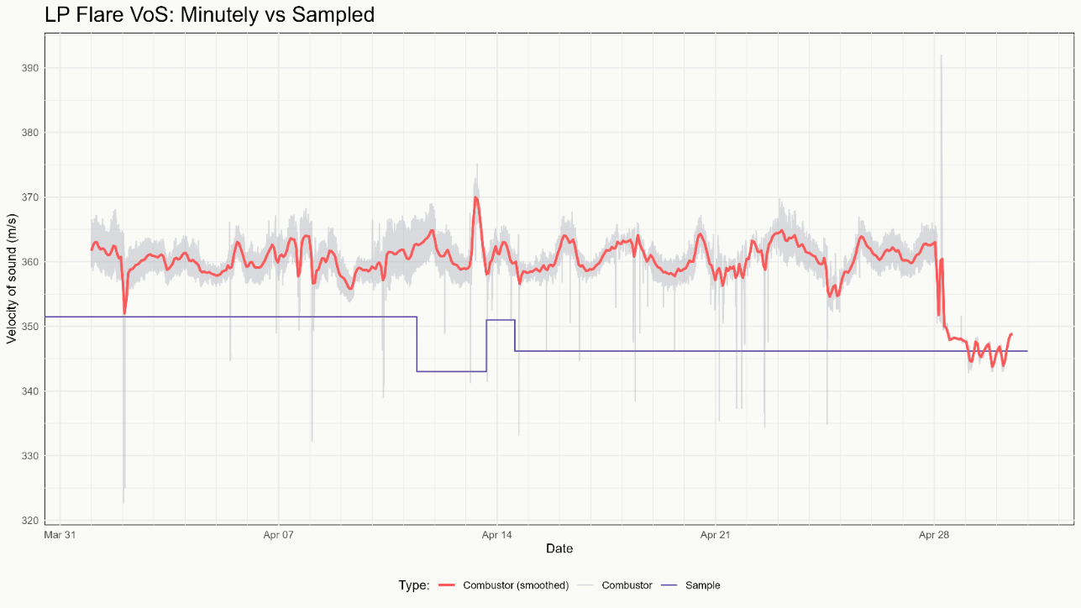
Figure 2 presents the reconciled values (in red) and compares them with the most recent samples taken from the LP Flare, as shown in Figure 1. The figure illustrates the superiority of live data over traditional sampling methods, both in terms of accuracy and temporal resolution. Furthermore, the reconciliation algorithm demonstrates its full potential when integrated with MSOS data obtained from the ultrasonic meter. This highlights a critical limitation of conventional sampling in reliably quantifying true flare emissions due to its inherent constraints in accuracy and frequency.

Fig. 2 – LP Flare Sample VS Reconciled (CHARM Combustor VCR).

4 RECONCILIATION ALGORITHM

To remedy an observed discrepancy between the speed of sound measured (MSOS) at an ultrasonic flowmeter (USM) and the theoretical speed of sound (TSOS) calculated by an equation of state, such as AGA8-2017, a mathematical optimisation algorithm is employed to adjust the estimated composition of the flare gas mixture such that the two speeds of sound are in agreement. Such estimates may be sourced by gas chromatographs, sampling, or process models such as Accord’s CHARM.

4.1 Reconciliation Techniques

The field of data reconciliation has become established as one advantageous to the flow measurement industry. The efficacy of reconciliation techniques has been proven in many papers and case studies [5], in addition to previous work by Accord ESL [6].

In development of the reconciliation functionality, Accord explored the use of a wide range of established reconciliation techniques. It was found that the best results were given by iterative procedures combined with carefully chosen constraints involving the speed of sound, AGA8 equations, and the composition mole fractions.

4.2 Testing Regime

When deployed in production, the true composition of the flare gas cannot be known for certain, thus the comparison of the reconciled and measured speeds of sound is the primary criterion by which the performance of the reconciliation algorithm may be assessed. Nonetheless, we may test the reconciliation algorithm against known compositions to determine its performance.

Accord tested the speed of sound reconciliation functionality against numerous flare gas mixture compositions obtained both by construction and from flares in operation in the North Sea, covering a breadth of samples seen in typical operation. The temperatures and pressures used were also representative of those found during typical flare operation.

First the speed of sound in the gas mixture was calculated using the AGA8-2017 equations of state which was to be considered as the measured speed of sound. Random noise was then added to the composition molar fractions, then the composition was normalised. This noisy composition was fed into the reconciliation algorithm and the results inspected. Here is presented a selection of said tests.

4.2.1 Test Setup

A sample of 9,834 gas mixture compositions, sourced from a variety of assets in the North Sea, was used as the test data source. This sample has a range of typical flare temperatures and pressures, in addition to varying quantities of C1, therefore covering a spread of speeds of sound likely to be measured as part of standard flare operation. Figure 3 shows four histograms showing the measured speeds of sound, C1 molar fractions, pressures, and temperatures of the test data sample each, illustrating the spread in the data.

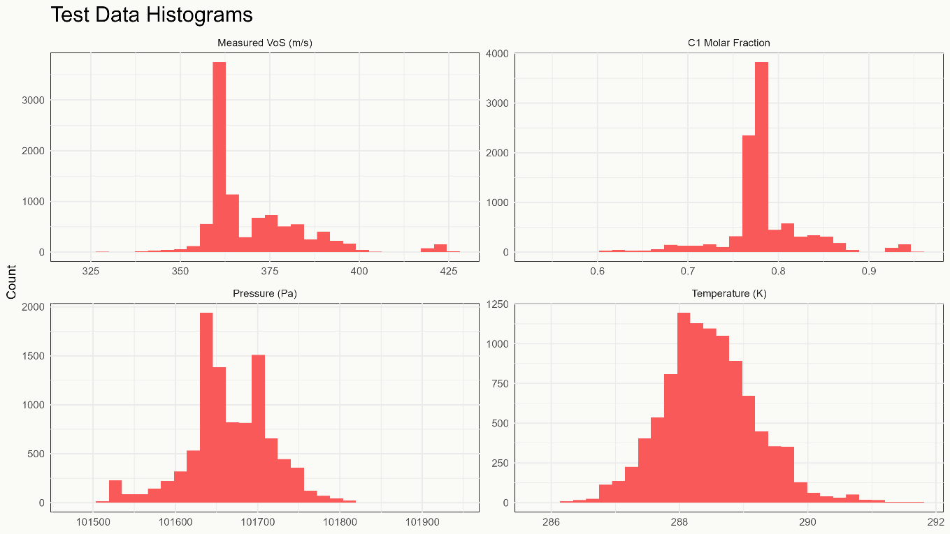
Fig. 3 – Histograms showing the measured speeds of sound, C1 molar fractions, pressures, and temperatures of the test data sample.

Using equations specified in AGA8-2017 the speed of sound in each gas mixture composition was calculated at the given temperature and pressure, before random noise was added to each component’s molar fraction. This random noise was sampled from a lognormal distribution with parameters selected at three levels of noisiness, detailed in Table 1, to ensure the mole fractions of each component remained positive, since the values a random variate distributed lognormally can take are bounded below by 0. After noise was added, the composition was normalised and the reconciliation algorithm applied.

At each noise level, the squared Euclidean distance from the original composition was calculated for both the noisy and reconciled compositions, according to $d^{2}=\sum_{i}{{(o}_{i}-{x_{i})}^{2}}$where d is the Euclidean distance, $o_{i}$ is the mole fraction of component $i$ in the original composition and $x_{i}$ is the mole fraction for component $i$ in the noisy or reconciled composition. Let the squared distance between the original and noisy composition be denoted by $d_{n}^{2}$ and similar for the reconciled composition be $d_{r}^{2}$.

Table 1 - Parameters of the lognormal noise distribution at each noise level.

To determine if there is a statistically significant difference between the sampled $d_{r}^{2}$ and $d_{n}^{2}$ the Mann-Whitney U test [7] may be applied. The test ascertains if a statistically significant difference between $d_{r}^{2}$ and $d_{n}^{2}$ is present, and therefore the effectiveness of the presented reconciliation algorithm. The one-tailed variant is applied because it is only of interest if $d_{r}^{2}$ is less than $d_{n}^{2}$.

4.2.2 Test Results

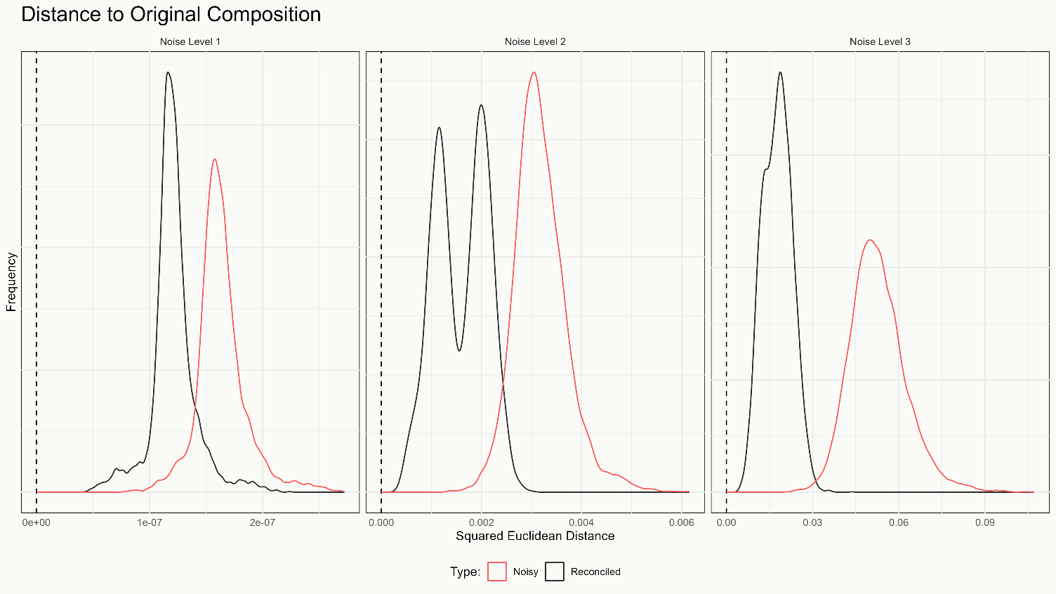
The test data sample of industry composition, at level of added noise, as described in Table 1, was reconciled to the original speed of sound. Following this, the squared Euclidean distance to the original composition was calculated. Figure 4 shows the distribution of distances from the noisy compositions in red and the reconciled compositions in black to the original composition at each level of noise. Visual inspection reveals that in every case Accord’s reconciliation procedure markedly reduces the distance to the original composition, and thus the reconciled gas mixture composition is more representative of the true composition than the noisy composition.
Fig. 4 – Distribution of squared Euclidean distances from the test sample of noisy compositions in red, and the reconciled compositions shown in black.

Results of the Mann-Whitney U test are summarised in Table 2. Due to the sample size, exact p-values were not calculable, consequently upper bounds are given. At every level of noise ample statistical evidence exists to conclude that the distance between the original and reconciled composition is less than that of the noisy composition and hence conclude that the reconciled composition is representative of the original to a greater degree than the noisy.

Table 2 - Summary of results from the Mann-Whitney U test.
Noise Level | Statistic Value | P Value
1 | 6,576,533 | < 2.2 • 10⁻¹⁶
2 | 899,006 | < 2.2 • 10⁻¹⁶
3 | 19,184 | < 2.2 • 10⁻¹⁶

4.3 Further Developments

While this paper presents the current state of the reconciliation functionality, it remains an ongoing work both within Accord and with our clients. One way the presented method can be extended is to incorporate the reconciliation of multiple gas streams, rather than a single gas mixture. In addition to the composition of each gas flow, the total flow rate can be reconciled against the flow rate measured at the USM in conjunction the relative flow rates of each. Under this extended reconciliation algorithm, unmeasured or unmeasurable flare sources can be estimated, providing insight to the operation of the plant.

Furthermore, statistical tests may be incorporated, inspecting the residuals of the reconciliation algorithm. If we assume the errors between the sampled or modelled composition and the true composition are normally distributed, with mean zero and known variance, in each component, then a chi-square test may be employed, commonly called the global test, to determine if the residuals, when considered all together, exceed what is expected under a pre-chosen threshold. More sophisticated tests have been developed in data reconciliation papers, weighting or truncating the usual chi-square test.

In general, it is expected that sampled or modelled flare gas flows will broadly align with the true flow, but instances where these tests detect a statistically significant discrepancy between MSOS and TSOS may be of interest to operators, possibly signalling abnormal operation, gross error or bias, mismeasurement, or meter malfunction among other possibilities.

Additionally, the assumption of known temperature and pressure may be relaxed, and these measurements considered as reconciliation variables, allowing them to be adjusted within a given uncertainty, for example the measurement uncertainty. Relaxing this assumption not only increases the applicability of the algorithm, allowing it to be utilised in situations where the temperature and pressure can only be estimated, not measured, but could lead to a quicker and closer convergence to the solution and thus a more representative estimate of the true gas mixture composition.

4.4 Limitations

Despite this reconciliation algorithm’s potential for myriad benefits to operators, it comes not without its drawbacks, some of which this paper has made mention of already. Preeminent among such limitations is the requirement for a USM to be installed and said algorithm is incompatible with other types of meters.

Furthermore, the current implementation of the algorithm requires a known temperature and pressure, in addition to an initial composition estimate. Such an estimate is of chief importance because this kind of optimisation is only capable of finding local minima, thus the obtained solution will only be global if the initial guess is sufficiently close to the global minimum. It is for this reason that Accord supports Combustor instances with an accompanying CHARM simulation, ensuring that the composition of the flare stream fed into the reconciliation algorithm, and in turn Combustor, is as representative of the true composition as possible.

Achieving optimal performance likewise may not be trivial. Parameters such as convergence tolerance and the weighting of parameters or constraints, require careful adjustment for optimal, even adequate, performance. Poorly chosen values may lead to difficulties like mismatches in component mole fractions, and a shift towards heavier compositions, undesirable for flare gas. Assessing whether a change to tuning parameters had a positive or negative impact, or indeed no impact at all, on the reconciled result may come with considerable challenges.

5 FURTHER APPLICATIONS

The method presented in this paper is not limited to flare streams but is generally applicable to any process gas stream for which SoS is measured and available. A selection of the possible applications beyond flare monitoring are outlined.

5.1 Stand-alone Use

As mentioned in section 2.2, typical deployments of Combustor are supported by a model of the process supplying the flare implemented in Accord’s CHARM software. But this VCR process has potential for stand-alone use, without the support of a process modelling package, ensuring that sufficiently representative estimates of the temperature, pressure, and crucially gas composition, naturally in addition to the speed of sound measurement, at the site of deployment are obtained.

Such types of usage benefit from considerable performance gains, in terms of computation time and complexity, and quicker deployment times since the need to develop and configure a process model is sidestepped. Nevertheless, in highly sensitive or dynamic processes the initial estimates to reconcile may need to be frequently updated in order to arrive at representative results, perhaps achieved by a frequent sampling campaign or continually updated estimates by a process engineer in the absence of an effective model.

5.2 Use Elsewhere in Plant Process

As noted above, this verification-check and reconciliation (VCR) process may be used outwith the context of flare monitoring. Indeed, at any point within a process where a USM is installed and uncertain composition this algorithm may be employed to reconcile sampled or modelled estimates of the gas flow composition to the measured speed of sound.

6 CONCLUSIONS

Verification of flare gas composition can be effectively achieved by comparing the speed of sound, either measured directly or derived using the AGA8-2017 standard. Due to the low uncertainty associated with both measurement and mathematical derivation (typically less than 1%), the speed of sound serves as a reliable and precise validation metric for flare gas composition. However, current regulations do not mandate validation procedures as part of the sampling and reporting requirements, highlighting a gap in regulatory oversight.

Accord has advanced its flare emissions technology through the integration of data reconciliation algorithms, which enable the modelled gas composition to align with the measured speed of sound obtained from an ultrasonic meter. This paper demonstrates that the technique significantly enhances the accuracy of gas composition determination compared to traditional process models and sampling methods, offering real-time accountability of emissions that conventional approaches cannot achieve.

The technique has been successfully implemented on a client’s asset and is currently operational. Additionally, this paper presents a general evaluation of the algorithm under increasing noise conditions. The testing yielded satisfactory results at the aggregated compositional level across all three noise scenarios, confirming the tool’s accuracy potential in contexts where sampling and other quantification techniques face technical limitations.

This technology shows strong promise for stand-alone deployment, independent of live process modelling tools such as CHARM. Furthermore, it may serve as a viable alternative to sampling in other areas of plant operations.

7 REFERENCES

[1] UKETS07 MRR - Sampling and analysis, July 2025.
[2] UKETS01 MRR - General guidance for installations - footnote (36), July 2025.
[3] ISO17089-1 Measurement of fluid flow in closed conduits — Ultrasonic meters for gas (2019).
[4] American Gas Association Report Number 8 part 1 (AGA 8), Thermodynamic properties of natural gas and related gases, 3rd Edition 2017.
ISO17089, measurement of fluid flow in closed conduits, ultrasonic meters for gas, meters for custody transfer and allocation measurement, (2019).
[5] Crowe et al. 1983, Reconciliation of Process Flow Rates by Matrix Projection.
Narasimhan and Jordache, 2000, Data Reconciliation and Gross Error Detection.
Britt and Luecke, 1973, The Estimation of Parameters in Nonlinear Implicit Models.
Alhaj-Dibo et al. 2007, Data Reconciliation: A Robust Approach Using a Contaminated Distribution
[6] Accord ESL, PUFMW 2008, Experiences in the Use of Uncertainty Based Allocation in a North Sea Offshore Oil Allocation System.
Accord ESL, NSFMW 2011, Gross Meter Error Detection and Elimination by Data Reconciliation.
Accord ESL, NSFMW 2013, Allocation in an Uncertain World: Maximising the Use of Data with UBA on Global Producer III.
Accord ESL, NSFMW 2019, Data Reconciliation in Microcosm – Reducing DP Meter Uncertainty. Oculus European Patent Awarded 2024.
[7] Mann, Henry B.; Whitney, Donald R. (1947). "On a Test of Whether one of Two Random Variables is Stochastically Larger than the Other".



The probability density function for a lognormal distribution is given by $f\left(x\right)=\frac{1}{xσ\sqrt{2π}}⋅\exp\left(-\frac{{\left(\log{x}-μ\right)}^{2}}{2σ^{2}}\right)$ for parameters μ and σ.
This is due to memory, specifically stack frame, limitations
Closeness here is defined by the objective function of the optimisation algorithm.

